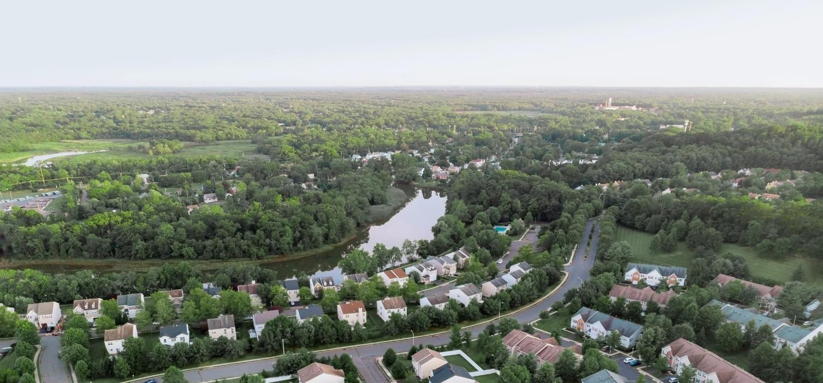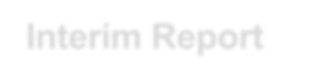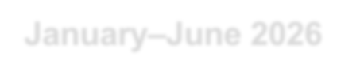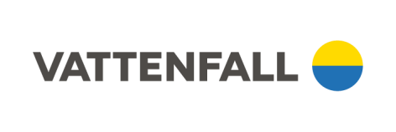
Interim Report

January
–
June

2026

Business highlights, April–June 2026  - The nuclear company Videberg Kraft has selected RollsRoyce SMR as supplier for new nuclear power at the Värö Peninsula in Sweden  - Agreement signed for sale of majority share in Videberg Kraft AB to the Swedish State  - Inauguration of the Bruzaholm hybrid park in Sweden, combining wind power (139 MW) with battery storage (38 MW / 38 MWh)  - Commissioning of two large-scale solar power parks in Germany with a total capacity of 126 MWp  - Vattenfall’s service operations business, NCC and Svenska kraftnät have initiated an eight-year collaboration to expand and upgrade 450 kilometres of transmission grid | Financial highlights, January–June 2026  - Underlying operating profit¹ increased by 45% to SEK 22,132 million (15,316)  - Operating profit¹ increased by 100% to SEK 28,860 million (14,434), whereof items affecting comparability SEK 6,728 million (-882)  - Profit for the period increased by 117% to SEK 23,529 million (10,828)  Financial highlights, April–June 2026  - Underlying operating profit¹ decreased by 30% to SEK 4,739 million (6,814)  - Operating profit¹ decreased by 20% to SEK 4,878 million (6,067), whereof items affecting comparability SEK 139 million (-747)  - Profit for the period increased by 14% to SEK 5,553 million  (4,867)

KEY DATA
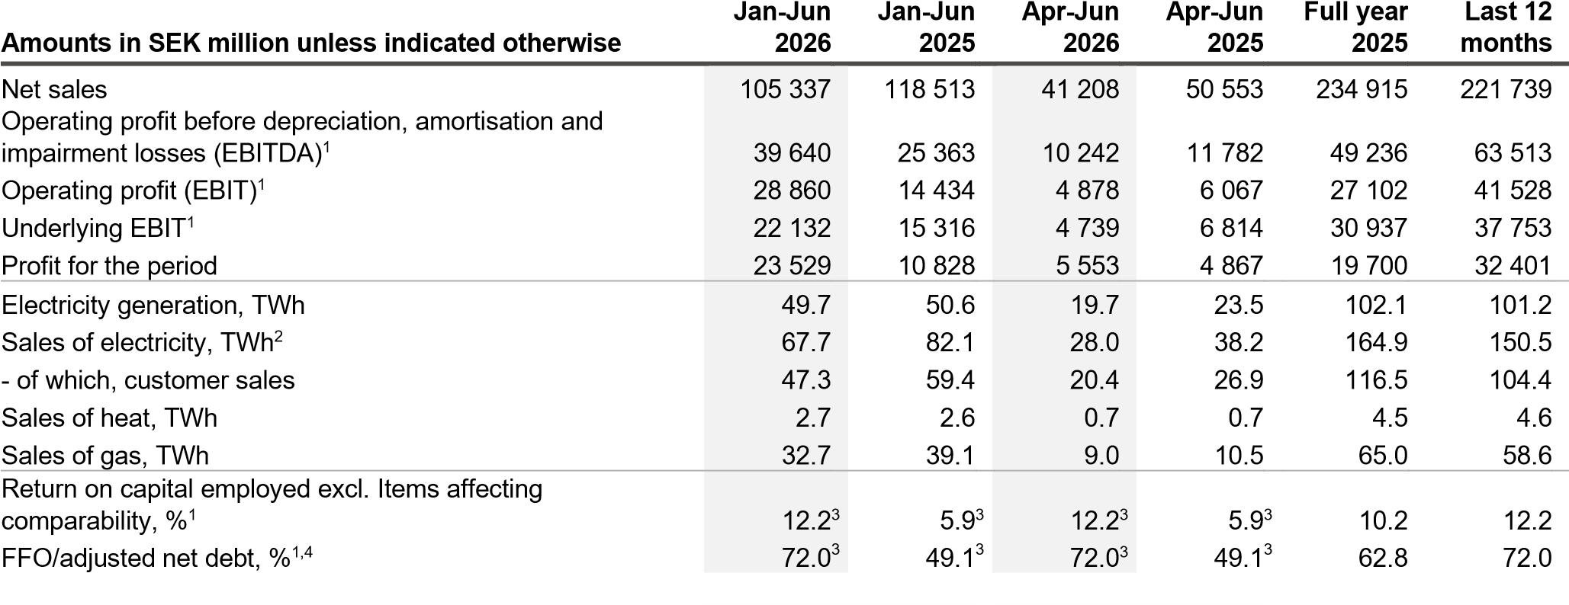
- See Definitions and calculations of key ratios for definitions of Alternative Performance Measures.
- Sales of electricity also include sales to Nord Pool Spot and deliveries to minority shareholders.
- Last 12-month values.
- The previously reported key ratio FFO has been removed and adjusted FFO is referred to as FFO from the first quarter of 2026. From the same point in time, Net payments to/from the Swedish Nuclear Waste Fund and Payments for provisions affecting adjusted net debt, are excluded from FFO. Prior periods have been restated.
1
VATTENFALL INTERIM REPORT JANUARY-JUNE 2026

CEO’s comment

Building the future energy system, step by step

Vattenfall delivered a strong result for the first half of 2026. The result was impacted by high Nordic prices especially in the first two months of the year. In addition, higher hydro and wind power generation and positive developments in the customer business and distribution contributed. During the second quarter, Vattenfall has progressed on a range of projects across our portfolio, driving the electrification of the markets we operate in.
Vattenfall remains determined to enable the fossil freedom that drives society forward. But to succeed, a stable and long-term investment framework is necessary. That is why we have been a consistent and clear advocate for maintaining the EU emission trading system (ETS), keeping it stable and free from ad hoc intervention. The frameworks provided by the European Commission will determine the investment climate for Vattenfall, our customers, and European industry as a whole.
High Nordic electricity prices at the beginning of the year Average electricity prices in Vattenfall’s markets were higher during the first half of the year compared to the same period last year. The electricity prices in the Nordics were more than twice as high, mainly due to weak hydrology and higher consumption driven by cold weather. In Vattenfall’s continental markets, electricity prices were about 9% higher, mainly due to higher gas prices. Volatile times causes legitimate concerns among our customers, where many value predictability. We do what we can to support, and one way of doing that is through our offering of long-term contracts.
Positive development in underlying operating profit Underlying operating profit for the first half-year increased by SEK 6.8 billion to SEK 22.1 billion, mainly due to higher prices in Vattenfall’s hydro and nuclear operations, higher volumes from hydro and wind power, as well as higher earnings from our German customer business and from distribution. However, the result in the second quarter was weighted down by lower nuclear volumes as well as lower earnings from ancillary services and pumped hydro. Profit for the period increased by SEK 12.7 billion to SEK 23.5 billion.
Supplier selection and agreement for new nuclear power
Underlying operating profit 22.1  SEK billion  (15.3) |  | Profit for the period 23.5  SEK billion  (10.8)
In June, the nuclear power company Videberg Kraft selected RollsRoyce SMR as supplier for new nuclear power in Sweden. Detailed planning will now begin for three modular reactors at the Värö Peninsula, next to Ringhals. Later the same month, Vattenfall and the industry consortium Industrikraft reached an agreement with the Swedish state on risk-sharing, financing and future ownership of Videberg Kraft. The new ownership structure is expected to come into effect in 2027, with the Swedish state owning 60% of the shares in the company, while Vattenfall and Industrikraft will retain 20% each. The financing model and joint ownership together with the state is unique. The next step is for the Government to notify the project to the European Commission for state aid assessment. We now have an agreement in which the risks are shared between commercial actors and the state, based on the principle that the party best able to control a risk is also responsible for it.
Driving the energy transition through business partnerships During the quarter, we made progress in a range of projects across the value chain. In southern Sweden, we inaugurated the Bruzaholm hybrid park, which combines wind power (139 MW) with battery storage (38 MW). Through a ten-year power purchase agreement with Volvo for 50% of the production, Vattenfall is providing long-term access to competitive electricity for Swedish industrial production. In our service operations business, we entered an eight-year strategic partnering collaboration with NCC and Svenska Kraftnät to expand and upgrade 450 kilometres of transmission grid in Västra Götaland. Through close collaboration, the partners aim to strengthen the operational capabilities and enable a more efficient build-out of the transmission grid.
In Germany, we commissioned the Juliusburg/Krukow solar power park (80 MWp), built with low emission steel that reduced emissions in construction and supply chain by 67%. Finally, in early July, Vattenfall installed the first monopile for the Nordlicht I offshore wind farm in the German North Sea. This is a milestone for Vattenfall, but also a meaningful contribution to the energy transition in our markets. Europe’s vulnerability from its dependence on fossil fuels has once again been exposed during the spring, with immediate effects on customers and businesses. Continued electrification, enabled by stable investment signals, is the way forward to ensure a competitive and secure Europe.
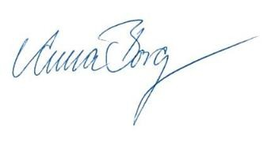
Anna Borg

President and CEO

FFO/adjusted net debt
72.0%
(49.1)
Return on capital employed excl. items
affecting comparability
12.2%
(5.9)

Group overview
Vattenfall generates electricity and heat from a portfolio of energy sources, such as hydro power, nuclear power, wind power, and some fossil fuels. We sell electricity, gas, and heat to private customers and businesses primarily in northern Europe. Vattenfall hedges parts of its future electricity generation through sales on the forward and futures markets.

Market development
The electricity market was during the first half-year 2026 characterised by higher electricity prices compared to the same period in 2025. In the Nordics, the higher prices were mainly driven by lower hydrological balance and higher electricity consumption in the beginning of the year due to cold weather. Lower nuclear power production also contributed to the higher prices. On Vattenfall’s continental markets, electricity prices were also higher compared to the same period last year, mainly driven by higher gas prices in the second quarter. This also affected the electricity prices in the most southern Swedish price area and in Denmark.

ELECTRICITY SPOT PRICES, EUR/MWh
The average spot price during the first half of 2026 increased in the Nordics, mainly driven by lower hydrological balance and cold weather. Prices on the Continent also increased mainly explained by higher gas prices in the second quarter.
Jan-Jun Apr-Jun
EUR/MWh | 2026 | 2025Change | 2026 | 2025 Change
Nordics | 79.0 | 36.0 119% | 68.2 | 26.5 157%
Germany | 98.7 | 90.7 9% | 95.2 | 69.7 37%
The Netherlands | 98.3 | 89.8 9% | 96.5 | 68.9 40%

NORDIC HYDROLOGY
Hydrological balance is a measure of the expected amount of energy that is stored in the form of snow, water reservoirs and groundwater in relation to normal circumstances. Historically, the electricity prices in the Nordics have had a negative correlation with the hydrological balance because the available hydropower capacity usually determines which type of energy is used. The electricity prices in the northern parts of the Nordics are still linked to the hydrological balance, while the correlation to the system price and price development in the southern parts has weakened.
-40
-30
-20
-10
0
10
20
2025
2026
NORDIC HYDROLOGICAL BALANCE (TW
h
)

At the end of the second quarter of 2026, the hydrological balance in the Nordic region was below normal. The reservoir levels of Vattenfall amounted to 10.6 TWh (14.4 TWh) at the end of the quarter, which is 0.9 TWh lower than the normal level.

NORDIC PRICE AREA DIFFERENCES
The electricity market in the Nordics is divided into different price areas. In Sweden, there are four price areas and Vattenfall's hydro power assets are mainly in SE1 and SE2, while the nuclear power assets are in SE3. Vattenfall also has wind power assets, most of which are located in SE4. In Denmark, there are two price areas, and Vattenfall has wind power assets in both areas, DK1 and DK2. The Nordic system price (SYS) is a reference price for all price areas and is calculated by the electricity exchange Nord Pool. Vattenfall hedges a substantive portion of its electricity production against the Nordic system price. Thereby, price area differences have an effect on the company’s result development.

SPOT PRICES PER PRICE AREA AND SYSTEM PRICE (EUR/MWh)
0
50
100
150
2024
2025
2026
SE1¹
SE2¹
SE3
SE4
DK1
DK2
SYS
¹Difference between SE1 and SE2 is invisible due to high correlation
The price area differences have been on a higher level in the first half-year compared to the same period last year. In northern Sweden, prices have decreased relative to SYS, while prices in southern Sweden and in Denmark have increased relative to SYS. For Vattenfall, this means lower prices for the production in the north of Sweden, SE1 and SE2, compared with the production in the south of Sweden.

INDICATIVE NORDIC HEDGE PRICES AND VOLUME HEDGE RATIO (SE, DK, FI) AS PER 30 JUNE 2026
Vattenfall's price hedging strategy is primarily focused on the Nordic generation assets because the primary risk exposure is linked to production of nuclear power and hydro power. The degree of hedging is highest for the next few years and decreases thereafter.
2026 2027 2028
EUR/MWh | 40 42 | 41
Hedge ratio (%) | 53 43 | 15

ACHIEVED NORDIC ELECTRICITY PRICES (SE, DK, FI)
The achieved price is the average price that Vattenfall received for its electricity production during the period and is impacted by the hedge ratio and hedge price (see above), the spot price and effects from price area differentials.
Full
Jan-Jun Apr-Jun
year
2025
2026
2025
2026
2025
EUR/MWh 54 39 40 39 39
Vattenfall's achieved price in the Nordics increased during the first half of 2026 driven by higher spot prices.

FUEL PRICES
The price of gas and carbon emission allowances affect mainly Vattenfall’s heat operations in the Netherlands. Gas prices also affect the operations within the operating segment Customers & Solutions, which is responsible for gas sales to customers. Fuel prices have an impact on the electricity prices on the Continent which impacts the generations operations.
Jan-Jun Apr-Jun
 | 2026 | 2025Change |  | 2026 | 2025 Change
Gas (EUR/MWh) | 42.9 | 41.2 | 4% | 45.9 | 35.6 29%
CO2 (EUR/t) | 75.7 | 71.2 | 6% | 75.2 | 69.0 9%
The price of gas has slightly increased during the first half of 2026, driven by geopolitical uncertainty. The price of emission allowances for carbon dioxide also increased compared to the first half of 2025.

PRICE MARGINS
The clean spark spread is the margin between the electricity price and the cost of gas and emissions allowances used for its generation. These spreads affect Vattenfall’s heat business in the Netherlands where the fossil-fired combined heat-and power (CHP) plants and condensing plants are located. Gas constitutes a majority of the fuel supply for Vattenfall's heat production, but a smaller share of the company's electricity production.
-40
-30
-20
-10
0
10
20
2025
2026
CLEAN SPARK SPREAD
(
EUR/MW
h
)

Clean Spark Spread NL (52% efficiency)
The monthly clean spark spread in the Netherlands was mostly negative during the first half of 2026, but on average slightly higher than in the same period 2025.

Generation development
Total electricity generation decreased by 0.9 TWh to 49.7 TWh (50.6) during the first half-year 2026. The decrease was mainly driven by lower nuclear power generation (-2.3 TWh), primarily from Forsmark 2 due to earlier planned annual outage compared to last year. In addition, generation from fossilbased power decreased (-1.2 TWh), mainly as a result of the divestment of the power plants in the IJmond region in the Netherlands on 1 January 2026. These decreases were partly offset by higher generation from hydro power (+1.0 TWh) and from wind power (+1.6 TWh) mainly due to higher wind speeds.

ELECTRICITY GENERATION (TWh)
19
19
9
2
0.1
21
18
8
4
0.1
0
5
10
15
20
25
Nuclear
Hydro
Wind
Fossil
Biomass,
waste
Jan-Jun 2026
Jan-Jun 2025

AVAILABILITY
The availability of nuclear power and wind power is not comparable given that different methods are used as generation of electricity from nuclear power is plannable and generation of electricity from wind power is dependent on wind speeds. Availability of nuclear power is calculated as the available generation divided by the generation possible if operating at full capacity during the same period, excluding planned outages. Availability of wind power is calculated as the ratio of actual revenue to the sum of lost revenue and actual revenue. Availability of nuclear power measures performance in terms of production optimisation while for wind the performance is measured in terms of revenue optimisation.
Jan-Jun
 | 2026 | 2025
Nuclear¹ | 95.7% | 93.5%
Wind - offshore | 94.5% | 92.2%
Wind – onshore | 94.2% | 94.7%
The availability of Vattenfall’s nuclear power increased during the first half of 2026, primarily as a result of higher availability at Ringhals. The availability of offshore wind power increased while the availability of onshore wind power was at a similar level as the same period last year.
¹ From the second quarter of 2025, nuclear availability is expressed according to UCR (Unit Capability Ratio) which isolates the effect of unplanned outages to give a more accurate picture of technical availability.

INSTALLED WIND CAPACITY
New installed wind power capacity in the last 12 months amounted to 205 MW and is attributable to Bruzaholm (139 MW) and Velinga (67 MW).
30 Jun 30 Jun 2026 2025
Onshore wind | 2,301 | 2,096²
Offshore wind | 4,454 | 4,454
Total (MW) | 6,755 | 6,550²

Sales development
Electricity sales, excluding sales to Nord Pool Spot and deliveries to minority owners, decreased by 12.1 TWh to 47.3 TWh (59.4 TWh) in the first half-year 2026, mainly due lower sales to grid operators in France during the first quarter and the divestment of the sales business in France on 31 March 2026. Gas sales decreased by 6.4 TWh to 32.7 TWh (39.1 TWh), mainly due to termination of gas sales to the previously owned heat business in Berlin. From the divestment in May 2024, until the end of October 2025, Vattenfall sold gas externally to the company. Heat sales amounted to 2.7 TWh (2.6 TWh).
Jan-Jun Apr-Jun
 | 2026 | 2025 | Change | 2026 | 2025 | Change
Sales of electricity to customers , TWh | 47.3 | 59.4 | -20% | 20.4 | 26.9 | -24%
Sales of gas, TWh | 32.7 | 39.1 | -16% | 9.0 | 10.5 | -14%
Sales of heat, TWh | 2.7 | 2.6 | 4% | 0.7 | 0.7 | -

TEMPERATURE EFFECTS
Temperature effects have an impact on the sales volume within the Customers & Solutions operating segment. Lower temperatures usually mean an increased demand for heating (including gas) and electricity. In the Nordic countries, this mainly affects sales of electricity and heat. In Germany and the Netherlands, gas is still the main source of heat, which means that lower temperatures increase the demand for gas in addition to increased heat sales.

TEMPERATURE DEVIATION FROM NORMAL LEVELS (ºC)
Jan-Jun Apr-Jun
 | 2026 | 2025 | 2026 | 2025
Nordics | 0.0 | 1.2 | 1.2 | 0.7
Netherlands | 1.4 | 1.2 | 1.8 | 1.8
Germany | 1.2 | 1.1 | 1.8 | 1.5
During the first half of 2026, the temperatures in the Nordics were in line with normal levels. In the Netherlands and Germany the temperatures were higher than normal, which affected sales negatively.
² The value has been adjusted compared with information previously published in Vattenfall’s financial reports.

Net sales  January–June: Consolidated net sales decreased by  SEK 13.2 billion (including negative currency effects of SEK 2.0 billion). The decrease is mainly explained by lower revenues from price hedges on the Nordic market, the divestment of the sales business in France, and negative volume effects in the customer sales of electricity and gas. This was partly offset by positive price effects in customer sales of electricity.  April–June: Consolidated net sales decreased by SEK 9.3 billion (including negative currency effects of SEK 0.1 billion). The decrease is mainly explained by lower revenues from price hedges on the Nordic market, negative volume effects in the customer sales of electricity and gas, and the divestment of the sales business in France. This was partly offset by positive price effects in customer sales of electricity.  Earnings  January–June: The underlying operating profit increased by SEK  6.8 billion in total, which is explained by:  - Higher earnings contribution from the Power Generation operating segment (SEK +2.0 billion) mainly due to higher achieved prices in the Nordics. In addition, higher volumes from hydro power and a higher trading result contributed positively.  - Higher earnings contribution from the Customers & Solutions operating segment (SEK +1.9 billion) mainly due to timing effects related to higher gas grid costs that impacted the customer business in Germany in the same period last year.  - Higher earnings contribution from the Wind operating segment (SEK +1.7 billion) driven by higher electricity prices and higher volumes mainly from offshore wind power.  - Higher earnings contribution from the Distribution operating segment (SEK +1.1 billion), mainly explained by higher revenues as a result of tariff adjustments for the local grid, increased transited volumes due to cold weather, and lower costs for the transmission grid.  - Other items, net (SEK 0.2 billion)  Items affecting comparability totalled SEK 6.7 billion (-0.9), mainly relating to changes in fair values of energy derivates and inventories  (SEK 4.1 billion) and capital gains relating to divestment of  Västerbergslagens Energi AB, power plants in the Netherlands and the French sales business (SEK 2.5 billion). See note 4 for further information. | Profit for the period amounted to SEK 23.5 billion (10.8), and in addition to the higher underlying operating profit, the result increased due to the higher items affecting comparability and a higher return from the Swedish Nuclear Waste Fund.  April–June: The underlying operating profit decreased by SEK 2.1 billion to SEK 4.7 billion. The result was mainly driven by a lower contribution from the Power Generation (SEK -2.4 billion) and Distribution operating segments (SEK -0.2 billion), partially offset by higher contributions from Customers & Solutions (SEK +0.4 billion) and Wind (SEK +0.1 billion).  Items affecting comparability for the second quarter of 2026 amounted to SEK 0.1 billion (-0.7), the majority of which relates to capital gains (SEK 1.1 billion), partly offset by negative changes in fair values of energy derivatives (SEK -0.9 billion). Profit for the period amounted to SEK 5.5 billion (4.9) and increased mainly due to higher return from the Swedish Nuclear Waste Fund.  Cash flow  January–June: Cash flow from operating activities before changes in operating assets and liabilities increased by SEK 4.6 billion mainly as a result of higher operating profit before depreciation, amortisation and impairment losses (EBITDA). This was partly offset by an increase in paid tax mainly relating to additional payments for previous tax years. Cash flow from changes in working capital totalled SEK 8.8 billion. The main contributors were the net of received and paid margin calls (SEK +10.7 billion) and higher operating liabilities in the Wind segment (SEK +1.6 billion). This was partly offset by lower operating liabilities (SEK -3.9 billion) and an increase in inventory (SEK -2.0 billion) in the Power Generation segment.  April–June: Cash flow from operating activities before changes in operating assets and liabilities decreased by SEK 0.9 billion mainly as a result of lower operating profit before depreciation, amortisation and impairment losses (EBITDA). Cash flow from changes in working capital totalled SEK -1.2 billion. The main contributors were lower operating liabilities in the Power Generation segment (SEK -4.5 billion), the net of received and paid margin calls (SEK -3.8 billion), and an increase in inventory in the Power Generation segment (SEK 2.0 billion). This was partly offset by lower operating receivables in the Customers & Solutions segment (SEK +8.5 billion).

KEY FIGURES – GROUP OVERVIEW
 | Jan-Jun | Jan-Jun | Apr-Jun | Apr-Jun | Full year | Last 12
Amounts in SEK million | 2026 | 2025 | 2026 | 2025 | 2025 | months
Net sales 105 337 118 513 41 208 50 553 234 915 221 739
Operating profit before depreciation, amortisation and
impairment losses (EBITDA)¹ 39 640 25 363 10 242 11 782 49 236 63 513 Operating profit (EBIT)¹ 28 860 14 434 4 878 6 067 27 102 41 528
Underlying operating profit¹ 22 132 15 316 4 739 6 814 30 937 37 753
Items affecting comparability¹ 6 728 - 882 139 - 747 - 3 835 3 775
Profit for the period 23 529 10 828 5 553 4 867 19 700 32 401
Funds from operations (FFO)¹ 26 803 23 038 7 942 9 939 46 145 49 910
Cash flow from changes in operating assets and operating
liabilities (working capital) 8 788 - 14 576 - 1 176 - 1 073 - 18 602 4 762 Cash flow from operating activities 34 129 6 203 6 572 7 536 23 245 51 171
1) See Definitions and calculations of key ratios for definitions of Alternative Performance Measures.
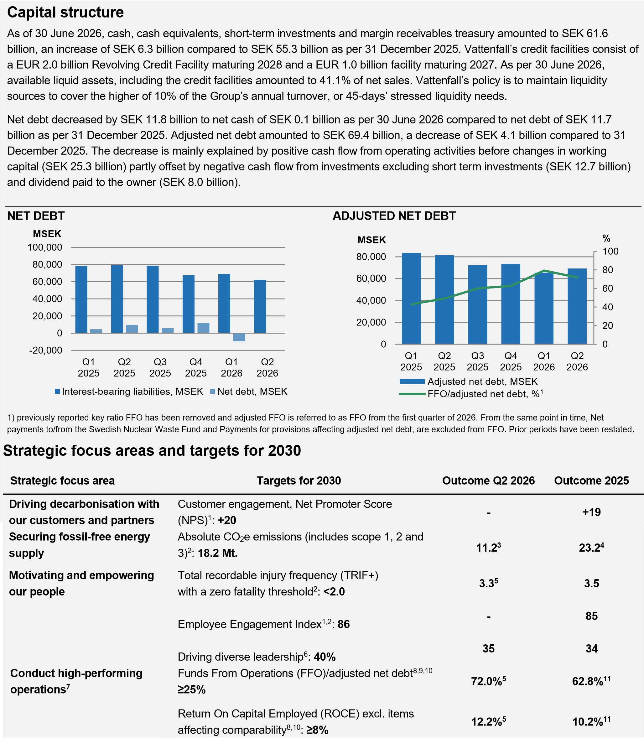
- Reported on an annual basis.
- Absolute emissions defined in accordance with Vattenfall’s Science-Based targets. For target definition and methodology see page 12 of Vattenfall’s Annual and Sustainability report 2025.
- The value is reflecting emissions during the period January-June 2026.
- The value is reflecting emissions during the period January-December 2025. Gas volumes sold to companies previously owned are not included in the target yet (2.4 Mio. tCO2e). With these gas volumes included the total absolute Scope 1, 2, 3 emissions are 25.9 Mio. tCO2e.
- Rolling 12-month values.
- Metric measured by the Female Manager Ratio.
- Financial targets set over a business cycle, 5-7 years.
- For definition see page 30.
- The previously reported key ratio FFO has been removed and adjusted FFO is referred to as FFO from the first quarter of 2026. The definition of FFO has also been updated. For reconciliation and more information, see supplementary information in connection with the consolidated statement of cash flows. The target level of ≥25% over a business cycle was met for the above periods both before and after the update of FFO. See Definitions of key ratios for more information.
- The key ratio has been adjusted and prior periods have been restated, see Definitions of key ratios for more information.
- The value has been adjusted compared with information previously published in Vattenfall’s financial reports.
7
VATTENFALL INTERIM REPORT JANUARY

Operating segments
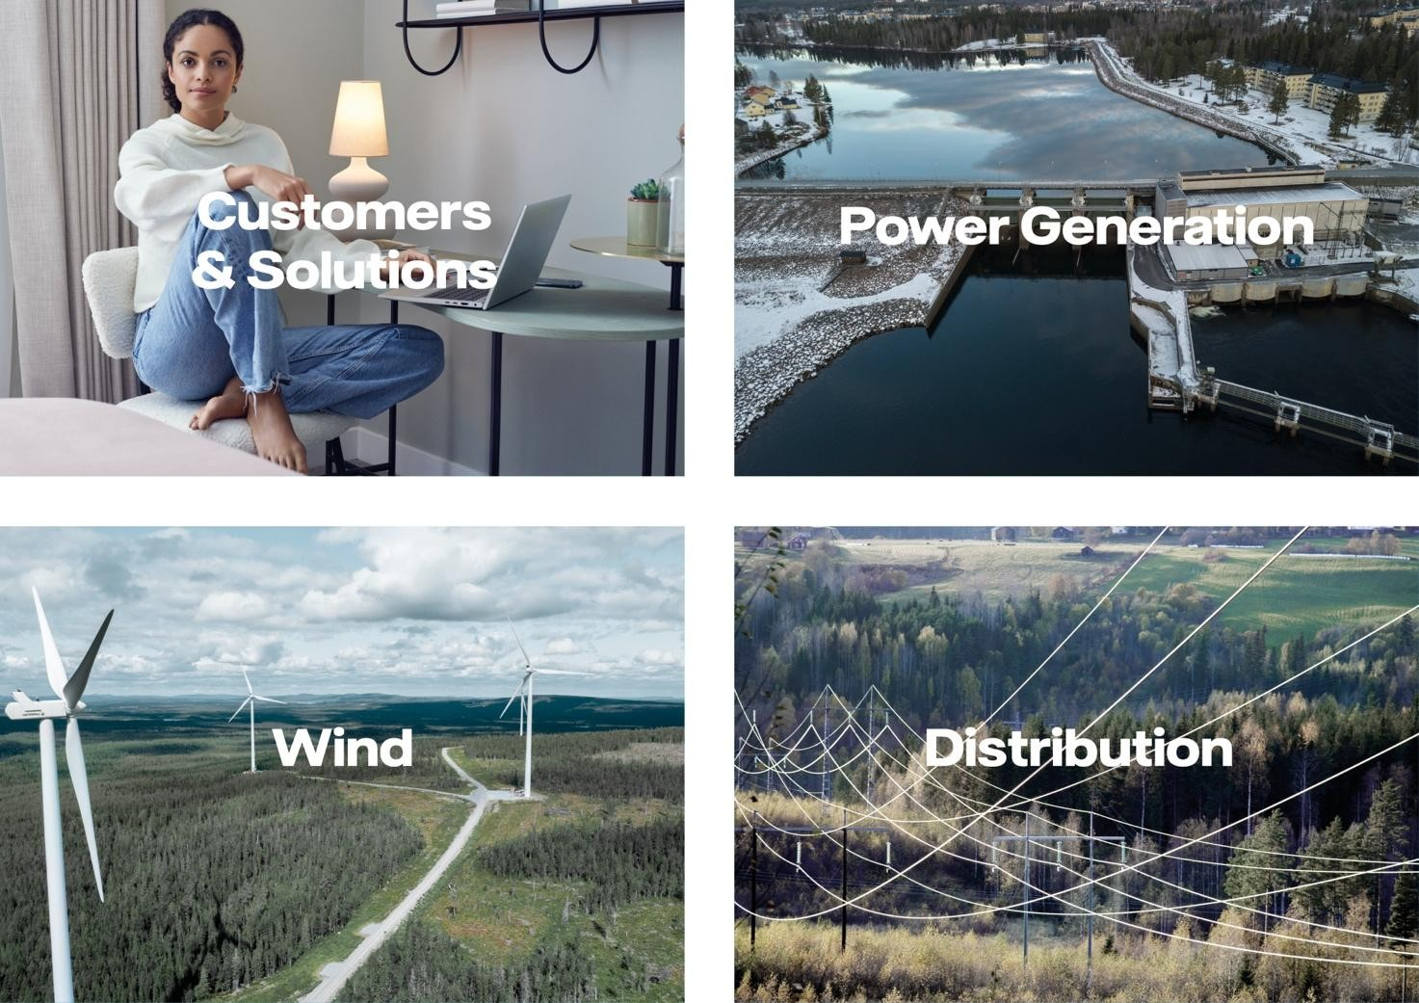
Jan-Jun Jan-Jun Apr-Jun Apr-Jun Full year Last 12

Amounts in SEK million 2026 2025 2026 2025 2025 months
Underlying EBIT  Customers & Solutions |  | 2 850 | 1 804 | 1 363 | 4 885 | 6 754
Underlying EBIT  Customers & Solutions | 4 719
- of which, heat operations | 558 | 728 | - 268 | - 262 | 894 | 724
Power Generation | 10 991 | 9 028 | 2 191 | 4 635 | 17 402 | 19 365
- of which, trading result | 1 157 | 701 | 452 | 215 | 1 787 | 2 243
Wind | 4 009 | 2 293 | 434 | 298 | 6 079 | 7 795
Distribution | 2 652 | 1 559 | 503 | 690 | 3 280 | 4 373
Other¹ | - 252 | - 443 | - 202 | - 195 | - 745 | - 554
Eliminations | 13 | 29 | 9 | 23 | 36 | 20
Underlying operating profit | 22 132 | 15 316 | 4 739 | 6 814 | 30 937 | 37 753
1) “Other” pertains mainly to all Staff functions, including Treasury, Shared Service Centres and capital gains and -losses from divestment of shares.

Customers & Solutions
The Customers & Solutions Business Area is responsible for Vattenfall’s customer relations, heat plants and gas-fired condensing plants as well as sales of electricity, gas, heat and energy services.

Delivering fossil-free energy and innovative solutions to our customers
- Long-term power purchase agreement signed for supply of renewable electricity to data centre development in Norway
- Testing of bidirectional charging for electric vehicles in pilot projects in Sweden and the Netherlands
- Vattenfall has divested its share in Västerbergslagens Energi AB and acquired the remaining 49% of Västerbergslagens Elförsäljning AB
Q1-Q2: Net sales decreased by 3%, compared to the same period in 2025. Underlying operating profit increased by 66%, mainly attributable to the customer business in Germany due to timing effects related to the higher gas grid costs imposed in 2025. The comparison was negatively affected by the divestments of the sales business in France and the power plants in the IJmond region in the Netherlands.
The customer base was stable compared to the end of 2025, at
11 million contracts, as a decrease following the divestment of France was offset by customer growth in Germany. Electricity sales decreased by 18% driven by the divestment of the sales business in France. Sales of gas increased by 4% mainly driven by customer growth in Germany and higher sales volumes to business customers in the Netherlands.
Q2: Net sales decreased by 1% compared to the same quarter last year. Underlying operating profit increased by 32% mainly attributable to the customer business in Germany due to timing effects related to the higher gas grid costs imposed in 2025. The comparison was negatively affected by the divestments of the sales business in France and the power plants in the IJmond region in the Netherlands. Electricity sales decreased by 22% mainly due to the divestment of the sales business in France. Sales of gas increased by 5% mainly driven by customer growth in Germany and higher sales volumes to business customers in the Netherlands.

Vattenfall has signed a long-term power purchase agreement with AI infrastructure company Nscale in Norway. Through the agreement, Vattenfall will supply renewable electricity to Nscale’s data centre development in Kvandal for 2027–2031. The agreement supports the expansion of AI infrastructure while providing long-term price stability and fossil-free electricity supply in a volatile energy market.
Vattenfall is testing vehicle-to-grid solutions in two pilots. In the Netherlands, a pilot was launched in May with Kia and Hyundai that enables households to use electric vehicles to store electricity and to feed electricity back into the grid. In Sweden, the concept is scaled with Energy Bank and Volkswagen, including the installation of around 200 bidirectional chargers. Both pilots aim to integrate EV batteries into energy and flexibility markets and support a more balanced energy system.
KEY FIGURES – CUSTOMERS & SOLUTIONS
Jan-Jun Jan-Jun Apr-Jun Apr-Jun Full year Last 12 Amounts in SEK million unless indicated otherwise 2026 2025 2026 2025 2025 months
Net sales | 92 964 | 95 794 | 35 928 | 36 182 | 181 551 | 178 721
External net sales | 84 885 | 87 394 | 32 640 | 33 044 | 166 183 | 163 674
Underlying EBITDA | 5 981 | 4 177 | 2 442 | 2 020 | 7 563 | 9 367
Underlying EBIT | 4 719 | 2 850 | 1 804 | 1 363 | 4 885 | 6 754
Electricity generation - TWh | 2.4 | 3.6 | 0.9 | 1.5 | 7.3 | 6.1
- of which, fossil-based power | 2.3 | 3.5 | 0.9 | 1.5 | 7.1 | 5.9
- of which, biomass, waste | 0.1 | 0.1 | — | — | 0.2 | 0.2
Sales of electricity, TWh | 44.9 | 54.9 | 19.1 | 24.6 | 108.2 | 98.2
- of which, private customers | 14.1 | 14.1 | 5.6 | 5.9 | 26.2 | 26.2
- of which, resellers | 6.2 | 14.9 | 2.2 | 6.7 | 28.9 | 20.2
- of which, business customers | 24.6 | 25.9 | 11.3 | 12.0 | 53.1 | 51.8
Sales of gas, TWh | 32.7 | 31.4 | 9.0 | 8.6 | 54.9 | 56.2
Sales of heat, TWh | 2.7 | 2.6 | 0.7 | 0.7 | 4.5 | 4.6
Number of employees, full-time equivalents | 5 330 | 5 589 | 5 330 | 5 589 | 5 518

Vattenfall has divested its shareholding in Västerbergslagens Energi AB to the municipalities of Ludvika and Fagersta. Västerbergslagens Energi operates electricity networks and district heating in the region. At the same time, Vattenfall acquired the remaining 49% of Västerbergslagens Elförsäljning AB, an electricity sales company with an established customer base. The transactions, completed in June, form part of Vattenfall’s assessment of its district heating operations in Sweden.

Power Generation
Power Generation comprises the Generation and Markets Business Areas. The segment includes Vattenfall’s hydro and nuclear power operations as well as optimisation and trading operations including certain large business customers. The result from hedging of the Group’s net exposure in electricity and fuel is reported in this segment.

Important milestones towards new nuclear power in Sweden
- The nuclear company Videberg Kraft has selected RollsRoyce SMR as supplier for new nuclear power at the Värö
Peninsula in Sweden
- Agreement signed for sale of majority share in Videberg Kraft AB to the Swedish State
- Feasibility study shows that Vattenfall’s five nuclear reactors have technical conditions for extending the operating time from 60 to 80 years
Q1-Q2: Net sales decreased by 19% compared with the same period last year. Underlying operating profit increased by 22%, mainly due to higher achieved prices in the Nordics, especially in the first quarter. In addition, higher volumes from hydro power and a higher trading result contributed positively. This was partly offset by lower volumes from nuclear power due to maintenance in the second quarter, a lower result from pumped hydro in Germany, and lower revenues from ancillary services.
Q2: Net sales decreased by 28%. Underlying operating profit decreased by 53%, mainly due to lower volumes from nuclear power. The lower volumes were explained by lower production at Ringhals 3 due to prolonged outage, Ringhals 4 operating at half capacity and earlier planned annual outage of Forsmark 2 compared to last year. In addition, the result was negatively impacted by lower revenues from ancillary services as well as lower results from pumped hydro in Germany.
During the quarter, the nuclear company Videberg Kraft selected Rolls-Royce SMR as supplier for new nuclear power in Sweden. The supplier selection marks an important milestone in the work towards new nuclear power at the Värö Peninsula, next to Ringhals. Detailed planning will now begin for three small modular reactors (SMRs), with a capacity of 470 MW per
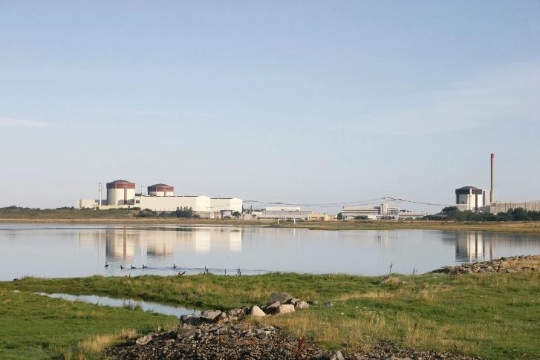
reactor. The first reactor is expected to be operational earliest in the mid-2030s.
In June, Vattenfall, the Swedish state and the consortium Industrikraft agreed on the future ownership structure, financing and risk-sharing principles for Videberg Kraft AB, the company established to develop new nuclear power at the Värö Peninsula. Under the agreement, the Swedish state will become the majority owner with a 60% stake, while Vattenfall and Industrikraft will each retain a 20% ownership stake. The agreement provides long-term conditions for the continued development of the project and represents an important milestone towards enabling new nuclear power in Sweden.
Vattenfall has completed a feasibility study examining the conditions for extending the operating time of Vattenfall’s five nuclear reactors from 60 to 80 years. The feasibility study shows that all reactors fulfill the technical conditions for operation up to 80 years. This would contribute fossil-free electricity production into the 2060s and benefit electricity customers as well as industry’s transition. A directional decision on extended operating time was made in 2024, but final investment decisions have not yet been made. Most of the major investments required to extend the operational time are not expected until the 2030s.

Net sales | 044 | 453 | 632 | 475 |  | 560
External net sales | 239 | 672 | 757 | 202 | 652 | 219
Underlying EBITDA | 519 | 515 | 465 | 881 | 445 | 449
Underlying EBIT | 991 | 028 | 191 | 635 | 402 | 365
- of which, trading result | 157 | 701 | 452 | 215 | 787 | 243
Electricity generation, TWh | 37.8 | 39.2 | 15.5 | 18.6 | 77.5 | 76.1
- of which, hydro power | 19.0 | 18.0 | 8.0 | 8.0 | 37.3 | 38.3
- of which, nuclear power | 18.8 | 21.2 | 7.5 | 10.6 | 40.2 | 37.8
Sales of electricity, TWh | 2.2 | 4.1 | 1.1 | 2.1 | 7.4 | 5.5
- of which, resellers | — | 3.1 | — | 1.5 | 5.4 | 2.3
- of which, business customers | 2.2 | 1.0 | 1.1 | 0.6 | 2.0 | 3.2
Sales of gas, TWh | — | 7.7 | — | 1.9 | 10.1 | 2.4
Number of employees, full-time equivalents | 659 | 586 | 659 | 586 | 561

KEY FIGURES – POWER GENERATION Jan-Jun Jan-Jun Apr-Jun Apr-Jun Full year Last 12 Amounts in SEK million unless indicated otherwise 2026 2025 2026 2025 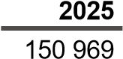 months

Wind
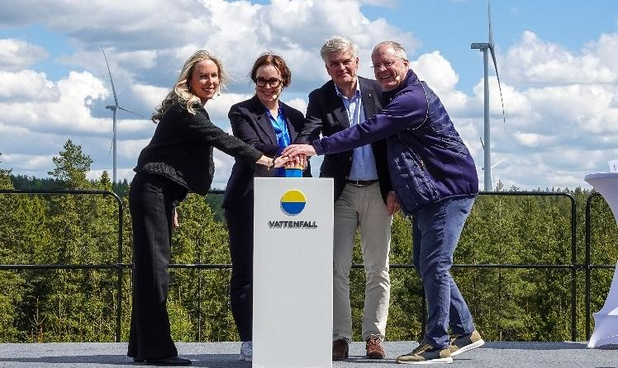
The Wind Business Area is responsible for development, construction and operation of Vattenfall’s wind farms as well as solar power parks and batteries.

Reducing CO₂-emissions with our partners
- Inauguration of the Bruzaholm hybrid park in Sweden, combining wind power (139 MW) with battery storage (38 MW / 38MWh)
- Commissioning of two large-scale solar power parks in Germany with a total capacity of 126 MWp
- Use of low-emission steel at the Juliusburg/Krukow solar park in Germany reduces CO₂-emissions by 67%

Q1-Q2: Net sales increased by 28% compared to the first half of 2025. Underlying operating profit increased by 75% driven by higher electricity prices as well as higher volumes. Electricity generation increased by 22% driven mainly by higher production from offshore wind power due to higher wind speeds and better availability.
Q2: Net sales increased by 23%. Underlying operating profit increased by 46% mainly as a result of higher electricity prices. Electricity generation decreased by 3% due to lower generation from offshore wind power.
Vattenfall has inaugurated the Bruzaholm hybrid park in
Sweden, with an estimated annual production of 460 GWh. Bruzaholm is a combined wind farm (139 MW) and battery energy storage system (38 MW / 38 MWh) that supports grid stability. A 10-year power purchase agreement with Volvo connects around half of the production directly to industrial demand.
At the Juliusburg/Krukow solar park in Germany, Vattenfall has used low-emission steel for the mounting substructures. This is Vattenfall’s first solar power park using low-emission steel which reduces CO₂-emissions in construction and supply chain by 67% compared to conventional steel. The solar power park was commissioned during the quarter and has a capacity of 80 MWp. In Germany, the Nauen solar power park has also been commissioned, with a total capacity of 46 MWp.
KEY FIGURES – WIND
Jan-Jun Jan-Jun Apr-Jun Apr-Jun Full year Last 12
Amounts in SEK million unless indicated otherwise 2026 2025 2026 2025 2025 months
Net sales | 13 196 | 10 347 | 5 270 | 4 284 | 22 885 | 25 734
External net sales | 750 | 1 822 | 277 | 900 | 3 825 | 2 753
Underlying EBITDA | 8 458 | 6 530 | 2 489 | 2 371 | 14 493 | 16 421
Underlying EBIT | 4 009 | 2 293 | 434 | 298 | 6 079 | 7 795
Electricity generation - wind power TWh¹ | 9.5 | 7.8 | 3.3 | 3.4 | 17.3 | 19.0
Sales of electricity, TWh  Number of employees, full-time equivalents | 0.2  1 853 | 0.4 | 0.2  1 853 | 0.2 | 0.9  1 849 | 0.7
 | 0.2  1 853 | 1 819 | 0.2  1 853 | 1 819 | 0.9  1 849 | 0.7
1) Including electricity generation from solar power.
Vattenfall and Copenhagen Infrastructure Partners (CIP) have selected the supplier of inter-array cables for the first phase of the Zeevonk offshore wind project in the Netherlands. The contract covers around 162 kilometres of cables. A final investment decision for the project is yet to be taken.

Distribution
The Distribution Business Area consists of Vattenfall’s electricity distribution operations in Sweden, Vattenfall’s service operations business and Power-as-a-Service offering.

Work to increase efficiency and shorten lead times
- Vattenfall’s service operations business, NCC and Svenska kraftnät have initiated an eight-year collaboration to expand and upgrade 450 kilometres of transmission grid
- Digital tools contribute to shorter lead times and better conditions for new electricity grid connections
- Vattenfall Distribution has been awarded Sweden’s most efficient electricity grid company 2026

Q1-Q2: Net sales increased by 7% compared to the same period in 2025. The underlying operating profit increased by 70%. The profit was positively affected by higher revenues as a result of tariff adjustments for the local grid, increased transited volumes due to cold weather, and lower costs for the transmission grid.
Q2: Net sales were in line with the second quarter in 2025. The underlying operating profit decreased by 27%, mainly due to higher personnel, maintenance and storm-related costs, as well as increased depreciation. This was partly offset by higher revenues as a result of tariff adjustments for the local grid.
Vattenfall’s service operations business, NCC and Svenska kraftnät have initiated an 8-year strategic collaboration to efficiently expand the transmission grid in Sweden. The business package includes expansion and upgrading of about 450 kilometres of transmission grid in Västra Götaland in Sweden. This type of collaboration within grid construction is unique and means that the partners work together from the early planning to completion, which strengthens operating capabilities.
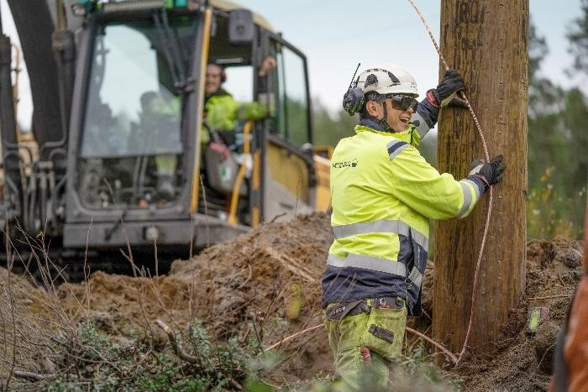
During the quarter, Vattenfall continued to drive the development towards increased efficiency and capacity in the electricity grid, with a particular focus on shortening lead times and improving conditions for new connections. In June, a capacity map was launched which increases transparency regarding available grid capacity, thereby strengthening the ability to plan and execute new projects. In addition, a new analysis tool has enabled more efficient utilisation of the electricity grid and significantly reduced connection lead times.
Vattenfall Distribution has been awarded as Sweden’s most efficient electricity grid company 2026 by Drivkraft Sverige, a Swedish trade association for fuel and charging companies. The award, that aims to reward best practice and improve dialogue between electricity grid companies and charging companies, recognises Vattenfall’s customer dialogue, processing times and work with continuous improvement.
The electricity grid company Västerbergslagens Elnät AB has been divested in connection to the sale of Västerbergslagens Energi AB. See page 9 for more information about the sale of Västerbergslagens Energi AB.

KEY FIGURES – DISTRIBUTION Jan-Jun Jan-Jun Apr-Jun Apr-Jun Full year Last 12 Amounts in SEK million unless indicated otherwise 2026 2025 2026 2025 2025 months
Net sales | 10 738 | 10 010 | 4 668 | 4 638 | 20 035 | 20 763
External net sales | 10 209 | 9 278 | 4 405 | 4 235 | 18 607 | 19 538
Underlying EBITDA | 4 485 | 3 257 | 1 431 | 1 553 | 6 773 | 8 001
Underlying EBIT | 2 652 | 1 559 | 503 | 690 | 3 280 | 4 373
Number of employees, full-time equivalents | 4 139 | 4 398 | 4 139 | 4 398 | 4 326

Other
Other pertains mainly to all Staff functions, including Treasury, Net sales consist primarily of revenues attributable to
Shared Service Centres and capital gains and -losses from Vattenfall’s service organisations such as Shared Services, IT divestment of shares. and Vattenfall Insurance.

KEY FIGURES – OTHER Jan-Jun Jan-Jun Apr-Jun Apr-Jun Full year Last 12 Amounts in SEK million unless indicated otherwise 2026 2025 2026 2025 2025 months
Net sales | 5 356 | 5 446 | 2 941 | 2 685 | 11 175 | 11 085
External net sales | 254 | 347 | 128 | 172 | 648 | 555
Underlying EBITDA | 234 | 97 | 45 | 41 | 247 | 384
Underlying EBIT | - 252 | - 443 | - 202 | - 195 | - 745 | - 554
Number of employees, full-time equivalents | 3 669 | 3 585 | 3 669 | 3 585 | 3 615

Consolidated income statement
 | Jan-Jun |  |  | Jan-Jun |  | Apr-Jun |  | Apr-Jun | Full year | Last 12
Amounts in SEK million | 2026 |  |  | 2025 |  | 2026 |  | 2025 | 2025 | months
Net sales |  | 105 337 | 118 513 |  | 41 208 |  | 50 553 |  | 234 915 | 221 739
Cost of purchases |  | - 48 272 | - 72 923 |  | - 21 375 |  | - 28 865 |  | - 145 015 | - 120 364
Other external expenses |  | - 7 527 | - 8 576 |  | - 3 951 |  | - 4 093 |  | - 17 929 | - 16 880
Personnel expenses |  | - 12 825 | - 12 466 |  | - 6 588 |  | - 6 352 |  | - 24 288 | - 24 647
Other operating income and expenses, net |  | 2 585 | 539 |  | 1 108 |  | 526 |  | 1 187 | 3 233
Share of profit from associated companies and joint ventures |  | 342 | 276 |  | - 160 |  | 13 |  | 366 | 432
Operating profit before depreciation, amortisation and impairment losses (EBITDA) |  | 39 640 | 25 363 |  | 10 242 |  | 11 782 |  | 49 236 | 63 513
Depreciation, amortisation and impairments |  | - 10 780 | - 10 929 |  | - 5 364 |  | - 5 715 |  | - 22 134 | - 21 985
Operating profit (EBIT) |  | 28 860 | 14 434 |  | 4 878 |  | 6 067 |  | 27 102 | 41 528
Financial income |  | 838 | 1 535 |  | 341 |  | 334 |  | 2 956 | 2 259
Financial expenses |  | - 2 922 | - 3 055 |  | - 1 448 |  | - 1 671 |  | - 6 086 | - 5 953
Return from the Swedish Nuclear Waste Fund |  | 3 608 | 1 355 |  | 3 642 |  | 1 952 |  | 2 011 | 4 264
Profit before income taxes |  | 30 384 | 14 269 |  | 7 413 |  | 6 682 |  | 25 983 | 42 098
Income taxes |  | - 6 855 | - 3 441 |  | - 1 860 |  | - 1 815 |  | - 6 283 | - 9 697
Profit for the period |  | 23 529 | 10 828 |  | 5 553 |  | 4 867 |  | 19 700 | 32 401
- Whereof attributable to owner of the parent company |  | 22 805 | 10 270 |  | 5 295 |  | 4 479 |  | 18 614 | 31 149
- Whereof attributable to non-controlling interests |  | 724 | 558 |  | 258 |  | 388 |  | 1 086 | 1 252
Supplementary information
32 690
22 132
17 413
9 881
4 739
3 691
Underlying EBITDA^{1,2} 25 605 11 889 51 557 58 642
Underlying EBIT^{1,2} 15 316 6 814 30 937 37 753
Adjusted profit for the period² 9 862 3 713 19 849 27 400

- See Note 4 for information on items affecting comparability.
- See Definitions of key ratios for more information.

Consolidated statement of comprehensive income
 | Jan-Jun |  |  | Jan-Jun |  | Apr-Jun |  | Apr-Jun | Full year | Last 12
Amounts in SEK million | 2026 |  |  | 2025 |  | 2026 |  | 2025 | 2025 | months
Profit for the period |  | 23 529 | 10 828 |  | 5 553 |  | 4 867 |  | 19 700 | 32 401
Other comprehensive income  Items that may be reclassified to the income statement Cash flow hedges  - Changes in fair value |  | 6 253 | - 9 163 |  | - 1 267 |  | - 4 378 |  | - 13 609 | 1 807
- Transferred to the income statement |  | - 589 | 3 392 |  | - 2 024 |  | 2 483 |  | 6 889 | 2 908
- Transferred to the balance sheet |  | 29 | 1 |  | 2 |  | 3 |  | 17 | 45
Hedging of net investments in foreign operations |  | - 854 | 1 274 |  | - 434 |  | - 770 |  | 2 530 | 402
Exchange rate differences, divested companies |  | 12 | — |  | 2 |  | — |  | - 58 | - 46
Exchange rate differences |  | 3 199 | - 4 544 |  | 1 557 |  | 3 405 |  | - 8 933 | - 1 190
Income taxes related to items that may be reclassified |  | - 1 851 | 1 267 |  | 1 168 |  | 641 |  | 1 105 | - 2 013
Total items that may be reclassified to the income statement |  | 6 199 | - 7 773 |  | - 996 |  | 1 384 |  | - 12 059 | 1 913
Items that will not be reclassified to the income statement  Remeasurement of defined benefit obligations |  | - 115 | 445 |  | - 115 |  | 445 |  | 1 559 | 999
Income taxes related to items that will not be reclassified |  | - 15 | - 136 |  | - 15 |  | - 136 |  | - 687 | - 566
Total items that will not be reclassified to the income statement |  | - 130 | 309 |  | - 130 |  | 309 |  | 872 | 433
Total other comprehensive income, net after income taxes |  | 6 069 | - 7 464 |  | - 1 126 |  | 1 693 |  | - 11 187 | 2 346
Total comprehensive income for the period |  | 29 598 | 3 364 |  | 4 427 |  | 6 560 |  | 8 513 | 34 747
- Whereof attributable to owner of the parent company |  | 28 495 | 3 440 |  | 3 986 |  | 5 725 |  | 8 560 | 33 615
- Whereof attributable to non-controlling interests |  | 1 103 | - 76 |  | 441 |  | 835 |  | - 47 | 1 132

Operating segments, Vattenfall Group
Jan-Jun Jan-Jun Apr-Jun Apr-Jun Full year Last 12 Amounts in SEK million 2026 2025 2026 2025 2025 months
Total net sales  Customers & Solutions |  | 95 794 |  | 36 182 | 181 551 | 178 721
Total net sales  Customers & Solutions |  | 95 794 | 35 928 | 36 182 | 181 551 | 178 721
Total net sales  Customers & Solutions | 92 964
- of which external sales  Power Generation | 84 885 | 87 394  76 453 | 32 640  22 632 | 33 044  31 475 | 166 183  150 969 | 163 674  136 560
- of which external sales  Power Generation | 62 044
- of which external sales  Wind | 9 239 | 19 672  10 347 | 3 757  5 270 | 12 202  4 284 | 45 652  22 885 | 35 219  25 734
- of which external sales  Wind | 13 196
- of which external sales  Distribution | 750 | 1 822  10 010 | 277 | 900  4 638 | 3 825  20 035 | 2 753  20 763
- of which external sales  Distribution | 10 738 | 1 822  10 010 | 4 668 | 900  4 638 | 3 825  20 035 | 2 753  20 763
- of which external sales  Other¹ | 10 209 5 356 | 9 278  5 446 | 4 405 | 4 235  2 685 | 18 607  11 175 | 19 538  11 085
- of which external sales  Other¹ | 10 209 5 356 | 9 278  5 446 | 2 941 | 4 235  2 685 | 18 607  11 175 | 19 538  11 085
- of which external sales  Eliminations | 254  - 78 961 | 347  - 79 537 | 128 | 172  - 28 711 | 648  - 151 700 | 555  - 151 124
- of which external sales  Eliminations | 254  - 78 961 | 347  - 79 537 | - 30 231 | 172  - 28 711 | 648  - 151 700 | 555  - 151 124
Total net sales  Operating profit before depreciation, amortisation and impairment losses (EBITDA) Customers & Solutions | 105 337 | 118 513  4 165 | 41 208 | 50 553  2 012 | 234 915  7 529 | 221 739  9 493
 | 6 129 | 118 513  4 165 | 2 058 | 50 553  2 012 | 234 915  7 529 | 221 739  9 493
Power Generation | 18 040 | 11 153 | 2 788 | 5 656 | 19 528 | 26 415
Wind | 8 458 | 6 563 | 2 489 | 2 405 | 14 493 | 16 388
Distribution | 4 486 | 3 261 | 1 431 | 1 553 | 6 782 | 8 007
Other¹ | 2 514 | 192 | 1 467 | 133 | 868 | 3 190
Eliminations | 13 | 29 | 9 | 23 | 36 | 20
Total | 39 640 | 25 363 | 10 242 | 11 782 | 49 236 | 63 513
Underlying EBITDA  Customers & Solutions | 5 981 | 4 177 | 2 442 | 2 020 | 7 563 | 9 367
Power Generation | 13 519 | 11 515 | 3 465 | 5 881 | 22 445 | 24 449
Wind | 8 458 | 6 530 | 2 489 | 2 371 | 14 493 | 16 421
Distribution | 4 485 | 3 257 | 1 431 | 1 553 | 6 773 | 8 001
Other¹ | 234 | 97 | 45 | 41 | 247 | 384
Eliminations | 13 | 29 | 9 | 23 | 36 | 20
Total | 32 690 | 25 605 | 9 881 | 11 889 | 51 557 | 58 642
Operating profit (EBIT)  Customers & Solutions | 4 688 | 2 838 | 1 241 | 1 355 | 4 089 | 5 939
Power Generation | 15 513 | 8 666 | 1 515 | 4 410 | 14 486 | 21 333
Wind | 4 009 | 1 687 | 434 | - 309 | 5 327 | 7 649
Distribution | 2 610 | 1 563 | 460 | 691 | 3 289 | 4 336
Other¹ | 2 027 | - 349 | 1 219 | - 103 | - 125 | 2 251
Eliminations | 13 | 29 | 9 | 23 | 36 | 20
Total²  Underlying EBIT  Customers & Solutions | 28 860 | 14 434  2 850 | 4 878 | 6 067  1 363 | 27 102  4 885 | 41 528  6 754
Total²  Underlying EBIT  Customers & Solutions | 4 719 | 14 434  2 850 | 1 804 | 6 067  1 363 | 27 102  4 885 | 41 528  6 754
Power Generation | 10 991 | 9 028 | 2 191 | 4 635 | 17 402 | 19 365
Wind | 4 009 | 2 293 | 434 | 298 | 6 079 | 7 795
Distribution | 2 652 | 1 559 | 503 | 690 | 3 280 | 4 373
Other¹ | - 252 | - 443 | - 202 | - 195 | - 745 | - 554
Eliminations | 13 | 29 | 9 | 23 | 36 | 20
Total | 22 132 | 15 316 | 4 739 | 6 814 | 30 937 | 37 753

- “Other” pertains mainly to all Staff functions, including Treasury, Shared Service Centres and capital gains and -losses from divestment of shares.
- Total operating profit plus financial net in the consolidated income statement amount to profit before tax.

Consolidated balance sheet
30 Jun 30 Jun 31 Dec
Amounts in SEK million 2026 2025 2025
Assets  Non-current assets  Property, plant and equipment | 281 349 | 273 785 | 275 353
Goodwill | 15 000 | 15 236 | 14 848
Other intangible assets | 4 787 | 3 654 | 4 303
Participations in associated companies and joint ventures | 5 516 | 5 175 | 4 912
Other shares and participations | 203 | 207 | 199
Share in the Swedish Nuclear Waste Fund | 61 194 | 57 085 | 58 201
Derivative assets | 5 260 | 4 128 | 3 898
Deferred tax assets | 3 025 | 6 808 | 6 100
Other assets | 3 604 | 3 395 | 3 165
Total non-current assets | 379 938 | 369 473 | 370 979
Current assets Inventories | 29 909 | 26 829 | 27 605
Trade receivables and other receivables | 38 699 | 38 159 | 35 791
Prepaid expenses and accrued income | 13 977 | 13 345 | 16 058
Other assets | 2 401 | 1 455 | 1 899
Current tax assets | 1 043 | 1 133 | 746
Margin receivables | 2 138 | 4 159 | 2 879
Derivative assets | 8 066 | 5 399 | 5 959
Short-term investments | 30 319 | 40 715 | 37 325
Cash and cash equivalents | 29 442 | 25 888 | 15 931
Assets held for sale | 665 | — | 2 841
Total current assets | 156 659 | 157 082 | 147 034
Total assets | 536 597 | 526 555 | 518 013
Equity and liabilities  Equity  Attributable to owner of the parent company | 193 100 | 167 352 | 172 676
Attributable to non-controlling interests | 26 252 | 27 436 | 26 718
Total equity | 219 352 | 194 788 | 199 394
Non-current liabilities  Hybrid Capital¹ | 20 984 | 21 176 | 20 539
Other interest-bearing liabilities | 34 390 | 39 359 | 33 338
Derivative liabilities | 6 787 | 6 996 | 6 543
Interest-bearing provisions | 121 623 | 125 648 | 122 710
Pension provisions | 25 403 | 26 889 | 25 122
Deferred tax liabilities | 15 296 | 12 722 | 13 936
Other non interest-bearing liabilities | 16 319 | 14 091 | 15 283
Total non-current liabilities | 240 802 | 246 881 | 237 471
Current liabilities  Trade payables and other liabilities | 22 130 | 25 577 | 23 995
Other interest-bearing liabilities | 6 447 | 18 298 | 13 404
Derivative liabilities | 11 937 | 10 232 | 7 958
Interest-bearing provisions | 3 198 | 2 775 | 3 166
Accrued expenses and deferred income | 23 797 | 23 087 | 25 516
Other non interest-bearing liabilities | 2 831 | 1 772 | 1 696
Margin liabilities | 1 027 | 506 | 360
Current tax liabilities | 4 406 | 2 639 | 3 306
Liabilities associated with assets held for sale | 670 | — | 1 747
Total current liabilities | 76 443 | 84 886 | 81 148
Total equity and liabilities | 536 597 | 526 555 | 518 013

1) One of the hybrid bonds amounting to SEK 10.9 billion has its first call date in the first quarter of 2027. Vattenfall intends to settle the bond at that time.

SUPPLEMENTARY INFORMATION
30 Jun 30 Jun 31 Dec
Amounts in SEK million 2026 2025 2025
Calculation of capital employed Property, plant and equipment | 281 349 |  | 273 785 | 275 353
Goodwill | 15 000 |  | 15 236 | 14 848
Other intangible assets | 4 787 |  | 3 654 | 4 303
Participations in associated companies and joint ventures | 5 516 |  | 5 175 | 4 912
Deferred and current tax assets | 4 068 |  | 7 941 | 6 846
Inventories | 29 909 |  | 26 829 | 27 605
Trade receivables and other receivables | 38 699 |  | 38 159 | 35 791
Prepaid expenses and accrued income | 13 977 |  | 13 345 | 16 058
Unavailable liquidity | 3 544 |  | 4 164 | 3 890
Other assets (non-interest-bearing) | 4 278 |  | 3 025 | 3 524
Total assets included in capital employed | 401 127 |  | 391 313 | 393 130
Deferred and current tax liabilities | - 19 702 |  | - 15 361 | - 17 242
Other non-interest-bearing liabilities | - 19 150 |  | - 15 863 | - 16 979
Trade payables and other liabilities | - 22 130 |  | - 25 577 | - 23 995
Accrued expenses and deferred income | - 23 797 |  | - 23 087 | - 25 516
Total non interest-bearing liabilities | - 84 779 |  | - 79 888 | - 83 732
Other interest-bearing provisions not related to adjusted net debt¹ | - 5 287 |  | - 5 428 | - 5 205
Adjustment related to assets/liabilities held for sale | - 9 |  | — | 1 055
Capital employed² | 311 052 |  | 305 997 | 305 248
Capital employed, average | 308 525 |  | 298 881 | 304 650
Calculation of net debt Hybrid Capital | - 20 984 |  | - 21 176 | - 20 539
Other interest-bearing liabilities | - 40 837 |  | - 57 657 | - 46 742
Margin liabilities, interest rate and currency derivatives | - 305 |  | - 412 | - 197
Total interest-bearing liabilities | - 62 126 |  | - 79 245 | - 67 478
Cash and cash equivalents | 29 442 |  | 25 888 | 15 931
Short-term investments incl. margin receivables treasury | 32 130 |  | 42 991 | 39 355
Loans to owners of non-controlling interests in foreign Group companies | 657 |  | 664 | 464
Net debt²  Calculation of adjusted net debt  Total interest-bearing liabilities | 103 |  | - 9 702  - 79 245 | - 11 728  - 67 478
 | - 62 126 |  | - 9 702  - 79 245 | - 11 728  - 67 478
Less 50% of Hybrid Capital³ | 10 492 |  | 10 588 | 10 270
Pension obligations | - 25 403 |  | - 26 889 | - 25 122
Dismantling and other environmental provisions | - 17 463 |  | - 16 341 | - 16 850
Provisions for nuclear power (net)⁴ | - 34 648 |  | - 42 351 | - 38 776
Less margin calls received treasury | 305 |  | 413 | 197
Less liabilities to owners of non-controlling interests | 7 899 |  | 7 332 | 7 645
Adjustment related to assets/liabilities held for sale | 2 |  | — | 39
Adjusted interest-bearing liabilities | - 120 942 |  | - 146 492 | - 130 075
Cash and cash equivalents and short-term investments incl. margin receivables treasury | 61 572 |  | 68 879 | 55 286
Less margin calls energy trading | - 6 447 |  | 335 | 5 237
Unavailable liquidity | - 3 544 |  | - 4 164 | - 3 890
Adjusted interest-bearing assets | 51 581 |  | 65 050 | 56 633
Adjusted net debt² | - 69 361 |  | - 81 442 | - 73 442

- Includes personnel-related provisions for non-pension purposes, provisions for tax and legal disputes and certain other provisions.
- See Definitions and calculations of key ratios for definitions of Alternative Performance Measures.
- 50% of Hybrid Capital is treated as equity by the rating agencies, which thereby reduces adjusted net debt.
- The calculation is based on Vattenfall’s share of ownership in the respective nuclear power plants, less Vattenfall’s share in the Swedish Nuclear Waste Fund and liabilities relating to funding of decommissioning obligations in Stade and Brokdorf. Vattenfall has the following ownership interests in the respective plants: Forsmark 66%, Ringhals 70.4%, Brokdorf 20%, Brunsbüttel 66.7%, Krümmel 50% and Stade 33.3%. (According to a special agreement, Vattenfall is responsible for 100% of the provisions for Ringhals.)

Consolidated statement of cash flows
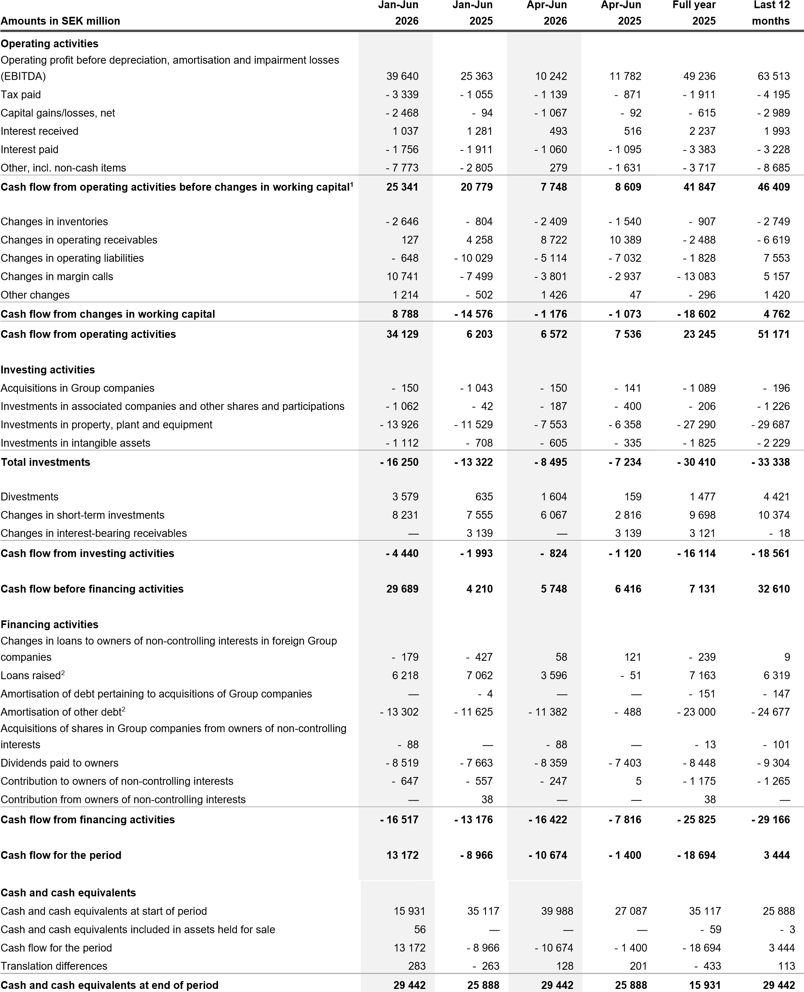

- As from the first quarter of 2026, this subtotal is referred to as Cash flow from operating activities before changes in working capital, instead of Funds from operations (FFO). For further information, see Definitions of key ratios.
- Short-term borrowings in which the duration is three months or shorter are reported net.

SUPPLEMENTARY INFORMATION
Jan-Jun Jan-Jun Apr-Jun Apr-Jun Full year Last 12
Amounts in SEK million 2026 2025 2026 2025 2025 months
FFO (funds from operations)  Cash flow from operating activities before changes in working capital | 25 341 | 20 779 |  | 7 748 | 8 609 | 41 847 | 46 409
Net payments to/from the Swedish Nuclear Waste Fund | - 615 | 79 |  | - 522 | 34 | 539 | - 155
Payments for provisions affecting adjusted net debt | 3 243 | 3 400 |  | 1 322 | 1 694 | 6 382 | 6 225
Dividends paid to owners of non-controlling interests | - 519 | - 663 |  | - 359 | - 403 | - 1 448 | - 1 304
Contribution to owners of non-controlling interests | - 647 | - 557 |  | - 247 | 5 | - 1 175 | - 1 265
FFO (funds from operations)^{1,2}  Cash flow after dividend  Cash flow before financing activities | 26 803  29 689 | 23 038 |  | 7 942  5 748 | 9 939 | 46 145  7 131 | 49 910  32 610
 | 26 803  29 689 | 4 210 |  | 7 942  5 748 | 6 416 | 46 145  7 131 | 49 910  32 610
Change in margin calls from financing operations | - 221 | 381 |  | - 25 | - 604 | 135 | - 467
Changes in short-term investments | - 8 231 | - 7 555 |  | - 6 067 | - 2 816 | - 9 698 | - 10 374
Acquisitions of shares in Group companies from owners of non-controlling interests | - 88 | — |  | - 88 | — | - 13 | - 101
Dividends paid to owners  Contribution to/from owners of non-controlling interests | - 8 519 - 647 | - 7 663 |  | - 8 359 - 247 | - 7 403 | - 8 448  - 1 137 | - 9 304  - 1 265
 | - 8 519 - 647 | - 519 |  | - 8 359 - 247 | 5 | - 8 448  - 1 137 | - 9 304  - 1 265
Cash flow after dividend  Change in net debt  Net debt at start of period | 11 983  - 11 728 | - 11 146 |  | - 9 038  9 398 | - 4 402 | - 12 030  2 767 | 11 099  4 884
 | 11 983  - 11 728 | 2 767 |  | - 9 038  9 398 | - 4 615 | - 12 030  2 767 | 11 099  4 884
Cash flow after dividend | 11 983 | - 11 146 |  | - 9 038 | - 4 402 | - 12 030 | 11 099
Changes as a result of valuation at fair value | 151 | 24 |  | - 14 | - 18 | 37 | 164
Changes in liabilities for leasing | - 291 | - 1 302 |  | - 100 | - 249 | - 2 873 | - 1 862
Interest-bearing liabilities/short-term investments acquired/divested | — | — |  | — | — | 190 | 190
Changes in liabilities pertaining to acquisitions of Group companies, discounting effects | — | — |  | — | — | 7 | 7
Cash and cash equivalents included in assets held for sale | 56 | — |  | — | — | - 59 | - 3
Exchange rate differences on net debt | - 68 | - 45 |  | - 143 | - 418 | 233 | 210
Net debt¹ at end of period | 103 | - 9 702 |  | 103 | - 9 702 | - 11 728 | 14 689
Cash flow from operating activities | 34 129 | 6 203 |  | 6 572 | 7 536 | 23 245 | 51 171
Maintenance/replacement investments | - 7 609 | - 8 453 |  | - 1 688 | - 4 615 | - 16 853 | - 16 009
Free cash flow¹ | 26 520 | - 2 250 |  | 4 884 | 2 921 | 6 392 | 35 162

INVESTMENTS
Electricity generation Wind and solar power | 5 977 | 3 152 | 2 845 | 1 603 | 7 715 | 10 540
Nuclear power | 1 089 | 950 | 664 | 541 | 2 414 | 2 553
Hydro power | 739 | 659 | 482 | 367 | 1 699 | 1 779
Gas | — | 56 | — | 29 | 119 | 63
Biomass, waste | 5 | 5 | 4 | 4 | 10 | 10
Total electricity generation | 7 810 | 4 822 | 3 995 | 2 544 | 11 957 | 14 945
Total electricity networks | 4 302 | 5 153 | 2 343 | 2 960 | 11 389 | 10 538
Combined heat and power/heat Heat networks | 716 | 683 | 415 | 404 | 1 833 | 1 866
Fossil-based power | 340 | 133 | 323 | 48 | 338 | 545
Other | 78 | 117 | 77 | 68 | 254 | 215
Total combined heat and power/heat | 1 134 | 933 | 815 | 520 | 2 425 | 2 626
Purchases of shares, shareholder contributions | 1 212 | 1 085 | 337 | 541 | 1 304 | 1 431
Other | 1 781 | 1 329 | 1 005 | 669 | 3 338 | 3 790
Total investments | 16 239 | 13 322 | 8 495 | 7 234 | 30 413 | 33 330
Accrued investments, unpaid invoices (-)/release of accrued investments (+) | 11 | — | — | — | 6 | 17
Cash and cash equivalents in acquired companies | — | — | — | — | - 9 | - 9
Total investments with cash flow effect | 16 250 | 13 322 | 8 495 | 7 234 | 30 410 | 33 338

- See Definitions of key ratios for definitions of Alternative Performance Measures.
- The previously reported key ratio FFO has been removed and adjusted FFO is referred to as FFO as from the first quarter of 2026. From the same point in time, Net payments to/from the Swedish Nuclear Waste Fund and Payments for provisions affecting adjusted net debt, are excluded from FFO. The revised definition is more closely aligned with the definition used by credit rating agencies. The key ratio has been restated retrospectively. For further information, see Definitions of key ratio.

Consolidated statement of changes in equity
30 Jun 2026 30 Jun 2025 31 Dec 2025
Amounts in SEK million | Attributable to owner of the parent company | Attributable to noncontrolling interests | Total equity | Attributable to owner of the parent  company | Attributable to non-  controlling interests | Total equity | Attributable to owner of the parent  company | Attributable to non-  controlling  interests | Total equity
Balance brought forward | 172 676 | 26 718 | 199 394 | 171 196 | 30 725 | 201 921 | 171 196 | 30 725 | 201 921
Profit for the period | 22 805 | 724 | 23 529 | 10 270 | 558 | 10 828 | 18 614 | 1 086 | 19 700
Total other comprehensive income for the period | 5 690 | 379 | 6 069 | - 6 830 | - 634 | - 7 464 | - 10 054 | - 1 133 | - 11 187
Total comprehensive income for the period | 28 495 | 1 103 | 29 598 | 3 440 | - 76 | 3 364 | 8 560 | - 47 | 8 513
Dividends paid to owners | - 8 000 | - 519 | - 8 519 | - 7 000 | - 963 | - 7 963 | - 7 000 | - 1 448 | - 8 448
Group contributions from(+)/to(-) owners of noncontrolling interests | — | — | — | — | — | — | — | 583 | 583
Changes in ownership in Group companies on acquisition/divestments of shares to owners of noncontrolling interests | - 71 | - 17 | - 88 | - 284 ¹ | - 1 731¹ | - 2 015 | - 304¹ | - 1 734 ¹ | - 2 038
Contribution to/from owners of non-controlling interests | — | - 647 | - 647 | — | - 519 | - 519 | — | - 1 137 | - 1 137
Other changes in ownership | — | - 386 | - 386 | — | — | — | — | — | —
Other changes | — | — | — | — | — | — | 224 | - 224 | —
Total transactions with equity holders | - 8 071 | - 1 569 | - 9 640 | - 7 284 | - 3 213 | - 10 497 | - 7 080 | - 3 960 | - 11 040
Balance carried forward | 193 100 | 26 252 | 219 352 | 167 352 | 27 436 | 194 788 | 172 676 | 26 718 | 199 394
- Of which, reserve for hedges | - 4 079 | 8 | - 4 071 | - 6 908 | 8 | - 6 900 | - 7 745 | 8 | - 7 737
1) Relates to the investment of shares in Nordlicht.

Quarterly information, Vattenfall Group
Q2 Q1 Q4 Q3 Q2 Q1
Amounts in SEK million unlesss otherwise stated 2026 2026 2025 2025 2025 2025
Income statement Net sales | 41 208 | 64 130 | 67 134 | 49 268 | 50 553 | 67 960
Operating profit before depreciation, amortisation and impairment losses  (EBITDA) | 10 242 | 29 399 ⁵ | 15 337 | 8 536 | 11 782 | 13 582
Underlying EBITDA¹ | 9 881 | 22 810 ⁵ | 14 651 | 11 302 | 11 889 | 13 717
Operating profit (EBIT) | 4 878 | 5  23 982 | 9 279 | 3 388 | 6 067 | 8 367
Underlying EBIT¹ | 4 739 | 5  17 393 | 9 467 | 6 154 | 6 814 | 8 502
Profit before income taxes | 7 413 | 5  22 971 | 8 688 | 3 026 | 6 682 | 7 586
Profit for the period | 5 553 | 5  17 976 | 6 603 | 2 269 | 4 867 | 5 961
- of which, attributable to owner of the parent company | 5 295 | 5  17 509 | 6 180 | 2 164 | 4 479 | 5 792
Adjusted profit for the period¹ | 3 691 | 5  13 722 | 5 926 | 4 060 | 3 713 | 6 149
Balance sheet Equity | 219 352 | 5  224 005 | 199 394 | 195 069 | 194 788 | 195 503
- of which, attributable to owners of the parent company | 193 100 | 5  197 185 | 172 676 | 167 902 | 167 352 | 168 624
Net debt¹ | 103 | 9 399 | - 11 728 | - 5 768 | - 9 702 | - 4 616
Adjusted net debt¹ | - 69 361 | - 65 455 | - 73 442 | - 72 370 | - 81 442 | - 83 463
Capital employed, average¹ | 308 525 | 306 295 | 304 650 | 293 546 | 298 881 | 315 090
Cash flow  Cash flow from operating activities before changes in working capital² | 7 748 | 17 592 | 12 505 | 8 563 | 8 609 | 12 170
FFO (Funds from operations)^{1,2} | 7 942 | 18 861 | 13 312 | 9 795 | 9 939 | 13 099
Cash flow from operating activities | 6 572 | 27 556 | 5 283 | 11 758 | 7 536 | - 1 333
Cash flow from investing activities | - 824 | - 3 615 | - 10 556 | - 3 564 | - 1 120 | - 872
Cash flow from financing activities | - 16 422 | - 95 | - 11 926 | - 723 | - 7 816 | - 5 360
Cash flow for the period | - 10 674 | 23 846 | - 17 199 | 7 471 | - 1 400 | - 7 565
Free cash flow¹  Financial targets^{1,4}  Return on capital employed excl. items affecting comparability, %  (target ≥8%) | 4 884 | 21 637  13.0 ⁵ | 367  10.2 | 8 275  7.6 | 2 921  5.9 | - 4 627  4.7
 | 12.2
FFO/adjusted net debt³, % (target ≥25%) | 72.0 | 79.3 | 62.8 | 60.2 | 49.1 | 43.1
Other key ratios^{1,4}  Return on equity, % | 16.6 | 16.6 ⁵ | 10.6 | 9.6 | 9.8 | 12.6
Cash flow interest cover (times) | 11.7 | 11.3 | 10.4 | 9.2 | 8.5 | 7.5
Net debt/EBITDA (times) | - 0.0 | - 0.1 | 0.2 | 0.1 | 0.2 | 0.1
Adjusted net debt/EBITDA (times) | 1.1 | 1.0 | 1.5 | 1.6 | 1.9 | 1.7
Return on capital employed, % | 13.5 | 14.0 ⁵ | 8.9 | 7.8 | 6.9 | 8.4

- See Definitions of key ratios for more information.
- The previously reported key ratio FFO has been removed and adjusted FFO is referred to as FFO as from the first quarter of 2026. The definition has been updated and the key ratio has been restated retrospectively. The subtotal previously referred to as FFO in the Consolidated statement of cash flows is now presented as cash flow from operating activities before changes in operating assets and liabilities. See Definitions of key ratios for further information.
- As a result of the updated definition of FFO, the outcome for FFO/adjusted net debt increased by 8.8 percentage points (8.4) as at 30 June 2026. The target level of ≥25% over a business cycle was met for the above periods both before and after the update of FFO. See Definitions of key ratios for further information.
- Last 12-months values.
- The value has been adjusted compared with information previously published in Vattenfall’s financial reports.

NOTE 1 | Accounting policies, risks and uncertainties

Accounting policies
This interim report for the Group has been prepared in accordance with
IAS 34 “Interim Financial Reporting”, and the Swedish Annual Accounts Act. The accounting policies and calculation methods applied in this interim report are the same as those described in Vattenfall’s Annual and Sustainability Report 2025. No amended accounting standards or interpretations effective from 1 January 2026 have had a material impact on the Vattenfall Group’s financial statements.
IFRS 18, Presentation and Disclosure in Financial Statements is a new standard that is effective from 1 January 2027. The standard replaces IAS 1, Presentation of Financial Statemens and introduces changes to the structure of the income statement, including defined subtotals, as well as new disclosure requirements for management-defined performance measures. Vattenfall is in the final stages of assessing the impact of the new standard, including identifying items that might require reclassification and remapping the income statement to the new structure. Management-defined performance measures are currently being finalised, and related reconciliations are being developed.
Vattenfall will apply IFRS 18 from 1 January 2027.

Risks and uncertainties
For a description of risks, uncertainties and risk management, refer to Vattenfall’s Annual and Sustainability Report 2025, pages 44-56. Apart from the below and the information provided under “Business highlights” in this report and under “Business highlights” in previously published interim reports in 2026, no material changes have occured since the publication of the Annual and Sustainability Report 2025.
The geopolitical situation deteriorated during the first half of the year as a result of the conflict in the Middle East. This development has contributed to increased uncertainty in the global energy and commodity markets, as well as disruptions to international trade and transportation flows. Vattenfall is closely monitoring the developments and continuously assessing any potential impacts on its operations.
NOTE 2 | Exchange rates

Changes regarding key ratios
Changes have been made to the following key ratios since Vattenfall’s Annual and Sustainability Report 2025:
- FFO (Funds from operations)
- Adjusted FFO
- FFO/adjusted net debt
- Adjusted FFO/adjusted net debt
For further information regarding changes, see Definitions of key ratios.

Other

Related party-transactions
Significant related-party transactions are described in Note 45 to the consolidated accounts in Vattenfall’s Annual and Sustainability Report 2025, no material changes have occurred since the publication.
At the end of June, Vattenfall entered into an agreement with the Swedish State to divest 60% of the shares in Videberg Kraft AB. The transaction is expected to be completed during 2027. Upon completion of the transaction, Vattenfalls ownership interest in Videberg Kraft AB will decrease from 80% to 20%. As Videberg Kraft AB is already accounted for as a joint venture under the equity method, the transaction is not expected to affect the consolidation method.

Gotlands Energi
KEY EXCHANGE RATES
Jan-Jun Jan-Jun Apr-Jun Apr-Jun Full year
2026 2025 2026 2025 2025
Average rate  EUR | 10.8061 | 11.1374 | 10.9090 | 10.9601 | 11.0728
DKK | 1.4463 | 1.4929 | 1.4598 | 1.4690 | 1.4837
GBP | 12.4455 | 13.2728 | 12.6004 | 12.9557 | 12.9654
USD | 9.2563 | 10.2279 | 9.4310 | 9.6946 | 9.8763

30 Jun 30 Jun 31 Dec
2026 2025 2025
Closing rate  EUR | 11.0656 | 11.1465 | 10.8215
DKK | 1.4804 | 1.4940 | 1.4489
GBP | 12.8464 | 13.0292 | 12.4014
USD | 9.6790 | 9.5107 | 9.2098

Vattenfall has entered into an agreement with Region Gotland to acquire the remaining 25% of the shares in Gotlands Energi AB for a purchase price of SEK 533 million. The decision by the Regional Council Assembly to approve the sale has been appealed, and the transaction will be completed once the decision has become legally binding.
NOTE 3 | Financial instruments

Accounting principles
For accounting policies applied, refer to Note 30, Financial instruments, in Vattenfall’s Annual and Sustainability Report 2025.

Difference between carrying amount and fair value
The carrying amounts of financial assets measured at amortised cost do not differ significantly from their fair values. The difference between carrying amounts and fair values for financial liabilities measured at amortised cost amounts to SEK 673 million (31 December 2025: 1 228).

Fair value hierarchy level 3
Derivative liabilities within level 3 consist of an option to enter into a power purchase agreement (PPA) at a fixed price that Vattenfall granted to BASF as part of the consideration for the shares in Nordlicht. Due to the long duration of the PPA, power forward rates are not observable for the duration of the contract. As the German power price is only observable for up to five years, Vattenfall has used a fundamental longterm market outlook for forward rates based on historical forward curves which has been extrapolated to estimate volatility.

FAIR VALUE HIERARCHY AS PER 30 JUNE 2026
Amounts in SEK million Level 1 Level 2 Level 3 Total
Assets  Share in the Swedish Nuclear Waste Fund¹ | — | 61 194 | — | 61 194
Derivative assets | — | 13 326 | — | 13 326
Short-term investments, cash equivalents and other shares and participations | 28 893 | 6 847 | — | 35 740
Total assets | 28 893 | 81 367 | — | 110 260
Liabilities  Derivative liabilities | — | 17 727 | 997 | 18 724
Other financial liabilities | — | — | 167 | 167
Total liabilities | — | 17 727 | 1 164 | 18 891

FAIR VALUE HIERARCHY AS PER 31 DECEMBER 2025
Amounts in SEK million | Level 1 | Level 2 | Level 3 | Total
Assets  Share in the Swedish Nuclear Waste Fund¹ | — | 58 201 | — | 58 201
Derivative assets | — | 9 857 | — | 9 857
Short-term investments, cash equivalents and other shares and participations | 36 691 | 4 314 | — | 41 005
Total assets | 36 691 | 72 372 | — | 109 063
Liabilities  Derivative liabilities | — | 13 492 | 1 009 | 14 501
Other financial liabilities | — | — | 163 | 163
Total liabilities — 13 492 1 172 14 664

1) As of the second quarter of 2026, Vattenfall classifies its share in the Swedish Nuclear Waste Fund as Level 2 within the fair value hierarchy, compared with Level 1 previously. The reclassification has not resulted in any change to the valuation methodology.

NOTE 4 | Items affecting comparability

Jan-Jun Jan-Jun Apr-Jun Apr-Jun Full year Last 12
Amounts in SEK million 2026 2025 2026 2025 2025 months
Capital gains¹ | 2 488 | 103 | 1 087 | 93 | 680 |  | 3 065
Capital losses | - 20 | - 9 | - 20 | - 1 | - 65 |  | - 76
Impairment losses² | - 222 | - 640 | - 222 | - 640 | - 1 514 |  | - 1 096
Provisions | 325 | 502 | — | 467 | 654 |  | 477
Changes in the fair value of energy derivatives | 3 619 | 100 | - 879 | - 472 | - 2 766 |  | 753
Changes in the fair value of inventories | 493 | - 931 | - 204 | - 187 | - 810 |  | 614
Other non-recurring items affecting comparability | 45 | - 7 | 377 | - 7 | - 14 |  | 38
Items affecting comparability³ | 6 728 | - 882 | 139 | - 747 | - 3 835 |  | 3 775

Items affecting comparability during the first half of 2026 amounted to Items affecting comparability during the first half of 2025 amounted to SEK 6,728 million. Capital gains amounted to SEK 2,488 million, mainly SEK -882 million. Impairment losses amounted to SEK -640 million, relating to divestment of assets within the operating segment Customers relating to onshore wind assets in Sweden. Provisions related to nuclear & Solutions. Provisions related to nuclear decreased by SEK 325 million decreased by SEK 502 million due to higher discount rate. The changes due to higher discount rate. The changes in fair value of energy in fair value of energy derivatives and inventories amounted to SEK -831 derivatives and inventories amounted to SEK 4,112 million in total. million in total.

- For more information on capital gains see Note 5, Acquired and divested operations.
- For more information on impairment losses see Note 6, Impairment losses and reversed impairment losses.
- See Definitions of key ratios for definitions of Alternative Performance Measures.

NOTE 5 | Acquired and divested operations
Acquired operations
Vattenfall did not make any material acquisitions during the period.

Divested operations

Sales business in France
On 31 March 2026, Vattenfall completed the divestment of its French electricity and gas sales business, the capital gain amounted to SEK 826 million.

Västerbergslagens Energi
On 15 June 2026, Vattenfall completed the divestment of its majority stake of 51% in Västerbergslagens Energi AB to the minority shareholders, the municipalities of Ludvika and Fagersta. The consideration amounted to SEK 1,436 million, and the capital gain amounted to SEK 1,057 million. In connection with the divestment,
Vattenfall acquired the remaining minority interests (49%) in Västerbergslagens Elförsäljning AB which had a minor impact on equity.
No other major operations have been divested during the period.

Divested assets

Power plants in the Netherlands
On 1 January 2026, Vattenfall completed the divestment of its power plants in the IJmond-region in the Netherlands. The divestment includes two power plants and one combined heat and power plant. The capital gain amounted to SEK 542 million.

Assets held for sale
Some assets related to the Customers & Solutions operating segment continue to be classified as assets held for sale, as it is highly probable that these assets will be recovered principally through a divestment rather than through continued use. The assets are available for immediate sale in their present condition. The divestment is expected to be finalised during 2026.
The sales business in France and the power plants in the Netherlands that were divested during the first quarter of 2026 were classified as assets held for sale as at 31 December 2025.
NOTE 6 | Impairment losses and reversed impairment losses

Accounting policy
Assessments are made on a regular basis throughout the year for any indication that an asset may have decreased in value. If any such indication is identified, the asset’s recoverable amount is estimated and an impairment test is performed. The principles for impairment test are described in Note 27, Impairment losses and reversed impairment losses, in Vattenfall’s Annual and Sustainability Report 2025.

Impairment losses
Impairment losses amounting to SEK 602 million (640) were recognised during the first half of 2026. The impairments primarily relate to assets within the Wind operating segment.
No previously recognised impairment losses were reversed through the income statement during the period.

NOTE 7 | Events after the balance sheet date
No events have occurred after the balance sheet date that are expected to have a significant impact on the consolidated financial statements.

The parent company Vattenfall AB

Accounting policies
This interim report for the parent company has been prepared in accordance with the Swedish Annual Accounts Act and RFR 2, Accounting for Legal Entities. The accounting policies applied in this interim report are the same as those described in Vattenfall's Annual and Sustainability Report 2025.

Period in brief January – June 2026
- Net sales amounted to SEK 29,706 million (24,330). The increase was primarily attributable to higher electricity prices.
- Costs of purchases amounted to SEK -17,557 million (-14,645). The increase was mainly driven by higher electricity prices.
- Other operating expenses amounted to SEK -3,894 million (-39). The increase was attributable to the transfer of the Swedish heat operations to the subsidiary Vattenfall Värme AB during the second quarter. The transfer was carried out at tax residual values. In connection with the transaction, untaxed reserves were dissolved, resulting in no impact on profit for the period.
- Result from participations in subsidiaries amounted to SEK 10,425 million (5,092), of which SEK 8,932 million relates to dividends received from subsidiaries in Germany and the Netherlands, and SEK 1,421 million relates to a capital gain on the disposal of Västerbergslagens Energi AB.
- The net financial items amounted to SEK -1,218 million (1,301).
- Profit for the period amounted to SEK 16,606 million (9,650).
- The balance sheet total amounted to SEK 312,361 million (31 December 2025: 312,038).
- Property, plant and equipment amounted to SEK 1,203 million (31 December 2025: 7,453). The decrease is due to the transfer of the heating operations to Vattenfall Värme AB.
- Dividend paid to the owner of SEK 8,000 million (7,000).
- Cash and cash equivalents, and short-term investments amounted to SEK 48,978 million (31 December 2025: 50,192).

Other
Significant related-party transactions are disclosed in Note 32, in Vattenfall’s Annual and Sustainability Report 2025. No material changes have occurred since the publication.
At the end of June, Vattenfall entered into an agreement with the Swedish State to divest 60% of the shares in Videberg Kraft AB. The transaction is expected to be completed during 2027. Upon completion of the transaction, Vattenfalls ownership interest in Videberg Kraft AB will decrease from 80% to 20%. As Videberg Kraft AB is already accounted for as a joint venture under the equity method, the transaction is not expected to affect the consolidation method.

Parent company income statement
Jan-Jun Jan-Jun Apr-Jun Apr-Jun Full year Last 12
Amounts in SEK million 2026 2025 2026 2025 2025 months
Net sales | 29 706 | 24 330 | 10 316 |  | 10 644 | 47 189 |  | 52 565
Cost of purchases¹ | - 17 557 | - 14 476 | - 5 978 |  | - 7 107 | - 30 454 |  | - 33 535
Other external expenses¹ | - 1 472 | - 2 882 | 93 |  | - 1 469 | - 4 403 |  | - 2 993
Personnel expenses | - 1 869 | - 1 760 | - 963 |  | - 850 | - 3 317 |  | - 3 426
Other operating incomes | 126 | 53 | 85 |  | 24 | 105 |  | 178
Other operating expenses | - 3 894 | - 39 | - 3 830 |  | - 18 | - 75 |  | - 3 930
Operating profit before depreciation, amortisation and impairment losses (EBITDA) | 5 040 | 5 226 | - 277 |  | 1 224 | 9 045 |  | 8 859
Depreciation, amortisation and impairments | - 390 | - 406 | - 177 |  | - 203 | - 827 |  | - 811
Operating profit (EBIT) | 4 650 | 4 820 | - 454 |  | 1 021 | 8 218 |  | 8 048
Result from participations in subsidiaries | 10 425 | 5 092 | 10 386 |  | 5 092 | 4 441 |  | 9 774
Result from participations in associated companies | 323 | — | — |  | - 57 | — |  | 323
Result from other shares and participations | 12 | — | 12 |  | — | — |  | 12
Other financial income | 1 954 | 3 745 | 1 087 |  | 56 | 6 817 |  | 5 026
Other financial expenses | - 3 172 | - 2 444 | - 1 736 |  | - 1 294 | - 4 157 |  | - 4 885
Profit before appropriations and income taxes  Appropriations | 14 192  3 962 | 11 213  - 230 | 9 295 |  | 4 818  - 115 | 15 319 |  | 18 298  - 484
 | 14 192  3 962 | 11 213  - 230 | 3 980 |  | 4 818  - 115 | - 4 676 |  | 18 298  - 484
Profit before income taxes  Income taxes | 18 154  - 1 548 | 10 983  - 1 333 | 13 275 |  | 4 703  - 42 | 10 643  - 1 440 |  | 17 814  - 1 655
Profit before income taxes  Income taxes | 18 154  - 1 548 | 10 983  - 1 333 | - 607
Profit for the period | 16 606 | 9 650 | 12 668 |  | 4 661 | 9 203 |  | 16 159

1) Cost related to nuclear power have been reclassified from Cost of purchases to Other external expenses, the comparable amounts have been updated.

Parent Company balance sheet
30 Jun 30 Jun 31 Dec
Amounts in SEK million 2026 2025 2025
Assets  Non-current assets  Intangible assets: non-current | 1 742 |  | 877 | 1 483
Property, plant and equipment | 1 203 |  | 7 439 | 7 453
Shares and participations | 166 373 |  | 167 437 | 165 711
Deferred tax assets | 1 253 |  | 348 | 638
Other non-current receivables | 2 912 |  | 3 026 | 1 844
Other non-current receivables, group | 75 322 |  | 65 096 | 66 653
Total non-current assets | 248 805 |  | 244 223 | 243 782
Current assets Inventories | 70 |  | 510 | 580
Intangible assets: current | 1 |  | — | 1
Current receivables | 7 115 |  | 7 632 | 8 846
Current receivables, group | 7 879 |  | 9 381 | 8 637
Short-term investments | 31 543 |  | 43 917 | 39 478
Cash and cash equivalents | 16 948 |  | 18 852 | 10 714
Total current assets | 63 556 |  | 80 292 | 68 256
Total assets | 312 361 |  | 324 515 | 312 038
Equity, provisions and liabilities  Equity  Restricted equity  Share capital (131,700,000 shares with a share quota value of SEK 50) | 6 585 |  | 6 585 | 6 585
Other reserves¹ | 1 504 |  | 785 | 1 101
Non-restricted equity  Retained earnings | 130 969 |  | 130 488 | 130 169
Profit for the period | 16 606 |  | 9 650 | 9 203
Total equity | 155 664 |  | 147 508 | 147 058
Untaxed reserves  Provisions²  Non-current liabilities  Hybrid capital³ | 5 621 |  | 6 713  6 673  21 175 | 9 583  7 662  20 539
 | 5 900 |  | 6 713  6 673  21 175 | 9 583  7 662  20 539
 | 20 984 |  | 6 713  6 673  21 175 | 9 583  7 662  20 539
Other interest-bearing liabilities | 23 065 |  | 30 090 | 23 593
Other interest-bearing liabilities, group | 223 |  | 221 | 224
Deferred tax liabilities | 280 |  | — | —
Other noninterest-bearing liabilities group | 1 575 |  | — | —
Other noninterest-bearing liabilities² | — |  | 3 089 | 320
Total non-current liabilities | 46 127 |  | 54 575 | 44 676
Current liabilities  Other interest-bearing liabilities | 4 462 |  | 17 889 | 10 934
Other interest-bearing liabilities, group | 70 828 |  | 70 543 | 71 012
Current tax liabilities | 1 337 |  | 996 | 755
Other noninterest-bearing liabilities | 3 280 |  | 5 512 | 4 946
Other noninterest-bearing liabilities, group | 19 142 |  | 14 106 | 15 412
Total current liabilities | 99 049 |  | 109 046 | 103 059
Total equity, provisions and liabilities | 312 361 |  | 324 515 | 312 038

- Other reserves concist of Fund for development expenditures.
- Future commitments for nuclear power operations have been reclassified from Other non-interest-bearing liabilities (long-term) to Provisions. Comparative amounts have been updated.
- One of the hybrid bonds amounting to SEK 10.9 billion has its first call date in the first quarter of 2027. Vattenfall intends to settle the bond at that time.

Definitions of key ratios

In order to ensure a fair presentation of the Group’s operations, Vattenfall uses a number of Alternative Performance Measures (APM) that are not defined in IFRS or in the Swedish Annual Accounts Act. The APMs that Vattenfall uses are described below. The APMs used are unchanged compared with prior periods except for the following measures that have changed since Vattenfall’s Annual and Sustainability report 2025:
- FFO (Funds from operations)
- Adjusted FFO
- FFO/adjusted net debt
- Adjusted FFO/adjusted net debt
For further information on the changes refer to each measure below.
Operating profit (EBIT, Earnings Before Interest and Tax): The difference between the operating income and the operating expenses, including share of profit from associated companies and joint ventures.
Refer to Consolidated income statement.
Operating profit before depreciation, amortisation and impairment losses (EBITDA, Earnings Before Interest, Tax, Depreciation and Amortisation): Refer to Consolidated income statement.
Items affecting comparability (IAC): Capital gains and capital losses from sale of shares and other non-current assets, impairment losses and reversed impairment losses from assets in operation or under construction and other material items that are of an infrequent nature. Also included here are changes in the fair value of energy derivatives, which do not qualify for hedge accounting. Changes in fair values of energy derivatives as well as inventory revaluation for proprietary trading activities are recognized in the underlying operating profit to reflect the overall trading performance. Refer to Note 4, Items affecting comparability for a reconciliation.
Underlying operating profit (Underlying EBIT): Operating profit excluding items affecting comparability. The measure enables improved comparability between periods by excluding items affecting comparability. Refer below for reconciliation.
Underlying operating profit before depreciation, amortisation and impairment losses (Underlying EBITDA): Operating profit excluding items affecting comparability, depreciation, amortisation and impairment losses. This measure enables a more fair comparison between periods by excluding items affecting comparability and items not affecting cash flow such as depreciation, amortisation and impairment losses. Refer below for reconciliation.
Adjusted profit for the period: Profit for the period, attributable to owner of the parent company excluding fair value changes and return from the Swedish Nuclear Waste Fund. Vattenfall's dividend policy is based on this measure.
Interest-bearing liabilities: Refer to supplementary information in connection with the Consolidated balance sheet for a reconciliation.
Net debt: Refer to supplementary information in connection with the Consolidated balance sheet and the Consolidated statement of cash flow for reconciliations.
Adjusted net debt: Refer to supplementary information in connection with the Consolidated balance sheet for reconciliation.
Capital employed: Total assets less financial assets, non interestbearing liabilities and certain other interest-bearing provisions which are not included in adjusted net debt. Refer to supplementary information in connection with the Consolidated balance sheet for reconciliation.
Return on capital employed (ROCE): Operating profit divided by average capital employed. Measures profitability without adjustments for items affecting comparability. Refer below for reconciliation.
Return on capital employed excluding items affecting comparability
(ROCE excl IAC): Underlying operating profit divided by average capital employed. Financial target that measures profitability. This measure excludes items affecting comparability to better reflect the underlying operations. Refer below for reconciliation.
Return on equity: Profit for the period attributable to owner of the parent company divided by average equity attributable to owners of the parent company, excluding the hedge reserve. The key ratio measures profitability by showing how much profit is generated in relation to its equity. The key ratio is presented because it is a common key ratio for measuring profitability.
Net debt/EBITDA and adjusted net debt/EBITDA: Net debt/ adjusted net debt divided by operating profit before depreciation, amortisation and impairment losses (EBITDA). The key ratio measures leverage and indicates the number of years required to repay net debt, given constant net debt and EBITDA. The key ratio is used by credit rating agencies in their assessment of Vattenfall’s credit rating.
FFO (Funds from operations): The previously reported key ratio FFO has been removed, and the subtotal previously referred to as FFO in the Consolidated statement of cash flows is now presented as cash flow from operating activities before changes in working capital. Adjusted FFO is, as from the first quarter of 2026, referred to as FFO. The key ratio is part of the financial target FFO/adjusted net debt. FFO is defined as cash flow from operating activities before changes in working capital excluding dividend and contribution attributable to non-controlling interests. These funds are excluded as they are not available for repayment of the Group’s debt. As from the first quarter of 2026, the definition of FFO has been updated to exclude net payments to/from the Swedish Nuclear Waste Fund and payments for provisions affecting adjusted net debt, from FFO. The revised definition is more closely aligned with the definition used by credit rating agencies. The key ratio has been restated retrospectively. For a reconciliation, refer to supplementary information in connection with the Consolidated statement of cash flows.
Adjusted FFO: Key ratio which, as from the first quarter of 2026, is referred to as FFO. See the definition above for further information.
FFO/adjusted net debt: The previously reported key ratio FFO/adjusted net debt has been removed and replaced by adjusted FFO/adjusted net debt as the financial target for the capital structure. As from the first quarter of 2026, adjusted FFO/adjusted net debt is referred to as FFO/adjusted net debt. The key ratio measures the Group’s ability to generate operating cash flow in relation to its debt. As from the first quarter of 2026, the definition of FFO has been updated; refer above for further information. The key ratio has been restated retrospectively. For information on how the adjustment has affected the outcome, see Quarterly information, Group. Refer below for reconciliation.
Adjusted FFO/adjusted net debt: Financial target for capital structure which, as from the first quarter of 2026, is referred to as FFO/adjusted net debt. See definition above for further information.
Free cash flow: Cash flow from operating activities less maintenance investments. Refer to Supplementary information in connection to Consolidated statement of cash flow, for a reconciliation.
Cash flow interest cover (previously FFO interest cover): Cash flow from operating activities before changes in working capital and financial expenses excluding the unwinding of discount on provisions, divided by financial expenses excluding the unwinding of discount on provisions. This key ratio measures a company’s ability to meet its interest obligations using cash flow from operating activities before changes in working capital. The key ratio is used by credit rating agencies in their assessment of Vattenfall’s credit rating.

Calculations of key ratios

UNDERLYING EBITDA, UNDERLYING EBIT AND ADJUSTED PROFIT FOR THE PERIOD
Jan-Jun Jan-Jun Apr-Jun Apr-Jun Full year Last 12
Amounts in SEK million 2026 2025 2026 2025 2025 months
Operating profit before depreciation, amortisation and impairment losses  (EBITDA) | 39 640 | 25 363 | 10 242 | 11 782 | 49 236 | 63 513
Items affecting comparability excl. impairment losses and reversed impairment losses | - 6 950 | 242 | - 361 | 107 | 2 321 | - 4 871
Underlying EBITDA | 32 690 | 25 605 | 9 881 | 11 889 | 51 557 | 58 642
Operating profit (EBIT) | 28 860 | 14 434 | 4 878 | 6 067 | 27 102 | 41 528
Items affecting comparability | - 6 728 | 882 | - 139 | 747 | 3 835 | - 3 775
Underlying EBIT | 22 132 | 15 316 | 4 739 | 6 814 | 30 937 | 37 753
Profit for the period, attributable to owner of the parent company | 22 805 | 10 270 | 5 295 | 4 479 | 18 614 | 31 149
Fair values and return from Nuclear Waste Fund, attributable to owner of the parent company | - 7 155 | - 357 | - 1 971 | - 994 | 1 889 | - 4 909
Tax effects | 1 763 | - 51 | 367 | 228 | - 654 | 1 160
Adjusted profit for the period | 17 413 | 9 862 | 3 691 | 3 713 | 19 849 | 27 400

FINANCIAL TARGETS
Key ratios based on last 12-month values July 2025 – June 2026:
Return on capital employed excl. items affecting comparability, % | Underlying EBIT  = 100 x  Capital employed, average |  | 37 753  308 525 | = | 12.2
FFO/adjusted net debt¹, % | FFO¹  = 100 x  Adjusted net debt |  | 49 910  69 361 | = | 72.0

OTHER KEY RATIOS
Key ratios based on last 12-month values July 2025 – June 2026:
Return on equity, % | Profit for the period attributable to owner of the parent company = 100 x |  |  | 31 149  188 040 | = | 16.6
Return on equity, % | Average equity attributable to owner of the |  |  | 31 149  188 040 | = | 16.6
 |  | parent company excl. the hedging reserve
 |  | Cash flow from operating activities before changes in
 |  | operating assets and liabilities² + financial expenses excl.
Cash flow interest cover, (times) | = | discounting effects attributable to provisions  Financial expenses excl. discounting effects attributable to |  | 50 737 4 328 | = | 11.7
 |  | provisions
Net debt/EBITDA, (times) | = | Net debt  EBITDA |  | - 103  63 513 | = | - 0.0
Adjusted net debt/ EBITDA, (times) | = | Adjusted net debt  EBITDA |  | 69 361  63 513 | = | 1.1
Return on capital employed, % | EBIT  = 100 x  Capital employed, average |  |  | 41 528  308 525 | = | 13.5

- The key ratio has been adjusted and restated retrospectively. For further information, see Definitions of key ratios.
- As from the first quarter of 2026, the previously reported subtotal FFO in the Consolidated statement of cash flows is referred to as Cash flow from operating activities before changes in operating assets and liabilities. For further information, see Definitions of key ratios.

Interim report signature
The Board of Directors and the President certify that this half-year interim report presents a true and fair overview of the Vattenfall Group’s and the Parent Company Vattenfall AB’s operations, financial position and results of operations, and describes the significant risks and uncertainties facing the Parent Company and the companies belonging to the Group.
Solna, 17 July 2026

Mats Granryd  Chairman of the Board  Pär Ekeroth  Ingemark Engkvist  Christian Levin  Nina Linander  Carola Puusteli | Anna Borg  President and CEO  Fredrik Rystedt  Robert Lönnqvist  Gunilla Saltin  Jeanette Regin  Marika Westman
32
VATTENFALL INTERIM REPORT JANUARY

Financial calendar
Interim report January-September, 29
October 2026

Year-end report, 5 February 2027 (preliminary)

Contact information
Vattenfall AB (publ)
169 92 Stockholm
Corporate identity number 556036-2138 T +46 8-739 50 00 www.vattenfall.com www.vattenfall.com/se
Anna Borg
President and CEO
T 08-739 50 00
Kerstin Ahlfont
CFO
T 08-739 50 00
Emmi Östlund
Acting Head of Group Control & Investor
Relations
T +46-76 139 49 23
Vattenfall’s press office T +46 8-739 50 10 press@vattenfall.com

Auditor’s report
Vattenfall AB, corporate identity number 556036-2138

Introduction
We have conducted a limited review of the condensed interim financial information (interim report) for Vattenfall AB company as of June 30, 2026, and the six-month period ending on that date. The board of directors and the managing director are responsible for preparing and presenting this interim report in accordance with IAS 34 and the Swedish Annual Accounts Act. Our responsibility is to express a conclusion on this interim report based on our limited review.

The focus and scope of the limited review
We have conducted our limited review in accordance with the International Standard on Review Engagements ISRE 2410, "Review of Interim Financial Information Performed by the Independent Auditor of the Entity." A limited review consists of making inquiries, primarily of persons responsible for financial and accounting matters, performing analytical procedures, and other review procedures. A limited review has a different focus and a significantly smaller scope compared to the focus and scope of an audit conducted in accordance with ISA and generally accepted auditing standards. The review procedures taken in a limited review do not enable us to obtain the assurance that we would become aware of all significant matters that might have been identified in an audit. Therefore, the conclusion expressed based on a limited review does not have the assurance that a conclusion expressed based on an audit has.

Conclusion
Based on our limited review, nothing has come to our attention that causes us to believe that the interim report is not, in all material respects, prepared for the group in accordance with IAS 34 and the Annual Accounts Act and for the parent company in accordance with the Annual Accounts Act.

Stockholm, 17 July 2026
Öhrlings PricewaterhouseCoopers AB

Eva Carlsvi Aleksander Lyckow
Auditor In-Charge Authorized Public Accountant
Authorized Public Accountant

This is a translation of the Swedish language original. In the event of any differences between this translation and the Swedish language original, the latter shall prevail.

33
VATTENFALL INTERIM REPORT JANUARY

The key ratio has been adjusted and prior periods have been restated, see Definitions of key ratios for more information.
Achieved prices from the spot market and hedges. Includes Nordic hydro, nuclear and wind power generation

