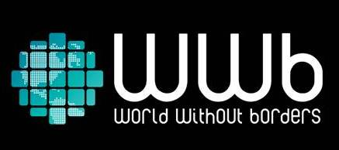
Lisbon, August 19 2013

WWb starts a social research to debate the possibility of a world without borders
WWb – World Without Borders is a project of the WWb Team, a group of people who are traveling around the globe to compose short movie clips with testimonies on how the world would be if there were no borders

Conceived as a research project, WWb is a journey around the world with the quest to discover how locals see their own country, what they think about the possibility of a world without borders and what reflex they believe that the inexistence of dividing lines between nations would have in their lives.
The goal is to promote a debate with many voices as to raise awareness to alternatives to the existing system. What would change if there were no borders? What would happen to the different cultural legacies? What would the consequences of a different world map be? What risks would we face? And what benefits?
These are some of the questions put forward by WWb – World Without Borders to different people from several countries. The conversations held will generate short documentaries that will be the inspirational base for the global discussion the project aims to promote.
“When creating our research project in 2012, it was immediately clear that we would assume ourselves as opinion collectors on this social research to raise awareness and global debate around the various sceneries to a borderless world” states Andrey Kiselev, coordinator of the project.
To carry out their quest, the WWb Team will drive the roads of America, Asia and Europe and sail the Pacific, the Atlantic Oceans and many seas throughout 2013 and 2014.
The trip started in Rio de Janeiro and the first guest of the project is Samir Abujamra, a Brazilian actor, cinematographer and host of the globo.tv show “Projeto Sumir”. The clip produced is available through this link: http://www.youtube.com/watch?v=nqAFFck7YZI.
All the testimonies collected, as well as travel insights from the WWb team and the guests will be displayed on the official website (wwbroute.com), twitter (twitter.com/WWBRoute), facebook (facebook.com/wwbroute), youtube (youtube.com/wwbroute) and instagram (@wwbroute).

For further information:
Patrícia Santos
patricia.santos@mbxagency.com
Tel. +351 917 790 010

