**Boulogne-Billancourt – June 24, 2014**

**Press Release**

**Lower-cost safety and versatility for trailers:**

**a new comprehensive rig offering in the MICHELIN X® MultiTM range**

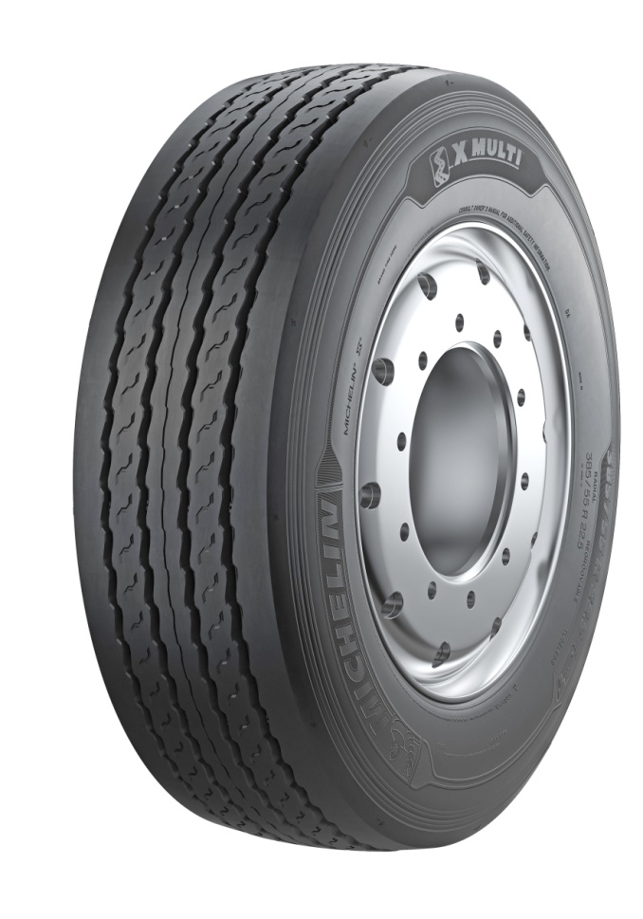

**MICHELIN X® MultiTM T**

**385/65 R 22.5**

**Media Relations: + 33 1 45 66 22 22**

**MICHELIN X® MultiTM T 385/65 R 22.5**

The MICHELIN X® Multi™ tire range has been expanded to include a new offering designed specifically for trailers: the MICHELIN X® Multi™ T. This solution allows regional transporters to outfit an entire rig with products from the MICHELIN X® Multi™ family.

The new MICHELIN X® Multi™ T is replacing the latest, regrooved versions of the MICHELIN XTE3 which, with over 4 million units sold in Europe since 2007, is the current market benchmark.

Michelin’s new trailer tire offering features a number of improvements in terms of cargo safety, certainty of on-time delivery and cost control, which are key priorities for road transporters. On a tractor-trailer, one tank of fuel in every three is used to overcome the rolling resistance of the tires; the trailer tires alone are accountable for half of this figure. The **operating gains** generated by the new MICHELIN X® Multi™ T are considerable, with **fuel consumption reduced by 0.7 liters per 100 km** (representing annual savings of €1,000 for a tractor-trailer covering 110,000 km) and **tread life extended by** **10%.** In addition, the **M+S (mud and snow) marking** attests that the new MICHELIN X® Multi™ T complies with legislation in certain countries, i.e. Norway, Turkey and Russia, concerning transportation in winter conditions.

With this innovation, regional transporters have access to a full tire offering that benefits from the best of Michelin technology.

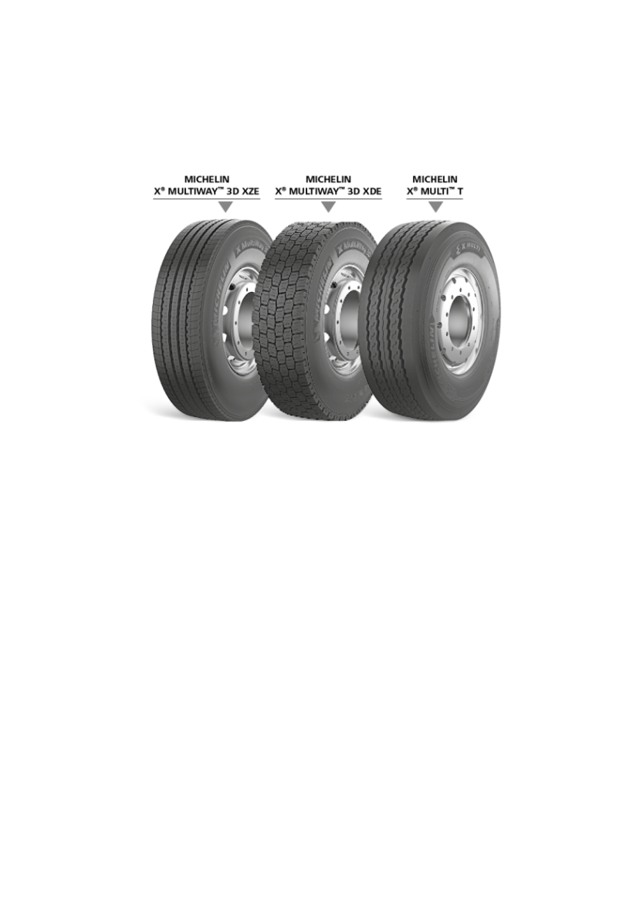

* 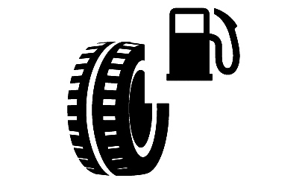

In the European tire labeling system, the new MICHELIN X® MultiTM T tire ranks among the best products on the market with respect to all three rating criteria, obtaining a B rating in both rolling resistance (a one-letter improvement on the previous generation) and wet braking, and a single wave symbol for a noise level of 69 dB.

The advantages offered by the MICHELIN® X MultiTM T reflect the resources allocated by the Group to R&D. At Michelin, R&D is underpinned by a team of 6,600 specialists on four continents working with an annual budget of over €640 million. They imagine and create the tires of today and tomorrow.

The main innovations introduced with the MICHELIN® X MultiTM T include:

**- Excellent longitudinal and lateral grip on dry and wet surfaces** owing to the tread design, which makes for **highly effective water dispersal and regular wear.** The **trailer tires** are accountable for **45 % of the braking performance** of a fully loaded tractor-trailer**:**

* The four **longitudinal grooves** enable **better water dispersal** throughout the tire's lifecycle.
* The groove **design** and **longer ridges** deliver excellent handling on wet surfaces.

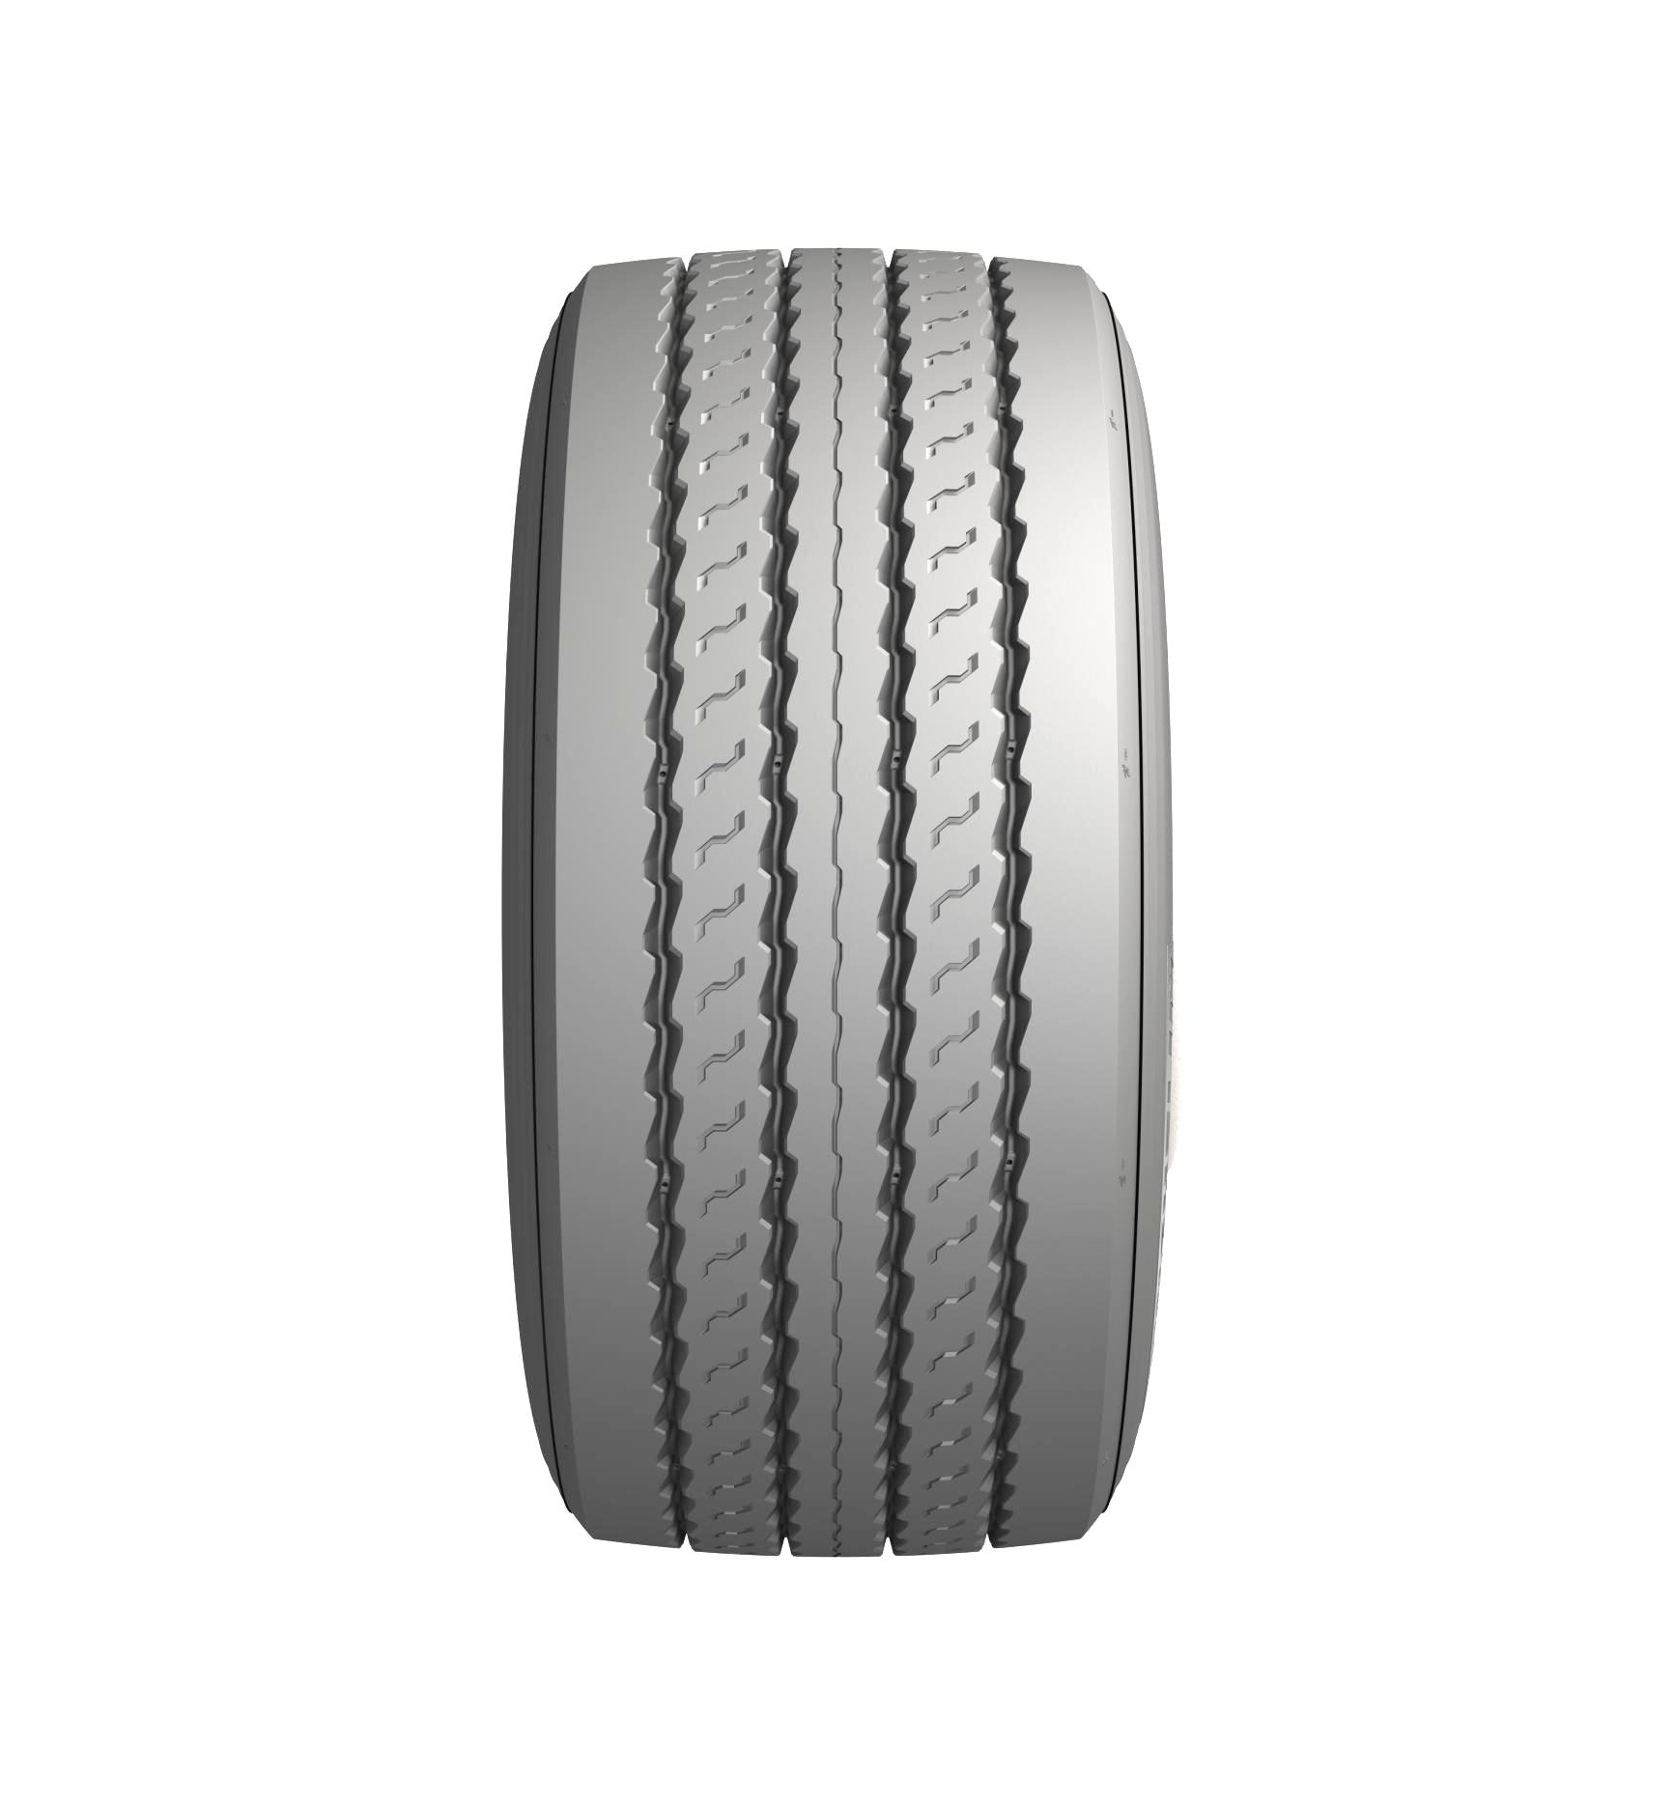

* **Greater longevity and reduced fuel consumption thanks to the use of new materials:** The MICHELIN X® MultiTM T tire now integrates a new rubber compound into the tread design that reduces rolling resistance and increases longevity. Dubbed “Carbion”, this innovation results from using both new components and new compounding processes.

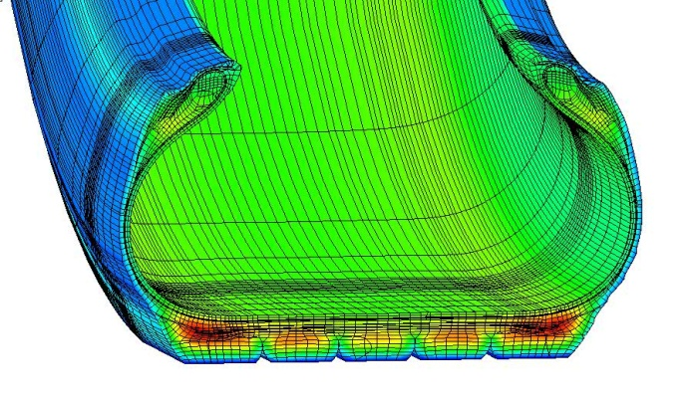

In equivalent load (4,500 kg), pressure (9 bar) and speed (100 km/h) conditions, the new compound heats up about 6° C less than its predecessor, thereby reducing rolling resistance, fuel consumption and CO2 emissions compared with the previous generation.

The new rubber blend also provides better resistance to abrasion during cargo shifting, which is particularly significant on trailer axles. This helps to increase the tires’ longevity and their potential to be regrooved and retreaded.

* **Enhanced environmental performance:** The MICHELIN® X MultiTM T tire is manufactured in Michelin Group plants located in Europe. They are all ISO 14001-certified facilities, and their environmental footprint has been reduced by 33.5% since 2005. Offering improved fuel efficiency and the ability to be regrooved and retreaded, the new tire represents a real advantage for transporters. Using Michelin Remix technology, the MICHELIN X® MultiTM has a retread acceptability rate of 88%. Every tire that is retreaded saves 55 kg of raw materials.

**A thoroughly versatile lineup**

Attentive to the needs of regional transporters, Michelin is introducing two additional versions of the MICHELIN X® MultiTM T:

* A more robust version of the MICHELIN X® MultiWayTM HD XZE, with a higher axle load capacity of 10 tonnes.
* A new MICHELIN X® MultiTM Winter T version, designed to meet mobility needs in severe winter conditions.

The MICHELIN X® Multi TTM and its more robust version will be available starting in July 2014. The 385/65 R 22.5 Winter model will be available in October 2014.

**Radio Frequency Identification (RFID)**

A radio frequency identification (RFID) chip is an intelligent, wireless electronic device that can be used to identify unique items according to a standard system in order to store and transfer the corresponding data. RIFD chips will gradually be embedded in MICHELIN X® MultiTM T tires. Customers can use an RIFD scanner and software available on the market to track their tire fleet and optimize inventory management.



**FOLLOW US**

 trucks.michelin.eu

 [www.youtube.com/michelintrucktyres](http://www.youtube.com/michelintrucktyres)

 Groupe Optimizing European Road Transport Costs

 @michelintruck