Press Release

Michelin Presents the X-STRADDLE 2
for Port Equipment Operators

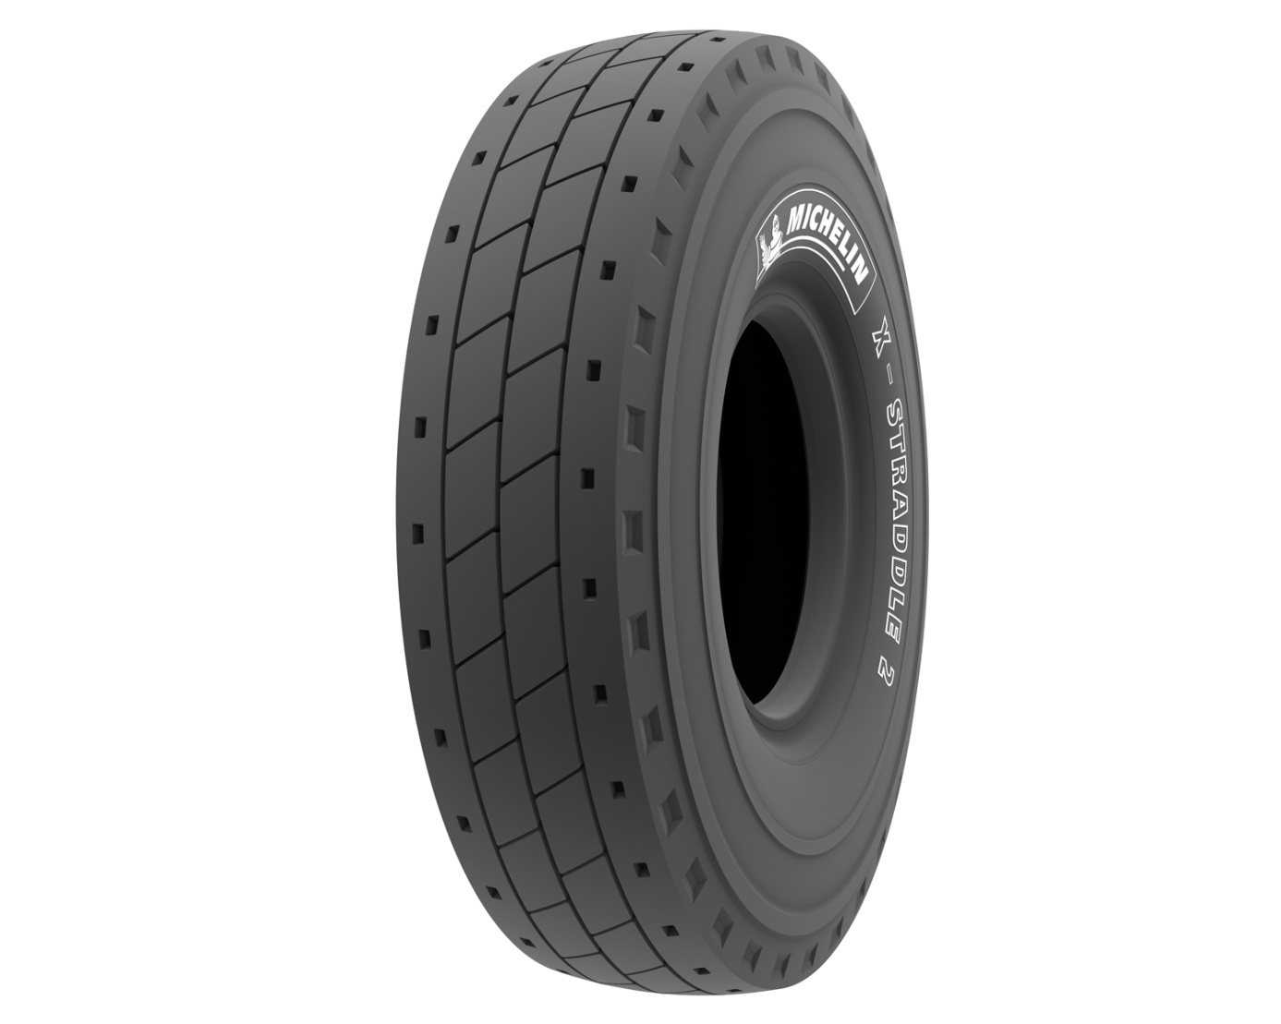

Media Relations: +33 1 45 66 22 22

The new MICHELIN X-STRADDLE 2
By delivering more than 30 % in productivity, the tire is an indispensable partner
for port equipment operators

Port operations are at the heart of the global economy.
The transport of goods by containers on cargo ships represents approximately two-thirds of global commerce, transiting products worth an estimated $4.1 trillion a year. These operations employ some 4.2 million people directly as well as 13.5 million indirectly.
It’s estimated that each week, 10,000 cargo ships call in one of the leading global ports to load and unload a substantial proportion of the world’s 17 million registered containers. Since shipping terminals operate around the clock, seven days a week, the reliability of machinery and equipment is an absolute necessity. According to Global Insight, the average annual increase in container traffic was 12% between 2001 and 2005 and 6.5% between 2006 and 2011. That’s a considerable rise in the years since that rainy Thursday morning on April 26, 1956, when American Malcolm McLean leveraged his experience in road haulage to first adapt the container to maritime transport.

Once on the dock, containers are lifted by machines called straddle carriers. While not certified for road use, these machines are also used in intermodal terminals. They measure more than ten meters long, over twelve meters high and nearly five meters wide. They must be capable of carrying loads of up to 60 tonnes at relatively low speeds not exceeding 30 km/h. By comparison, these machines weigh as much as an empty Airbus A320, which gives an idea of the loads underwent by these tires, especially since all axles are steering axles. The tires must be able to carry very heavy loads and withstand cargo-shifting. Resistance to heat build-up is also important. Straddle carriers rarely travel long distances at the same speed – conditions in which tires operate at constant temperature. On the contrary, they make constant stops and starts, move backward and forward, and are thus subject to considerable heat stress.
Nonetheless, solutions to improve and optimize the mode of transport can have a considerable impact on the fluidity of these operations, which, like most economic activities, are subject to time and efficiency constraints. While single spreader straddle carriers, designed to carry one container, are still in the majority, the number of double spreader carriers, designed to carry either one or two containers, is on the rise, a clear illustration that operators are looking for greater productivity. Fully assuming its role as a technology leader, Michelin was the first to provide tires for both types of machines with the goal of optimizing each type of straddle carrier’s performance.
If all the containers carried on a 11,000 TEU cargo ship were to be carried by rail, the train would have to be 77 kilometers long. As is the case with many transport activities, optimizing operations in large part requires improvements in tire performance, a key component in enhancing productivity. The challenges are equally complex, since straddle carriers operate in narrow, crowded spaces where machines must be both maneuverable and stable.
This is the challenge facing the new MICHELIN X-STRADDLE 2, the tire at the heart of marine terminal operations. Delivering improved safety, productivity (by increasing both load capacity and operating speed), longevity, user comfort and environmental protection, Michelin’s technological prowess enhances all aspects of tire performance while meeting objectives that are seemingly irreconcilable. Leveraging its constant commitment to improving mobility, Michelin has developed considerable research resources through its Technology Center, which employs 6,000 researchers on three continents and was backed by a budget of €622 million in 2012, an increase of 5.1% over the previous year.

The new MICHELIN X-STRADDLE 2 makes marine terminal operations safer while increasing productivity by more than 30%.
The MICHELIN X-STRADDLE 2, like its predecessor, the MICHELIN X-STRADDLE, delivers all the benefits of radial technology – a Michelin invention – to improve marine terminal operations.
The new MICHELIN X-STRADDLE 2 is designed, in size 16.00 R25, for single spreader straddle carriers. For double spreader straddle carriers, Michelin has kept the size 480/95 R25 MICHELIN X-STRADDLE tire in the catalogue. The new MICHELIN X-STRADDLE 2 is available in both the original equipment and replacement markets as from June 1, 2013.

The tire provides port equipment operators with improvements in five areas that help to increase productivity.

- Enhanced safety. Thanks its more protective sidewalls and new bead region design, the new MICHELIN X-STRADDLE 2 is more robust and provides operators with greater reliability as well as enhanced safety. The narrower grooves reduce the risk of objects lodging in the tread. Lastly, the new MICHELIN X-STRADDLE 2 delivers improved grip, handling and stability. It is also easier to mount and dismount on wheels during tire maintenance and change operations.
- Improved productivity. Productivity in port operations depends on the ability to transport more containers faster and more safely. Compared with the previous-generation MICHELIN X-STRADDLE, the new MICHELIN X-STRADDLE 2 offers a 17% increase in top speed (from 30 to 35 km/h) and a 25% increase in per-hour distance (from 12 to 15 km). At the same time, the new tire’s load capacity offers a 7% increase from 14 to 15 tonnes per tire. The combined impact of these improvements increases the theorical productivity of the new MICHELIN X-STRADDLE 2 by more than 30%, thus positioning the tire as a key enhancer of port operations productivity.
- Increased longevity. The MICHELIN X-STRADDLE 2 is much longer lasting thanks to its new tread pattern and casing, its innovative new dual-compound tread and an optimized cooling system on both the tread and the shoulders. The new tread, which contains 4% more rubber, helps to increase longevity by up to 15%. This significantly lowers total cost of ownership, for both tires and machines.
- Greater operator comfort. The new tread wears more regularly while also reducing vibrations. This improves driver comfort, thus helping to make machine operations safer.
- Enhanced environmental performance. In addition to its greater longevity, the new MICHELIN X-STRADDLE 2 is produced in ISO 14001-certified plants, which have seen their environmental impact reduced by 16% since 2005. What’s more, the tire can be retreaded and easily repaired in the appropriate network. In addition, the new MICHELIN X-STRADDLE 2 uses fewer raw materials while delivering improved operating performance.

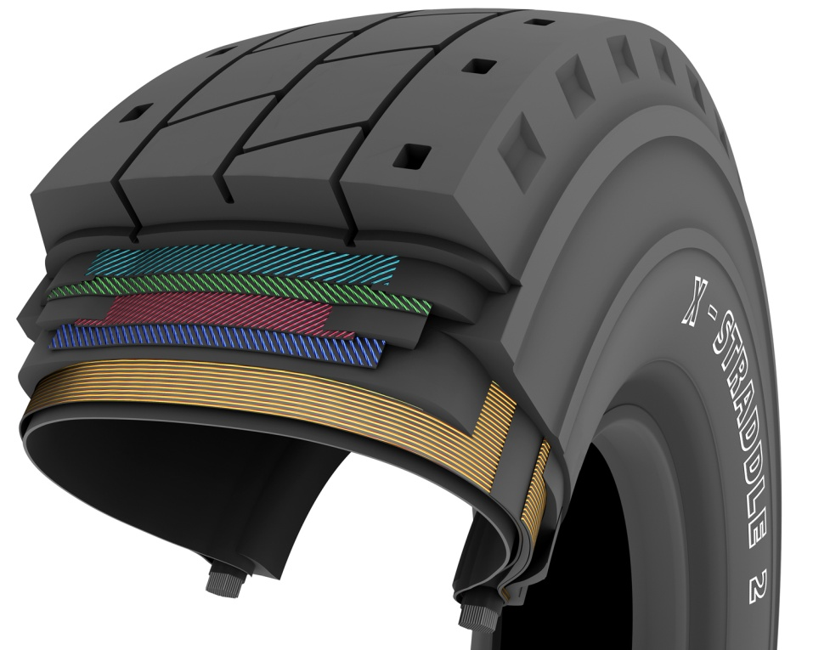

The design of the new MICHELIN X-STRADDLE 2 reflects its outstanding versatility. The new grooves in the tread help to avoid heat build-up while maintenance is facilitated by a wear indicator that is readily visible on the shoulders and provides immediate feedback on the tire’s wear rate remaining life. The protective belts on the sidewalls attest to its resistance to punctures an shearing. With all of these features, the MICHELIN X-STRADDLE 2 is designed to meet the challenges of marine terminal operations.

Michelin’s Earthmover operations: Key figures

1
The cost, in million of dollars, of a curing mold in which an Earthmover tire is produced. Manufacturing one of these extremely complex piece can take up to one year.

7
The number of Michelin Group production facilities around the world that manufacture Earthmover tires.

30
The productivity gain, as a percentage, provided by the MICHELIN X STRADDLE 2, compared with its predecessor.

46
The number of different tread patterns in the MICHELIN Earthmover tire lineup. A special tire has been developed for each type of use in order to respond more effectively to customer needs.

95
The number of sizes in the Earthmover tire catalogue. They range from 8 inches for forklifts to 63 inches for dump trucks used in quarries.

100
The percentage of Earthmover tires that integrate radial technology.

100
The weight, in tonnes, that a MICHELIN XDR2 tire can carry.

200
The number of components in an Earthmover tire, which in fact is a truly high-tech product.

400
The weight, in tonnes, of a curing press used to mold a MICHELIN Earthmover tire. At the opposite extreme, these tires have a number of features that can be seen only with a microscope.

3,500
The number of people worldwide involved in the Michelin Group’s Earthmover operations.

5,445
The weight, in kilograms, of the largest MICHELIN Earthmover tires.

17,000
The number of solar panels installed on the Group’s Earthmover tire plant in Le Puy-en-Velay, France. This is equal to the surface area of three football fields, making it one of the largest solar energy installations on any production plant roof in France. This is just one of Michelin's environmental stewardship strategy.

3 million
The distance, in kilometers, covered every year in tests of Earthmover tires conducted at the Michelin research center in Almeria, Spain.

4.1 trillion
The estimated value, in dollars, of the goods transported each year by containers through one of the world's ports.

Michelin’s Earthmover operations: Milestones

1959: The world’s first radial Earthmover tire is produced.

1977: Opening of the Michelin testing center in Almeria, Spain. It is the first – and still the only – testing center in the world fully dedicated to Earthmover tires.

1998: The first low-profile tire for dump trucks is produced. The new tire increases the load capacity of large dump trucks.

2001: Launch of the MICHELIN XDR 59/80 R 63, the world’s largest tire.

2007: Introduction of the Michelin Earthmover Management System (MEMS), the first electronic data system for managing Earthmover tires.

2011: Launch of the MICHELIN XZM2+, a tire specially designed for reach stackers.

2013: Launch of the MICHELIN X STRADDLE 2, a new generation of tires intended to improve the productivity of marine terminal operations.

Appendices

Michelin Group: Milestones

For more than a century, MICHELIN has dedicated all its expertise and innovation to enhancing mobility for motorists around the world.

1889: Founding of Michelin et Cie.
1891: Michelin files its first patents for removable and repairable tires.
1895: Michelin introduces Éclair, the first car to be fitted with pneumatic tires.
1898: Birth of Bibendum, the Michelin Man.
1900: First MICHELIN guide published.
1905: Introduction of the Michelin semelle tread with hobnails to improve tire grip and durability.
1910: First 1/200,000 scale Michelin road map published.
1913: Michelin invents the removable steel wheel.
1923: First low-pressure car tire (2.5 bar).
1926: Michelin creates its first Green Guide for tourists.
1930: Michelin files a patent for the integrated tube tire.
1938: Michelin launches Metalic, the first truck tire with a steel casing.
1946: Michelin invents the radial tire.
1959: Michelin introduces the first radial tire for earthmovers.
1979: The Michelin radial tire wins the Formula 1 championship.
1981: The MICHELIN Air X is the first radial aircraft tire.
1989: Michelin launches the first online travel itinerary service, on France’s Minitel teletext network.
1992: Launch of the fuel-efficient MICHELIN ENERGY™ tire.
1993: Michelin invents the new C3M tire manufacturing process.
1995: The US space shuttle lands on MICHELIN tires.
1996: Michelin invents the vertically anchored PAX System tire.
1998: The first Michelin Challenge Bibendum, the world’s leading clean vehicle event.
1998: The Michelin Man’s 100th birthday.
2000: Michelin Man voted best logo of all time by an international jury.
2001: Michelin brings to market the world’s largest earthmover tire.
2003: Launch of MICHELIN brand automotive accessories.
2004: New corporate signature introduced: “Michelin, a better way forward.”
2004: Launch of the MICHELIN XeoBib, the first agricultural tire that operates at constant low pressure.
2005: Michelin provides tires for the new Airbus A-380 aircraft - Launch of the MICHELIN Power Race, the first dual compound racing tire approved for road use.
2006: Michelin revolutionizes truck tires with MICHELIN Durable Technologies.
2007: Launch of the new MICHELIN ENERGY™ Saver tire, which reduces fuel consumption by nearly 0.2 liters per 100 kilometers, thereby lowering carbon emissions by almost 4 grams per kilometer.
2008: Introduction of the new MICHELIN® X® ENERGY™ SAVERGREEN truck tire.
2009: 100th edition of the MICHELIN guide France.
2010: Market launch of the MICHELIN Pilot Sport 3 and MICHELIN Pilot Super Sport tires.
2012: Launch of the MICHELIN Primacy 3 tire in Europe.
2012: European launch of two new high-performance winter tires, the MICHELIN Pilot Alpin and MICHELIN Latitude Alpin.

Michelin Group: Key Figures

Founded: 1889
Production base: 71 production sites in 18 countries
Number of employees: 113,400 worldwide
Technology Center: More than 6,000 researchers on three continents: North America, Europe and Asia
Annual R&D budget: €622 million, up 5.1% over 2011
Annual output: 176 million tires produced, over 10 million maps and guides sold in more than 170 countries, and 875 million itineraries calculated by ViaMichelin
2011 net sales: 21.474 billion euros

Compared with the prior-generation MICHELIN X-STRADDLE.
Source: Valuation of the Liner Shipping Industry, IHS Global Report, 2009.
Source: IHS Global Report, 2009 data
Twenty Foot Equivalent Unit: this corresponds to a volume of 38.55 cubic meters (6.1m x 2.44m x 2.59m)
These conditions are dependent of site and conditions of use.
Compared with the prior-generation tire.

