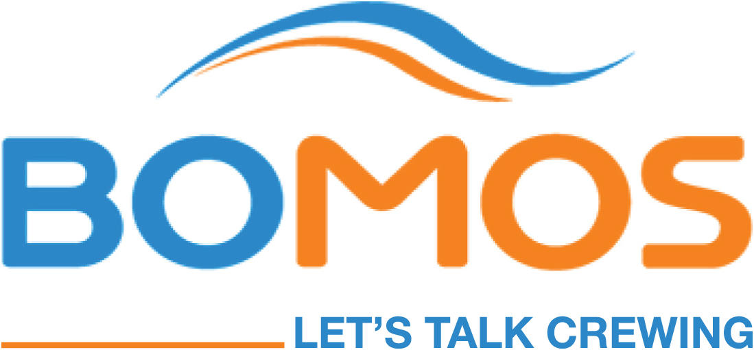
PRESS RELEASE
Oslo, June 2, 2015

Weathering the storm through lower manning costs

Blue Ocean Marine & Offshore Solutions (BOMOS) has today announced their new strategy to focus much stronger on cost reductions as shipping and offshore companies continue their fight for survival in the challenging market conditions.

“Current financial realities are calling for some tough decisions and there is an increasing demand to improve operating margins. There is no single solution to radically change the cost structure of shipping and offshore companies. Instead, these companies will reach their goals with a combination of several actions. And labor costs is one of them,” says CEO Cristina Garcia and Paal Utvik, one of the investors behind BOMOS.

Established January 2014, BOMOS obtained its license to operate as a crew provider the same year in November and its staff is well qualified within a wide scope of shipping activities, ranging from offshore rigs and support vessels , chemical and product tankers, to VLCC´s, gas, container and bulk carriers.

Lower seafarer prices: the option is out there
Labor is a major cost for a shipping company’s P&L. BOMOS says that many shipowners are reducing their own permanent crew and opting for more cost effective qualified crewing vendors to supply trained temporary crew during this very tight period. The increased competition between the independent crewing suppliers benefits the owners in the end.

“The current global economic situation is having a clear and significant impact on global shipping operations. Some manning agreements no longer fit. Shipowners need budgets that work for them and are ready to look for cheaper options. That option, negotiating lower seafarer prices, is out there,” says Utvik.

Lowering cost by analyzing every step of the supply chain
Throughout the process of reducing costs and downsizing, shipowners need to ensure that their crews remain safe and productive, which means focusing on people and maintaining the same level of skills and quality.

“There are solutions out there. Shipowners can cut costs and improve quality and operations by using a crew provider that has much stronger cost culture from the ground up. In doing so, they shift the administrative burden and free key personnel to focus on core operations,” maintains Garcia.

BOMOS combines over 80 years of in-house seafaring consultancy experience and supplies first class manning services, and, according to Garcia, BOMOS is all about crewing.

“We provide our clients access to well-trained, ocean-going personnel. We understand this industry, from recruitment, training, deployment, and repatriation, to accounts payable, payroll, port agency services and coordination with seafarers’ unions,” she says.

Ready to talk
“The benefit of being the new kid on the block is that we can think new and innovative from the very beginning. We are ready to assist the industry with the right personnel and become a valued sparring partner to help them achieve their budgetary and operational goals. We are ready to talk, do business and help shipping companies weather the storm, emerge successfully and continue to operate in the years to come,” said Utvik.

###

For further information contact:

Cristina Garcia  President, BOMOS  cgarcia@bom-offshore.com  +63-9178601497 | Paal Utvik  Chairman, BOMOS  pu@lmholdings.com  + 47 94 84 23 42

About BOMOS
BOMOS provides specialised recruitment solutions for the offshore and shipping industry and multiple vessel types. We are proud to meet the demands of vessel and rig owners in an ever-changing environment and supply competent officers and ratings for permanent, contractual and interim roles internationally.

