PRESS RELEASE 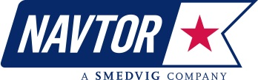
NAVTOR launches AVCS on ‘Pay As You Sail’ basis

8 April, 2014, Egersund, Norway - NAVTOR has reached a landmark agreement with the United Kingdom Hydrographic Office (UKHO) to offer the ADMIRALTY Vector Chart Service (AVCS) to mariners on a ‘pay as you sail’ (PAYS) basis. The Norwegian e-navigation pioneer, which introduced the world’s first DNV type-approved PAYS service in 2012, launches the NAVTOR PAYS with AVCS solution today.

AVCS is the world’s leading ENC service for ECDIS, offering the widest coverage in the marketplace. With over 12,500 Electronic Navigational Charts (ENCs), AVCS allows mariners to navigate an unparalleled number of international shipping routes. Delivering AVCS on PAYS will transform its accessibility to the market.

Business and Communication Manager Willy Zeiler explains: “PAYS allows navigators to instantly access the ENCs they need for planning purposes, levying charges only for the charts they actually use during voyages. It’s a flexible, user-friendly and efficient way to navigate, making it easier to order and manage an ENC portfolio.”

He continues: “It is something that the market has eagerly been waiting for. This collaboration between NAVTOR and the UKHO marks a significant step forward in the way that e-navigation solutions are delivered to the end user. We’re proud to be working with the UKHO and using NAVTOR’s advanced technology to connect with its customers.”

The NAVTOR PAYS with AVCS solution will be distributed to users on a pre-loaded NavStick USB device, which when inserted into a ship’s ECDIS will instantly install the required AVCS coverage. The latest AVCS charts and updates can then be regularly retrieved using NAVTOR’s online programme NavSync, ensuring that all vessels are kept up to date easily.

Jason Scholey, UKHO’s Senior Product Manager – Charts, comments: “AVCS is the world’s preferred ENC service for ECDIS. We’re very pleased Navtor are launching the NAVTOR PAYS with AVCS solution to provide customers with additional choice when purchasing their ENCs.”

Navtor says the majority of its customers now opt for a PAYS solution, with vessels such as ferries and liners that sail set routes usually signing up to a standard subscription model based on set geographical areas.

Zeiler is keen to stress that it’s not only ECDIS-mandated vessels, such as passenger ships, that are signing up with NAVTOR.

He notes: “Many ship owners appreciate the tangible benefits of a service that provides safe, efficient and predictable operations, whether they are subject to IMO regulations or not. Norwegian offshore support vessel owners are an interesting case in point, with ship owners who control more than 70% of the national offshore fleet now utilising NAVTOR. This boils down to their desire for effective ship management, rather than any regulatory requirement.”

About NAVTOR
With its head office in Egersund, NAVTOR has a team of personnel with extensive experience in the development, marketing, sales and support of official electronic charts and navigational information services for the professional maritime market. NAVTOR has a subsidiary in St. Petersburg manned by experienced technical experts specialized in the field of ECDIS kernels and maritime software development.

About Smedvig
The Norwegian naval captain Peder Smedvig founded a shipping company in Stavanger in 1915, which over the first half of last century became one of the larger ship owners in Norway. When oil was discovered in the North Sea, the company moved in 1960s into the offshore oil industry with investments in supply ships, oil tankers and in 1973 built the first Norwegian owned drilling rig “West Venture”. The company acquired multiple rigs throughout the 1970s and 1980s and took the drilling company public in 1990. Smedvig ASA was sold in January 2006, and today Smedvig Family Office is an international investment company with interest in multiple asset classes. Smedvig still remains in Stavanger with its main office and with the establishment of NAVTOR the company has re-entered the shipping industry.

About UKHO

1. UKHO, an Executive Agency of the Ministry of Defence, has been charting the world’s oceans for more than 200 years with the primary aim of providing navigational products and services for the Royal Navy and merchant mariners to save and protect lives at sea. In addition it serves small craft and leisure mariners and provides a range of consultancy services.
2. UKHO also plays a central role, in support of the Maritime and Coastguard Agency, in discharging the navigation element of the UK’s Safety of Life at Sea Treaty obligations for waters of UK national responsibility.
3. UKHO produces a worldwide series of some 3,500 paper nautical charts, 200 publications under the ADMIRALTY brand and Electronic Navigational Charts (ENCs). The ADMIRALTY portfolio is sold globally and used by nearly 70% of international shipping.

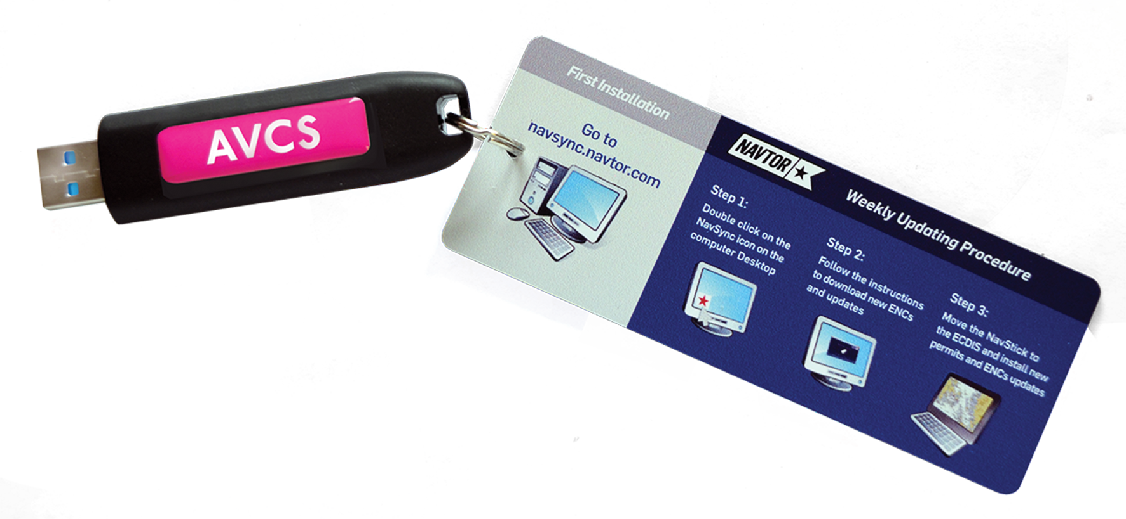

No CD or DVD distribution required. Global AVCS coverage is instantly available on the NavStick. All license files are included for the operation area and are easily installed on the ship’s ECDIS. The NavStick opens all AVCS in the defined “Pay As You Sail” operation area.

Media Contact:
