PRESS RELEASE 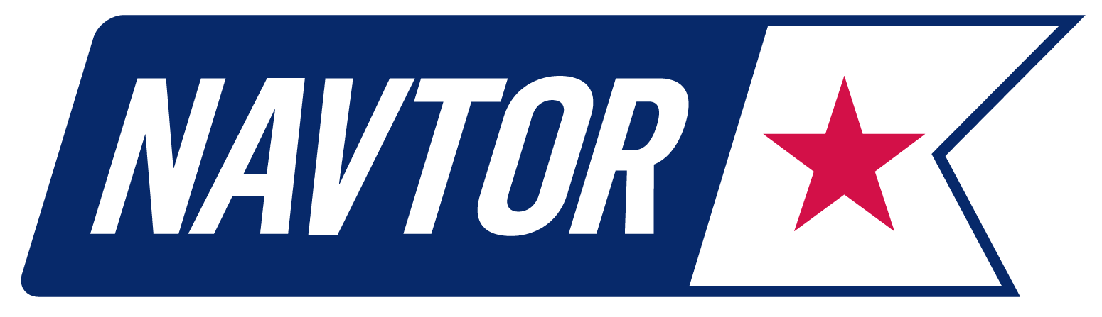
GC Rieber Shipping chooses NAVTOR for fleet-wide total navigation solution

31 October 2016, Norway: Specialist ship owner, operator and manager GC Rieber has signed a fleet-wide agreement with NAVTOR for a total vessel navigation solution, spanning both paper and digital deliveries. NAVTOR, a global leader in e-navigation technology and services, will now install products throughout GC Rieber’s portfolio of advanced seismic and offshore ships, enhancing overall fleet efficiency, safety and cost control.

The agreement is far reaching in scope. It covers the delivery of all digital and paper charts and publications, provided on a Pay As You Sail (PAYS) basis, alongside products and services including weather and route optimisation services, navigational management solution NavTracker, and the installation of NavBox units. These, one of NAVTOR’s latest innovations, connect with ECDIS and automatically download the latest navigational data without navigators having to check for updates.

“We have a long-standing objective of simplifying tasks for navigators and enhancing efficiency for owners and operators,” comments NAVTOR CEO Tor Svanes. “This is encapsulated by our latest agreement with GC Rieber Shipping.

“By offering them a single concept across their entire fleet we can ensure time and cost savings – with a seamless distribution of charts and publications and minimal administration. This dramatically cuts workloads, ensures regulatory compliance and safety, and gives land-based teams a complete overview of chart usage, management and expenditure. By choosing PAYS, the team only pay for the charts they actually use, while all are available for planning purposes.”

He continues: “Here we can see the potential of e-navigation realised – connecting all vessels, navigators and management teams on one platform for optimal routes, operations and overall business efficiency. In the shipping climate of today, and tomorrow, it makes perfect sense.”

GC Rieber operates a fleet of nine vessels - including some of the industry’s most advanced seismic ships - with installation of all NAVTOR’s products and services expected by the end of 2016.

Geir Rasmussen, Marine Superintendent at the Bergen-based business, said of the decision to use NAVTOR as a single navigational vendor: “As a shipowner and operator we are focused on maximising both efficiency and the quality of our operations – something that all our customers and stakeholders benefit from. The NAVTOR solution fits perfectly within that framework, uniting all vessels with a single solution that pays real dividends.

“NAVTOR is established, stable and high quality in its deliverables, so we feel confident consolidating all our navigation needs with them. What’s more the team is innovative – constantly striving for new solutions and the means to deliver added value. This continual process of improvement is important to us and we look forward to benefiting from, and contributing to, their further e-navigation developments.”

NAVTOR, which has opened new offices in Japan and Singapore over the course of the last year, launched its ENC service to the market in 2012. Since that time it has built a global customer base and recorded a series of market firsts, launching the world’s first type approved Pay As You Sail ENC service, the first digital chart table (NavStation) and, recently, a new software module to automate and digitise the mandatory process of vessel passage planning.

About NAVTOR
NAVTOR is a market leader in the provision of innovative e-navigation solutions, services and technology for the maritime sector. All of NAVTOR’s products and services are developed in line with the company philosophy of simplifying tasks, increasing efficiency and improving operations. Through the application of cutting edge digital technology, NAVTOR’s team makes life easier for navigators, and safer, clearer and more efficient for shipowners and operators.
The firm was established in 2011 and is headquartered in Egersund, Norway, with subsidiaries in St Petersburg, Russia (NAVTOR Russia LLC), Singapore (NAVTOR Singapore Ltd. Ptd.), Japan (NAVTOR Japan K.K.) and Sweden (NAVTOR NAUTIC AB).

www.navtor.com

Media Contact:
Willy Zeiler
Marketing & Communications Manager
willy.zeiler@navtor.com
mobile: +47 906 67 036

