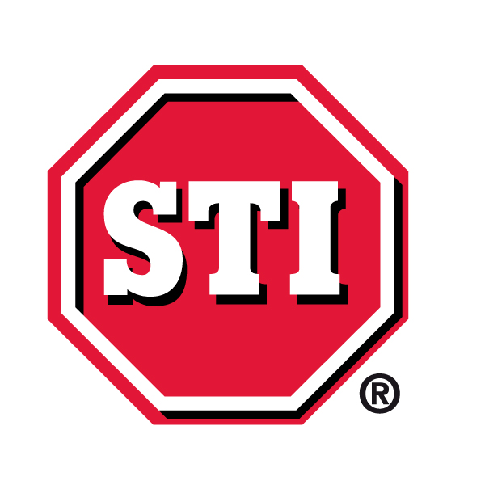

STI (Europe) launches new safety device for harsh environments

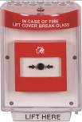STI (Europe) has unveiled the new Enviro Stopper® an IP rated protective enclosure designed to extend the life and reliability of devices exposed to water and harsh environments. It offers protection to manual call points and switches against dust and water ingress both outside and inside, as well as preventing tampering, vandalism and damage from accidental or malicious operation. Ideal for wash down areas and saline atmospheres.
The Enviro Stopper® consists of a clear, tamper-proof, tough polycarbonate cover (IP56) and backbox (IP66) that can accommodate a standard European call point or switch. When the cover is opened a deterrent alarm is emitted and will draw immediate attention to the area. When the cover is closed, the unit is sealed and achieves an overall rating of IP56 preventing dust, grime and water getting to the device. Available in red, green, yellow, blue, white and black.

-ENDS-

About STI
For over thirty years STI has marketed a unique range of products throughout the world to prevent false fire alarms and the theft, vandalism and misuse of the devices that protect everyone. Uniquely designed products are available for a wide variety of applications including smoke detectors, fire extinguishers, call points, safety beacons, emergency exits, AED defibrillators and many more.

STI Europe Contact | Agency Contact
Michala Ford  STI (Europe)  Unit 49G Pipers Road, Park Farm Industrial Est.  Redditch  Worcestershire  B98 0HU  UK | Helena Osborn  Unit 1, Cutbush Court  Danehill  Lower Earley  Reading, RG6 4UW  UK
Tel: +44 (0)1527 520999  E-mail: Micki@sti-europe.com  http://www.sti-europe.com/uk/ | Tel: +44 1189 759880  Email: helena.osborn@protean.co.uk  www.proteanmarketing.com

