

For immediate release
Mek installs new AOI system at SMTC Ontario

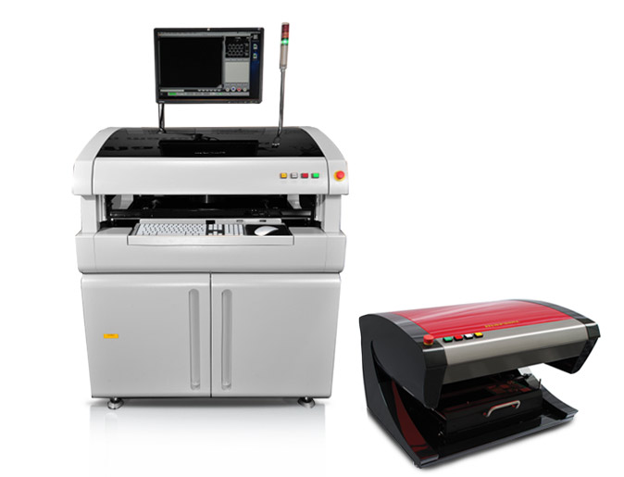MEK Europe BV, formerly known as Marantz Business Electronics, and its distributor, CGI Americas, have recently announced the installation of the fourth AOI system within SMTC. The Toronto headquartered EMS provider recently commissioned an iSpector HDA 650, complementing systems in operation at its San Jose and Chihuahua, Mexico facilities.

SMTC is a global electronics manufacturing services provider, recently awarded a Frost & Sullivan 2012 Global EMS Award for Product Quality Leadership. They are specialized in delivering fully integrated and customized contract manufacturing services to both original equipment manufacturers and emerging technology companies within the industrial, medical, computing and communication market segments. Their services include PCBA production, systems integration and testing, as well as design, engineering and supply chain management services developed over 25 years of EMS operations and experience. Fundamental to their latest selection of AOI equipment was the “world class quality support” received for the existing systems at both San Jose and their 17.5 acre Mexico campus facilities.

The Mek iSpector series also includes the world’s first desktop AOI system to offer one top camera and eight side cameras in 45/45 degree configuration. Solder joints of increasingly popular 45 degree space-saving circuitry designs can now be inspected with 10µm resolution side cameras. Combining simultaneous 9 camera inspection, true 24-bit colour imaging technology and 3D Solder Meniscus profiling, these systems deliver advanced AOI performance with either manual or fully automated PCB handling.

-ENDS-

About Mek Europe BV
A former division of Marantz well known for its high quality Audio/Video products, MEK Japan (Marantz Electronics Kabushiki Kaisha), developed its first AOI system in 1994. Developed to inspect PCB assemblies for correct component placement and soldering, the company’s original AOI system was designed for use in Marantz factories. Proving to be a highly successful, cost-effective alternative to traditional human inspection, MEK developed its first generation commercial system in 1996. With a steadily growing installed base, MEK Japan and its European headquarters, MEK Europe BV, have sold over 5000 units worldwide to date. Now well established as a leading force in AOI technologies, the company recently launched a 5D post-print SPI system which combines 3D and 2D image processing methodologies to deliver unprecedented defect detection.

About CGI Americas
CGI Americas is the N. American distributor for MEK Europe BV. CGI Americas, based in Santa Ana, California, distributes and supports equipment for some of the worlds leading inspection companies. With over 150 years combined experience in the PCB and PCBA field, CGI is uniquely positioned with MEK to provide their customers with world class support.

MEK Europe BV Contact | Agency Contact | CGI Americas contact
Henk Biemans  MEK Europe  PO Box 12,  5688 ZG  Oirschot  The Netherlands | Helena Osborn  Unit 1, Cutbush Court  Danehill  Lower Earley  Reading, RG6 4UW  UK | Martin Gershenson  General Manager  CGI Americas  2750 S. Harbor Blvd. Suite A  Santa Ana, CA 92704  USA
Tel: +31 40 71 14 111  Email: info@mek-europe.com  www.mek-europe.com | Tel: +44 1189 759880  Email: helena.osborn@protean.co.uk  www.proteanmarketing.com | Tel: +1 (714) 545-7888  Email:martin@cgi-americas.com  www.cgi-americas.com

