MEK’s breakout AOI and SPI technologies featured at SMT Nuremberg

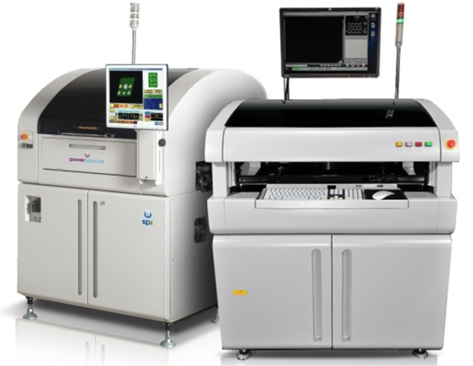
Mek Europe BV, formerly known as Marantz Business Electronics, will bring its unique range of AOI technologies to this year’s SMT Hybrid exhibition in Nuremberg. Featured Mek demonstrations include a variety of 9-camera inspection systems showcased by SmartRep at stand # 7-419. Mek development partner DJK Europe will showcase their 5D SPI at stand # 7-117.

PowerSpector S1 Solder Paste Inspection by MEK employs a unique new “5D” technology that delivers true area, shape, offset, volume and height measurement together and complete for the first time. PowerSpector S1’s high speed post-print SPI process incorporates patented new sensor technology and simultaneously combines 3D and 2D image processing methodologies along with elegant real-time SPC process data management that delivers defect detection far beyond current industry standards.

Jeremy Saise, Mek Technical Director said, “Having demonstrated this SPI product almost continuously for the past six months, I can say without hesitation that virtually everyone with an opportunity to see it has agreed it is a genuine leap forward in SPI technology and productivity.”

SMT visitors will also discover a new generation iSpector desktop AOI system that unites advanced optical performance with inherent flexibility and accuracy. iSpector was the world’s first desktop system to offer one top camera and eight side cameras in 45/45 degree configuration. Increasingly popular 45 degree space-saving circuitry designs can now be inspected with 10µm resolution side cameras. Combining simultaneous 9 camera inspection, true 24-bit colour imaging technology and 3D Solder Meniscus profiling, these systems deliver advanced AOI performance with either manual or fully automated PCB handling.

The Mek Inspection Island serves multiple lines while eliminating the requirement to manually handle PCBs. Featuring unique repair & traceability software for effective post processing of defects, operators are afforded the flexibility to select classification on the fly, through manual intervention.

Mek General manager Henk Biemans explained. “Traditionally, island operation has only been available for customers with an inline machine model, plus a loader and unloader. We’ve taken our most cost-effective and popular desktop model and combined it with a proven, conveyor/rack storage system to dramatically reduce the cost and complexity associated with automatic offline inspection. Innovations like this have enabled our customers to break out and rediscover AOI.”

-ENDS-

About MEK Europe BV
A former division of Marantz well known for its high quality Audio/Video products, MEK Japan (Marantz Electronics Kabushiki Kaisha), developed its first AOI system in 1994. Developed to inspect PCB assemblies for correct component placement and soldering, the company’s original AOI system was designed for use in Marantz factories. Proving to be a highly successful, cost-effective alternative to traditional human inspection, MEK developed its first generation commercial system in 1996. With a steadily growing installed base, MEK Japan and its European headquarters, MEK Europe BV, have sold over 5000 units worldwide to date. Now well established as a leading force in AOI technologies, the company recently launched a 5D post-print SPI system which combines 3D and 2D image processing methodologies to deliver unprecedented defect detection.

MEK Europe BV Contact | Agency Contact
Henk Biemans  MEK Europe  PO Box 12,  5688 ZG  Oirschot  The Netherlands | Helena Osborn  Unit 1, Cutbush Court  Danehill  Lower Earley  Reading, RG6 4UW  UK
Tel: +31 40 71 14 111  Email: info@mek-europe.com  www.mek-europe.com | Tel: +44 1189 759880  Email: helena.osborn@protean.co.uk  www.proteanmarketing.com

