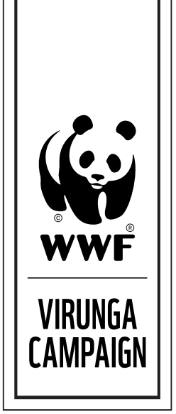

PRESS RELEASE FOR IMMEDIATE RELEASE
WWF statement on Virunga warden

16 April 2014 – The chief warden of Democratic Republic of the Congo’s Virunga National Park, Emmanuel de Merode, has been shot in an ambush, according to a statement on the park’s official website. The Belgian national is in “serious, but stable condition,” the statement says. De Merode was attacked while travelling from the provincial capital of Goma to the park’s headquarters yesterday, but no additional details are available.

“Emmanuel is a dedicated conservationist putting his life on the line every day to protect Virunga National Park, its rangers, its endangered species and the people that depend on the park for their livelihoods,” said Lasse Gustavsson, Executive Director of Conservation at WWF International. “I know how much Emmanuel loves this park. He continues to be a source of inspiration to those around him and I wish him a swift recovery.”

Virunga is Africa’s oldest national park, founded in 1925, a World Heritage Site and a Ramsar wetland of international importance. It is the most biodiverse protected area in Africa, and one of the four parks in the world home to critically endangered mountain gorillas, of which only about 880 remain. Virunga recently reopened for gorilla treks after being closed during a period of conflict in the east of the country.

CONTACT

Alona Rivord, arivord@wwfint.org, +41 79 959 1963. Images of Virunga National Park are available for media use here.

ABOUT WWF

WWF is one of the world's largest and most respected independent conservation organizations, with over 5 million supporters and a global network active in over 100 countries. WWF's mission is to stop the degradation of the Earth's natural environment and to build a future in which humans live in harmony with nature, by conserving the world's biological diversity, ensuring that the use of renewable natural resources is sustainable, and promoting the reduction of pollution and wasteful consumption.

Visit panda.org/virungainfo for additional resources and follow us @WWF_media

