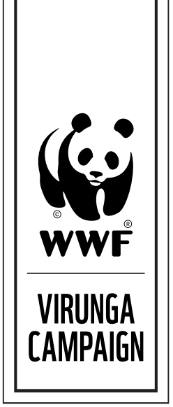

PRESS RELEASE FOR IMMEDIATE RELEASE
UK government opposes Soco’s oil exploration in Virunga

Geneva, Switzerland – Plans by London-based oil company Soco International PLC to explore for oil in a fragile African World Heritage Site have hit firm opposition from the UK government.

In a written response to a question on the issue posed by a fellow UK parliament member, Parliamentary Undersecretary of State for Foreign and Commonwealth Affairs Mark Simmonds reiterated last week that the country is against Soco’s oil activities in area.

“The UK continues to oppose oil exploration in Virunga National Park,” Simmonds said. “The park is a World Heritage Site listed by UNESCO as being ‘in Danger’.”

Simmonds added that British diplomats in Democratic Republic of the Congo (DRC) have notified Congolese authorities of the country’s position.

“The UK embassy in Kinshasa has raised oil exploration in the park at various levels in the DRC government and we have made clear to them that we oppose such activity.”

Despite concerns from humanitarian groups, conservationists and local community members, Soco has moved forward with oil exploration in Virunga, Africa’s oldest national park.

Earlier this month WWF filed a formal complaint with the UK government alleging that Soco’s operations in DRC violate human rights and environmental standards. Evidence submitted includes reports of unlawful detentions, intimidation and threats against the safety of anti-oil activists, WWF contends.

“Soco has disregarded good business practice by flouting international treaty provisions that are meant to protect the outstanding universal value of this World Heritage Site,” said Lasse Gustavsson, Executive Director of Conservation at WWF International. “That is not how a responsible corporation behaves. Virunga is no place for an oil company and Soco should leave now.”

Over half a million people have joined WWF to demand that Virunga National Park be protected from the damaging impacts of oil. The World Heritage Site is home to endangered species and provides fish and freshwater to over 50,000 nearby residents.

CONTACT

Alona Rivord, arivord@wwfint.org, +41 79 959 1963.

ABOUT WWF

WWF is one of the world's largest and most respected independent conservation organizations, with over 5 million supporters and a global network active in over 100 countries. WWF's mission is to stop the degradation of the Earth's natural environment and to build a future in which humans live in harmony with nature, by conserving the world's biological diversity, ensuring that the use of renewable natural resources is sustainable, and promoting the reduction of pollution and wasteful consumption..

Visit panda.org/virungainfo for additional resources and follow us @WWF_media

