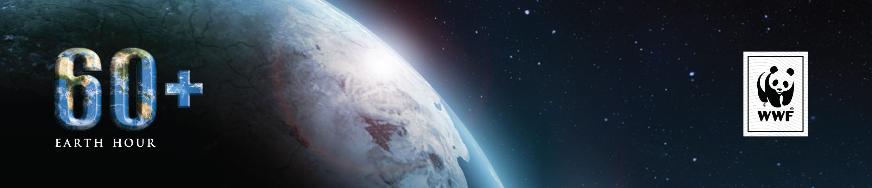

FOR IMMEDIATE RELEASE

MESSI LEADS WORLD’S TOP SPORTS AND ENTERTAINMENT CELEBRITIES
SUPPORTING EARTH HOUR

MARCH 22 2013, SINGAPORE: World famous sports and showbiz celebrities are showing they care for the planet through their support of Earth Hour on social media platforms Facebook and Twitter, inspiring their fans to join in the world’s largest mass participation event on the planet, for the planet.

Lionel Messi, Jessica Alba, Gisele Bunchen, Yoko Ono, Miranda Kerr, Alejandro Sanz, Doutzen Kroes, Ian Somerhalder, Alicia Sliverstone, McFly are just some of the celebrities asking fans to turn off their lights on March 23, 8:30PM. Lionel Messi, who has 43 million fans on Facebook asked them to accept the challenge and join Earth Hour.

Celebrities from Asia with a combined social media following of 20 million are also leading the efforts for Earth Hour this year, lending their voices of support for the campaign and taking up the challenge to inspire ongoing positive actions for the environment beyond the hour.

Nadya Hutagalung, Utt Panichkul, Pevita Pearce, Andy F. Noya, Ariel from NOAH, G.E.M., Eason Chan , Kay Tse, Shruti Hassan, Marc Nelson, Rovilson Fernandez, Mikee Cojuangco-Jaworski, Bathiya & Santhush (BNS), Li Bingbing, Yu Quan, Chen Yibing , Li Yundi, Li Yuchun, Harlem Yu, Sonia Sui, JJ Lin, Amber Kuo, Christine Fan and S.H.E are among the biggest names in Asia supporting the global environmental movement now in its seventh year.

It’s not only sports and entertainment celebrities rallying for action. Also on the eve of the seventh Earth Hour, UN Secretary General Ban Ki-moon has called on the world to mobilise beyond the hour as extreme weather increasingly harms families, communities and economies.

“We participate with an undimmed determination to take action on climate change. Everyone has a role to play. Governments need to provide the political will, businesses can contribute solutions, and civil society, especially young people, can mobilise global action. Together, let’s do our part and shed light on common sense answers for a cleaner, greener world,” said the UN Secretary-General.

As an open sourced campaign powered by WWF, Earth Hour uses social media to connect a global community of people inspired to change the world we live in and support from these stars take the campaign to new levels of engagement with young people who will benefit the most from a sustainable planet.

Earth Hour 2013 will take place at 8.30pm – 9.30pm on Saturday 23 March

-ends-

For live updates on Earth Hour 2013 starting Thursday March 21, go to http://earthhour.org/live
A timeline of stories for Earth Hour 2013: http://ehour.me/ehtimeline2013
See the Earth Hour 2013 Official Video at www.ehour.me/2013ViD
Press images can be downloaded at http://earthhour.org/media-centre/images
Downloadable video footage of the global event will be available in four B-rolls for media, covering major regions at http://www.earthhour.org/media-centre/videos

Media enquiries:
Benjamin Vozzo, Earth Hour Global E:benjamin@earthhour.org Ph: +65 8223 1728
Mai Tatoy, Earth Hour Global E: mai@earthhour.org Ph: +65 9017 7411

To join the global community head to:
- Earth Hour www.earthhour.org
- Facebook www.facebook.com/earthhour
- Twitter www.twitter.com/earthhour
- YouTube www.YouTube.com/EarthHour
- Google+ plus.google.com/+EarthHour

About Earth Hour
Earth Hour is a global environmental initiative by WWF. Individuals, businesses, governments and communities are invited to join the global community for the world’s largest the world’s largest voluntary action for the environment that has become the iconic symbol of people’s commitment to protect the planet. This year sees a celebration of environmental outcomes generated by its participants around the world. In 2013, Earth Hour’s ‘I Will If You Will’ concept invites individuals and organisations to challenge others to an ongoing environmental commitment beyond the hour. Earth Hour began in one city in 2007 and by 2012 involved hundreds of millions of people in 152 countries across every continent, receiving reports as ‘the world’s largest campaign for the planet’.

About WWF
WWF is one of the world’s largest and most respected independent conservation organisations, with almost five million supporters and a global network active in more than 100 countries. WWF’s mission is to stop the degradation of the earth’s natural environment and to build a future in which humans live in harmony with nature, by conserving the world’s biological diversity, ensuring that the use of renewable natural resources is sustainable, and promoting the reduction of pollution and wasteful consumption.

