

Super Dry will launch another new oxidation free MSD drying process at SMT Nuremberg

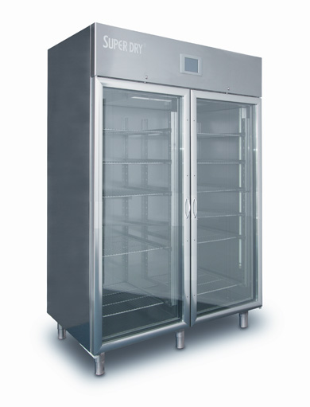Super Dry by Totech (www.superdry.info) has launched an advanced oxidation and inter-metallic free alternative to oven baking of moisture sensitive components and PCBs that will be on display in Nuremberg at SMT/Hybrid Packaging.
The Super Dry MSD applications and technology team will be on hand May 8-10 at the Nuremberg Exhibition Center in Hall 7, Booth 7-529 to demonstrate this breakthrough technology.
Designed to exceed the formidable challenges associated with IPC J-STD-033C and IPC 1601 for handling Moisture Sensitive Devices and PCBs, Super Dry XSD Series desiccant cabinets offer a process combining ultra low humidity and mild temperatures proven to replace oven baking of components and PCBs safely and at a fraction of the cost. IPC 1601 prohibits the baking of OSP coated boards, and warns against baking any board types. The Super Dry XSD cabinets can dry PCBs and other moisture sensitive devices at high speeds without the oxidation and inter-metallic growth induced by baking. And, unlike vacuum or baking ovens, the XSD cabinets also offer cost effective long term and short term MSD safe storage solutions in full compliance with 033C specifications.
“We have not only developed solutions for a significant electronics process problem, but they are also unmatched in environmental friendliness,” explained Jos Brehler, Totech EU Managing director. “These systems consume less than 1% of the energy of traditional baking methods while at the same time reducing overall floor space and logistics.”
The XSD Cabinet Series has recently been expanded with two additional configurations that employ a unique, energy saving dual wall insulated steel and glass design and the U5002 "Dynamic Series" closed loop dehumidification. Optimal humidity levels are below 0.5%RH and vapor content of less than 0.05g.m^{3.} Recovery time after door openings, the most overlooked operational function of MSD storage systems, is unmatched at <240 seconds. In addition, their unique design regenerates only when necessary according to cabinet load, thereby further reducing energy consumption, which averages less than 30W/hr.

Oxidation has always been a very significant drawback of baking components, and in fact even a single bake cycle at typical 125º temperatures will significantly increase wetting times. The Super Dry process dramatically reduces this oxidation risk, because it employs mild, low heat delivered within an exceptionally dry atmosphere. The oxygen molecules in water are a much greater catalyst to the oxidation process than those in the air. So heating at the sub 0.5% RH levels the XSD is capable of achieving does not promote the oxidation common to traditional processes. And furthermore, 50 degrees C is safe for tapes and reels, enabling drying of taped component without damage. This fully eliminates the cost and logistics of removing components from tape prior to drying, then re-taping for subsequent production use.

Learn more at www.superdry.info
Ends
About Totech Super Dry®
Delivering globally to the world’s top tier OEM and EMS companies, and manufacturing in Asia and in Europe, Totech Super Dry has become the industry measure for ultra low humidity storage cabinets. Proper control of moisture sensitive devices (MSDs) per IPC and JEDEC standards has become more critical than ever since the introduction of lead free and its higher reflow temperatures. Boasting 0.5% relative humidity control and the fastest recovery times, Super Dry cabinets are available in a wide range of sizes and configurations, all with certified performance control measures.
About Stratesys Group
Serving the Southern California market, Stratesys Group provides its customer base a unique, new value by leveraging CRM technology along with its depth of industry and product knowledge. Their line card not only consists of traditional Production Supplies and Automated Assembly Equipment, but includes Test & Measurement, Chemical Process and Clean Room product lines as well as specialist services.

Company Contact | Agency Contact
Richard Heimsch  Totech Super Dry  235 Colovista Parkway  Austin, TX 78602  USA | Helena Osborn  Unit 1, Cutbush Court  Danehill  Lower Earley  Reading, RG6 4UW  UK
Tel: +1 312 513 3513  Email: rich@heimsch.com  www.totech.eu.com | Tel: +44 1189 759880  Email: helena.osborn@protean.co.uk  www.proteanmarketing.com

