  - New brand family from EUPEN
Eupen, Belgium, 21 April 2017. EUPEN Foam Products has reorganised its diverse product range with four new brands. This greater clarity will allow customers to find the solution they need quickly and easily. From bedding to furniture, the premium foams in the Eucabase®, Eucaselect®, Eucafeel® and Eucavisco® brands are perfectly suited for every sector. The Belgian foam manufacturer will present its new brand family at the Interzum trade fair in Cologne from 16 to 19 May 2017 (hall 11.2, stand J001).

New brands offer reliable EUPEN quality
Each product in the new family of brands offers the proven quality of EUPEN Foam Products. All foams are certified to Standard 100 by Oeko-Tex® (product class 1), and exceed the required standards. Tough hardness tolerances ensure consistently high foam quality. To this, EUPEN adds its expertise and decades of experience in chemicals, along with continuous development in foam production. Customers can rely on high-quality, German-made machinery and high-pressure foam systems. Sales Manager Pascal Timmerman: "Our four new brands combine all of our expertise."

Greater clarity in a diverse product range
The new brands Eucabase®, Eucaselect®, Eucafeel® and Eucavisco® provide greater clarity in EUPEN's large range of products. Timmerman: "The new brands make it faster and easier for customers to find what they are looking for." They are also classified according to density and quality into the variants classic, plus and first. "This allows us to offer the right foam at all times", explains Timmerman.

Eucabase® for robustness, Eucaselect® for comfort
The Eucabase® brand offers foams that are especially sturdy and robust. These dimensionally stable foams boast high load-bearing capacity and can be processed reliably for different purposes. The variety of premium products in the Eucaselect® range offers the perfect high-quality solution for every need. One particular highlight is the Select 5531 foam, with its comfort index of 3.02. R&D and QM Manager Jean-Pierre Doeuillet: "The Eucaselect® foams offer high elasticity with a particularly open cell structure. This gives them an extraordinary load-bearing capacity and excellent hysteresis." The foams therefore offer the perfect night's sleep.

Eucafeel® for special foams, Eucavisco® for memory effect
The premium foams in the Eucafeel® range have extremely open pores, are hydrophilic, and are outstanding at dissipating heat. They are perfect for controlling heat and moisture, creating a sleeping environment that is fresh at all times. Eucavisco® foams stand out thanks to their excellent memory effect, with the foam adapting perfectly to the shape of the body. "The combination of open pores and memory effect makes the Eucavisco® foams especially breathable", adds Doeuillet.

Premium foams from EUPEN
Kabelwerk Eupen AG has been producing foams in the Meuse-Rhine region for over 60 years. Its products are used in mattresses, furniture, and the automotive industry. The company's EUPEN Foam Products division develops and produces sleep products made from polyurethane foam at its production facility, which measures 35,000 m² and employs over 90 people. EUPEN also cooperates with international partners and customers, and has subsidiaries in Belgium, Germany, France and the Netherlands.

EUPEN at Interzum 2017 in Cologne
EUPEN will present its four new premium foam brands – Eucabase®, Eucaselect®, Eucafeel® and Eucavisco® – at the Interzum 2017 trade fair in Cologne from 16 to 19 May. Visitors can get to know the new EUPEN brand family in hall 11.2, stand J001.

Press contact:
Pascal Timmerman
Sales Manager
Kabelwerk Eupen AG
Foam Division
Oestrasse 42
B-4700 Eupen

timmerman@eucafoam.com
www.eupen.com/foam
Telephone: +32 (0)87 - 59 78 19
Mobile: +32 (0)470 - 98 73 95

Pictures:
Picture 1:
Caption Picture 1:
The new brand family from EUPEN Foam Products offers a wide range of premium foams.
Picture 2:
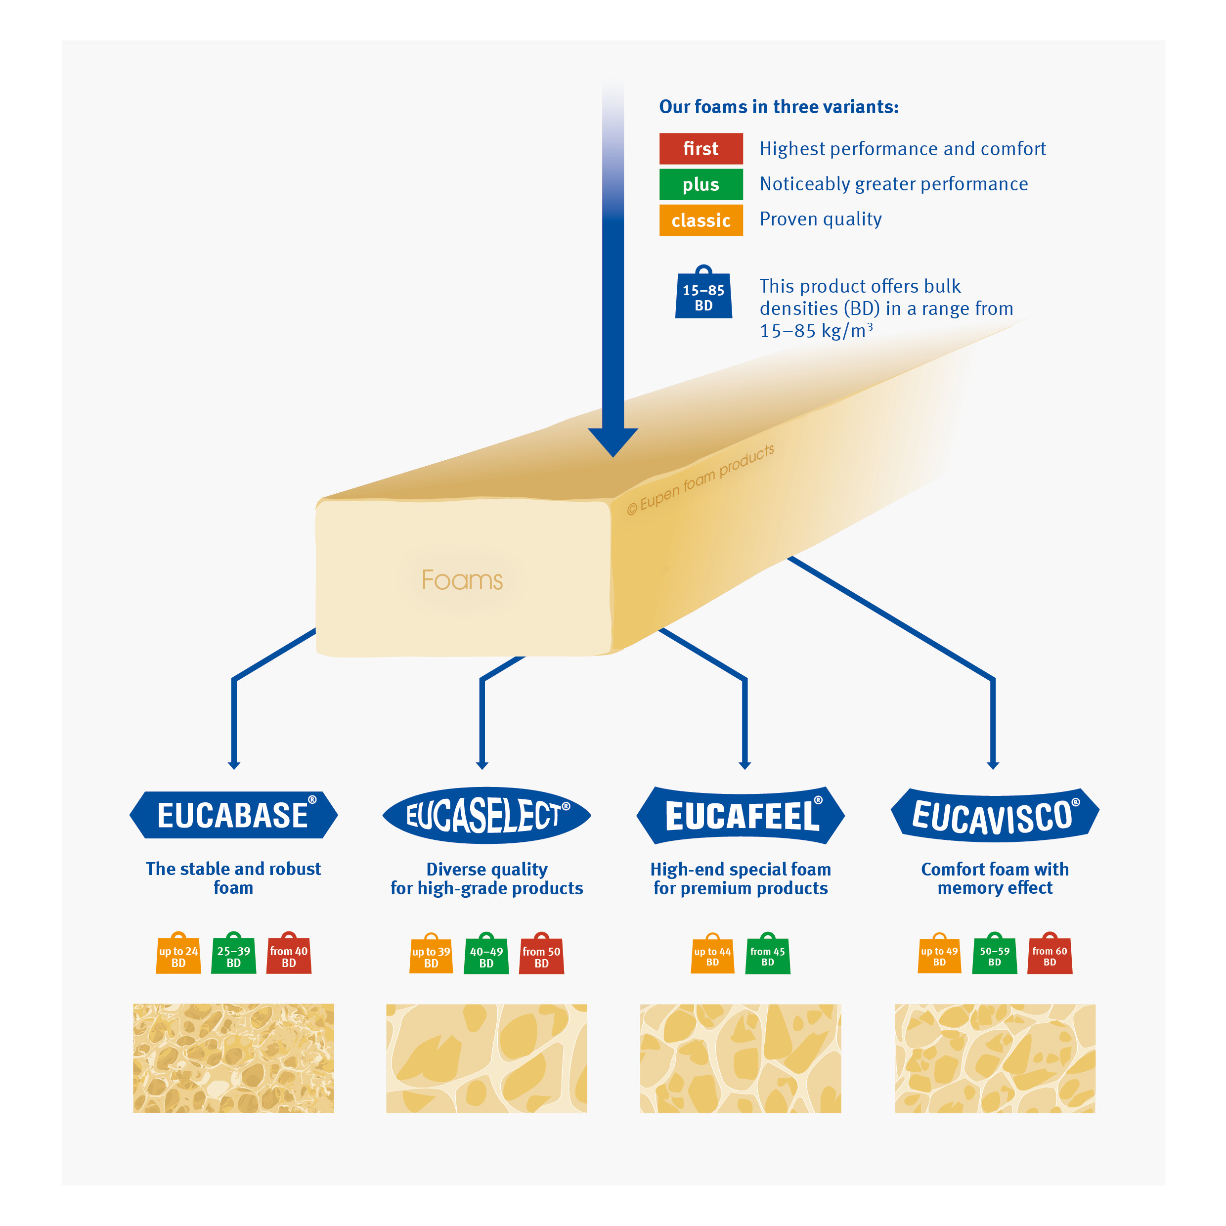
Caption Picture 2:
The new brands are available in the classic, plus and first variants, and offer densities of 15 kg/m3 to 85 kg/m3.

