APEX FA On-board 3D SPI featured at IPC Midwest Electronics August 22-23

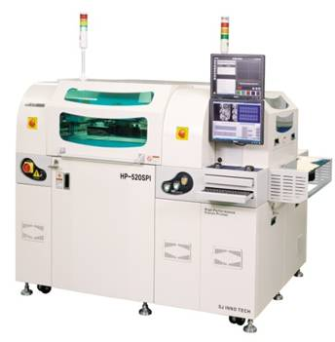SMT equipment and process specialist Apex Factory Automation features stencil printing with integrated 3D solder paste inspection. SJ Inno Tech, the successful Korean manufacturer of precision print systems for SMT and Solar technologies, produces the closed loop system. Its features and capabilities will be highlighted at next weeks’ IPC Midwest Electronics in Schaumburg, IL. at Booth 803.

With a worldwide installed base of over 1000 machines, SJ Inno Tech print systems have been an established presence throughout Asia’s gruelling electronics production market since 1997. Renowned for delivering state-of-the-art features at unmatched value, all SJ Inno Tech printers feature post-print 2D inspection and sophisticated board fixturing alternatives. Since 2007 they have been the only printer manufacturer in the world to offer fully integrated built-in 3D SPI. APEX FA will be on hand at booth #803 to discuss the advantages of this closed loop controlled system.

Apex FA Sales and Support Manager Will Crist, explains: “We’re excited to have SJ Inno Tech’s unique products in our SMT line up. All eleven models offer high end functionality at surprising price points. Their elegant designs address all the critical elements of repeatable fine pitch printing, not only 2D and 3D inspection.”
“Auto balanced squeegee pressure, adjustable even within the print stroke. Multi-function under stencil cleaning that’s four times as effective as comparable systems. 3 stage conveyors, dual lane transport, sophisticated PCB fixturing and fiducial detection…the list goes on and on.”

Progressive EMS providers and OEM in-sourcers throughout North America are increasingly recognizing the unique new service and support commitment and transparent business model introduced by Apex Factory Automation. Their highly scalable equipment offering also includes the comprehensive range of Mirae pick and place machines and TSM reflow ovens.

Delivering an entirely new experience in process applications, technical service and commercial support to the North American PCBA marketplace, the Apex team works alongside customers to select and customize an optimized SMT production line for every manufacturing requirement – from low to high volume. For more information about Apex Factory Automation, visit www.apexfa.com.

-ENDS-
About Apex Factory Automation:
Apex Factory Automation is part of a family of companies that have successfully serviced and supported customers in a variety of industries for more than 25 years. Their team of advanced surface mount technology experts are now delivering an entirely new experience in process applications, technical service and commercial support to the North American PCBA marketplace. Apex FA specializes in delivering carefully tailored and uniquely supported manufacturing solutions to OEM In-Sourcers and progressive EMS providers at the highest possible value. These include globally proven, advanced surface mount technologies from Mirae, SJ Innotech and TSM.

Apex Factory Automation Contact | Protean Marketing Contact
Will Crist  Sales and Support Manager  Apex Factory Automation  14526 Lee Road  Chantilly, VA 20151 | Helena Osborn  Unit 1, Cutbush Court  Danehill  Lower Earley  Reading, RG6 4UW, UK
Tel: 1-888-383-4555  Email: wcrist@apexfa.com  Web: www.apexfa.com | Tel: +44 1189 759880  Email: helena.osborn@protean.co.uk  www.proteanmarketing.com

