Summer tyre test

Nokian Line rated "good" in the 2016 ADAC summer tyre test

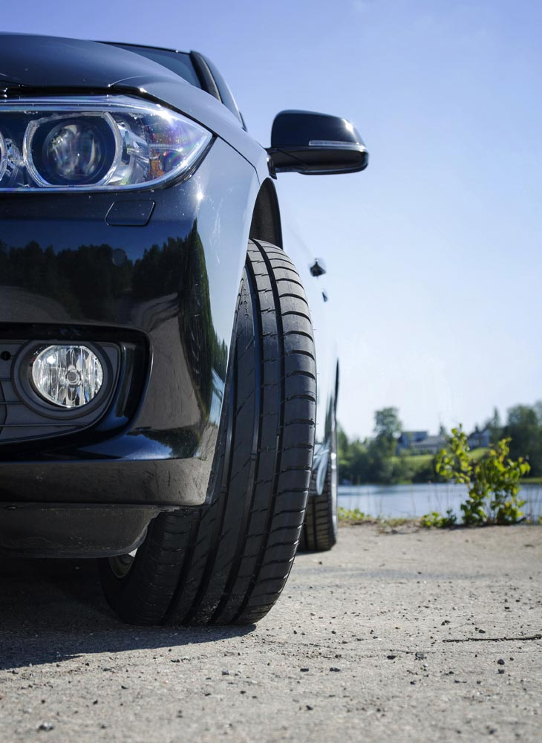
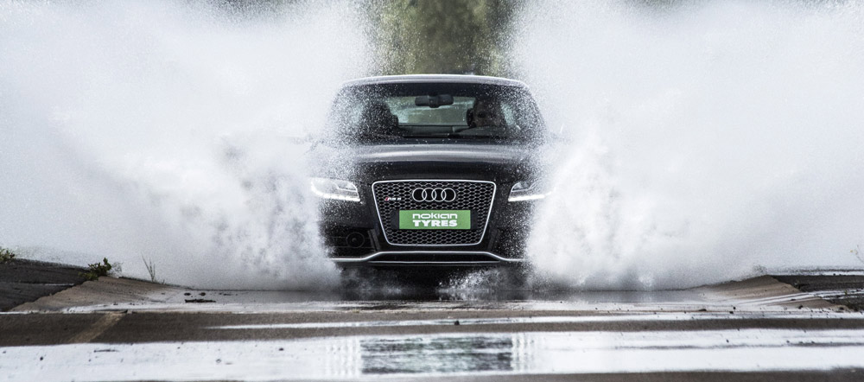
"Strengths: + very balanced, + especially good on dry roads, + good on wet roads, + quite low fuel consumption" according to the assessment of the German automobile club ADAC for the Nokian Line summer tyre for small and compact cars sized 185/65 R15 H. Nokian Line is "Highly recommended" by the automobile clubs TCS from Switzerland and ÖAMTC from Austria.
Nokian zLine is recommended by ADAC highlighting its “quite low fuel consumption” in the automobile club’s 2016 summer tyre test for mid-range cars with tyre size 225/45 R 17 Y. The Nokian zLine is rated "good" in the "dry road", "fuel consumption" and "wear" test criteria. The assessment of TCS and ÖAMTC is "Recommended".

The sporty Nokian zLine is "highly recommended"

"Highly recommended" is the test result of the sporty Nokian zLine in the 2016 summer tyre test by German car magazine Auto Zeitung and GTÜ technical inspection organisation. Nokian zLine drives safely and predictably on wet roads. “The low rolling resistance is one of the Nokian zLine's strengths".
.

Nokian Weatherproof All-Weather tyre scores "good +"

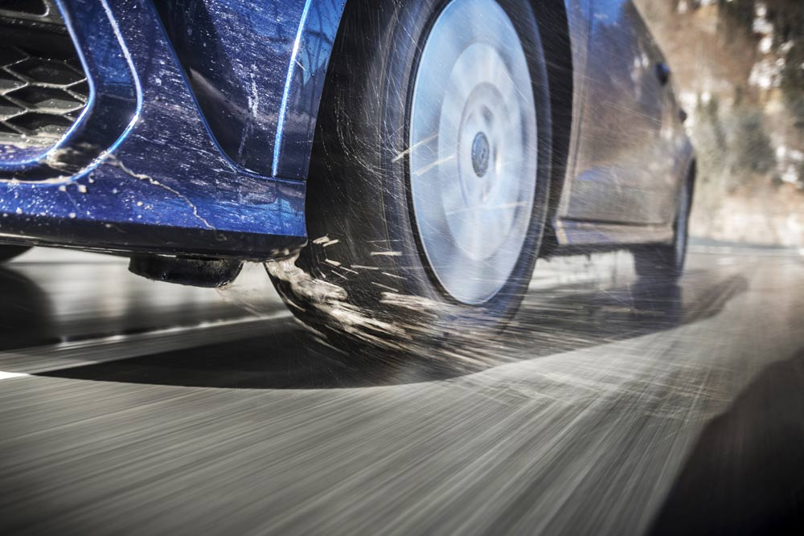
The Nokian Weatherproof All-Weather tyre scores "good +" overall results, obtaining the "GUTE FAHRT-recommendation" and ranks on the 2nd place in the 2016 all-season tyre test of the German car magazine GUTE FAHRT. "Very good -" in winter category with the best traction and best braking in snow. The Nokian Weatherproof shows good and balanced performance on dry roads and the brakes work well on wet road surfaces. The aquaplaning test result is "very good". Its rolling resistance is "very good" as well.

ADAC, TCS and ÖAMTC tested 32 summer tyres of the sizes 185/65 R15 H and 225/45 R 17 Y by strict criteria and requirements. 14 summer tyres of size 225/45 R 17 competed in the test done by Auto Zeitung. GUTE FAHRT compared 9 tyres of size 205/55 R 16.

www.nokiantyres.com
Vianor tyre and car service from Nokian Tyres:
http://vianor.com

Photo captions

Nokian_zLine_001.jpg
Photo caption:

Nokian zLine: "highly recommended" by "Auto Zeitung" and GTÜ, recommended by ADAC, TCS and ÖAMTC as well in the 2016 summer tyre tests Photo: Nokian Tyres

Nokian_Line_004.jpg
Photo caption:

The Nokian Line is "good" in the ADAC 2016 summer tyre test Photo: Nokian Tyres

Nokian_Weatherproof_022.jpg
Photo caption:

The Nokian Weatherproof all-season All-Weather tyre scores the "good +" overall results in the 2016 all-season tyre test of the car magazine "GUTE FAHRT" Photo: Nokian Tyres

Photo downloads Nokian Line summer tyres
www.nokiantyres.com/NokianLine

Photo downloads Nokian zLine summer tyres
www.nokiantyres.com/NokianzLine

Photo Downloads Nokian Weatherproof All-season tyre
www.nokiantyres.com/NokianWeatherproof

Videos

Nokian summer tyres – Testing at the extremes

https://youtu.be/6kT0wLEOxY4

Nokian Line - Test winning summer tyre for Central Europe
http://youtu.be/YbsERA80v18

The new Nokian zLine - sporty, cool performance for Central European summer
https://youtu.be/tm-FodKRM0M

New Nokian Weatherproof, all-weather tyres for Central Europe
https://youtu.be/LonBy4JsbQI

Further information

Nokian Tyres introduces three brand new summer tyres
http://www.nokiantyres.com/company/news-article/nokian-tyres-introduces-three-brand-new-summer-tyres/

New Nokian Line – Top performance for wet roads
https://www.nokiantyres.com/company/news-article/new-nokian-line-top-performance-for-wet-roads-2/

The new Nokian zLine – sporty, cool performance for fast driving
https://www.nokiantyres.com/company/news-article/the-new-nokian-zline-sporty-cool-performance-for-fast-driving-2/

Nokian Weatherproof All-Weather tyres – safe year-round driving comfort
http://www.nokiantyres.com/company/news-article/nokian-weatherproof-all-weather-tyres-safe-year-round-driving-comfort/

Nokian Tyres is the world’s northernmost tyre manufacturer and innovation leader

Nokian Tyres is the world’s northernmost tyre manufacturer. The company promotes and facilitates safe travel in demanding conditions. Whether driving through a winter storm or heavy summer rain, Nokian tyres offer reliability, performance, and peace of mind. The Finnish company is the only tyre manufacturer to focus on products for demanding conditions and customer requirements. As the world’s leading winter tyre specialist, Nokian Tyres offers innovative tyres for passenger cars, trucks, and heavy machinery that are mainly marketed in areas with challenging driving conditions due to snow, forests and varying seasons.

Nokian Tyres is the inventor of the winter tyre and has been designing, testing and patenting innovative tyres for 80 years. Exceptionally demanding conditions require quick thinking, a relentless fighting spirit and the ability to cooperate. This recipe is also used to create the market’s most advanced summer tyres that master rough roads and heavy weather. Furthermore, premium brand Nokian Tyres produces tyres especially developed for European weather and the higher speeds on European motorways.

Large summer tyre and winter tyre and range available from the premium brand Nokian Tyres

The new AA Class Nokian eLine 2 premium summer tyre provides the best of the tyre label class A in wet grip, fuel consumption, advanced security and greener mobility. The new Nokian iLine summer tyre brings better driving comfort and economy for small and medium cars.

Nokian Tyres’ exceptionally wide range of premium winter tyres includes the new Nokian WR D4, Nokian WR A4 high-performance tyre, Nokian WR SUV 3, Nokian WR C3 van tyres and Nokian Weatherproof All-Weather tyres, as well as multiple test winner Nokian WR D3.

Nokian Tyres’ products deliver excellent safety, save fuel and are the forerunners of environmental friendliness. The company is number 1 in terms of brand recognition and appreciation in Scandinavia and Russia and has a positive, exceptional image.

Increased safety through innovations: Driving Safety Indicator (DSI) with aquaplaning warning

The Driving Safety Indicator on the summer tyres informs drivers of the groove depth as a simple figure from 8 to 3. An aquaplaning alert within this warns of the danger of aquaplaning with a water drop symbol. It disappears when there are only four millimetres of remaining tread, alerting the driver of the increased risk.

Nokian Tyres achieved a 1.360 billion euro turnover in 2015

Nokian Tyres achieved a turnover of 1.360 billion euros in 2015 and had over 4,000 employees. In Europe, Nokian Tyres operates with own sales companies in ten countries. The company also owns the Vianor tyre and car-service chain that comprises more than 1,400 outlets in 26 countries.

www.nokiantyres.com

Vianor tyre and car-service of Nokian Tyres:
http://vianor.com

Press contact:
Dr Falk Köhler PR
Dr Falk Köhler
Tel. +49 40 54 73 12 12
Email Dr.Falk.Koehler@Dr-Falk-Koehler.de
www.Dr-Falk-Koehler.de
Ödenweg 59
22397 Hamburg
Germany

More information:

www.twitter.com/NokianTyresCom
www.youtube.com/NokianTyresCom
www.facebook.com/nokiantyres
www.linkedin.com/company/nokian-tyres-plc
Motorist blog:
http://community.nokiantyres.com/
Expert blog:
http://nordictyreblog.com/

Nokian Tyres Europe
Nokian Tyres s.r.o

V Parku 2336/22

148 00 Praha 4
Czech Republic
Managing Director Central Europe Hannu Liitsola, Tel. +420 605 236 440
Email hannu.liitsola@nokiantyres.com
Technical Customer Service Manager CE Sven Dittmann, Dipl.-Ing., Tel. +49 160 908 944 04

Email sven.dittmann@nokiantyres.com

Marketing Manager Lukáš Líbal, Tel. +420 222 507 759

Email lukas.libal@nokiantyres.com
www.nokiantyres.com

Nokian Tyres Finnland Headquarters
Nokian Tyres plc
Pirkkalaistie 7
P.O.Box 20
37101 Nokia
Finland
Product Development Manager Olli Seppälä, Tel. +358 10 401 7549
E-Mail olli.seppala@nokiantyres.com
Head of Product Management Petri J. Niemi, Tel. +358 10 401 7646
Email petrij.niemi@nokiantyres.com
Technical Customer Service Manager Matti Morri, Tel. +358 10 401 7621

Email matti.morri@nokiantyres.com
Product Development Manager Jarno Ahvenlammi, Tel. +358 10 401 7741
Email jarno.ahvenlammi@nokiantyres.com
Development Manager Juha Pirhonen, Tel. +358 10 401 7708

Email juha.pirhonen@nokiantyres.com
Product Manager Central Europe Stéphane Clepkens, Tel. +358 50 462 7536
Email stephane.clepkens@nokiantyres.com
www.nokiantyres.com

