Introducing Stingray – a new era in cycle protection.
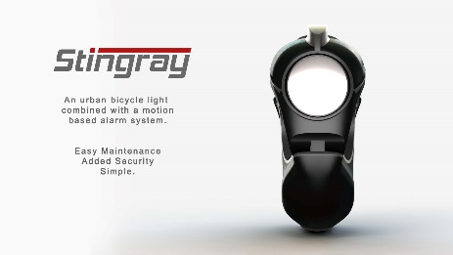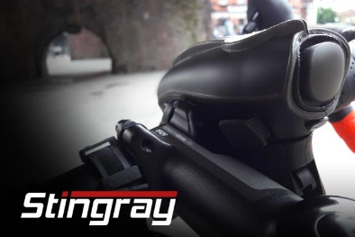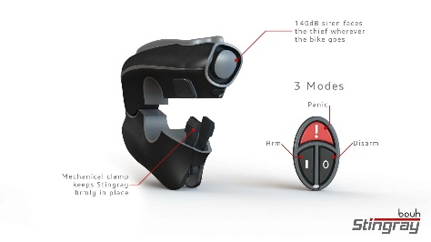

A NEW bicycle security device which shocks thieves with a 140db siren has launched a £50k crowdfunding bid on Indiegogo
Stingray, serves as a high-quality 300-lumen front light, but when armed via a remote keyfob, it becomes a tamper-proof alarm which activates if stolen.
The device which launches its Indiegogo campaign on October 10, is the invention of Manchester University Electronics graduate, Obaidah Sheikh, who has been a victim of bike thieves three times.
He said: “When a thief takes your bike, no-one knows he’s a bike thief. To passers-by it’s just another cyclist.
“Once your lock or chain is cut or broken, there’s no reason for the criminal to stop what they’re doing.
“Stingray is another layer of security – it’s a 140db siren – the same volume as a fire truck – which goes off in their face and keeps going off. It’s a very effective way of saying – this isn’t yours get off!
“Stingray is designed to be the ideal combination of two things that every commuting cyclist needs – lights and security.”
As a light Stingray features five operating modes and an oval beam shape. The internal lithium battery is rechargeable via USB and offers up to 10 hours burn-time.
The alarm is activated by a radio-control fob – similar to those used for car alarms. As well putting the device into security mode it engages an internal lock meaning the Stingray cannot be removed.
The whole unit weighs less than 250g and the fob also features a panic button, to activate the alarm in emergencies.
For more info and to see the campaign page: https://igg.me/at/Bouh
For images, info, interviews etc please contact: press@bouh.co.uk or call 0161 637 6616

