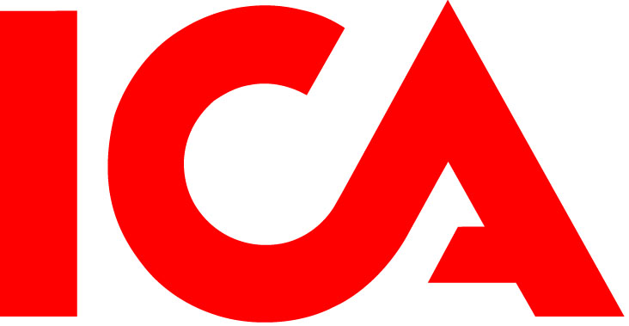

ICA streamlines its Norwegian operations

As our next step in the Norwegian market, ICA will streamline ICA Norway’s operations by focusing strictly on the discount and supermarket segments. As a consequence of this strategy change, ICA Norway will leave the hypermarket segment and initiate a sales process of the Norwegian ICA Maxi stores.

In recent years, we have implemented a number of measures to reverse ICA Norway’s negative results.

- A key point has been the launch of the new Rimi concept, which has been very well received by customers and generated marked sales increases. We have also initiated a successful modernization of our ICA Supermarked stores. Now we choose to fully focus on these formats and continue to assess additional measures and evaluate our store base in order to improve the performance of ICA Norway, said Kenneth Bengtsson, CEO and President ICA AB.

There are 25 ICA Maxi stores in Norway today. In 2010, ICA Maxi store sales amounted to NOK 3,041 million. ICA Norway owns nine of the properties where the stores are located; the others are leased from an outside landlord.

According to a previous decision, ICA Maxi Sjölyst will be converted to ICA Supermarked. The number of full and part time employees amounts to approximately 1,500 in the 24 Maxi stores that will be sold.

For further information:
ICA’s press office, phone no +46 70 253 66 60

