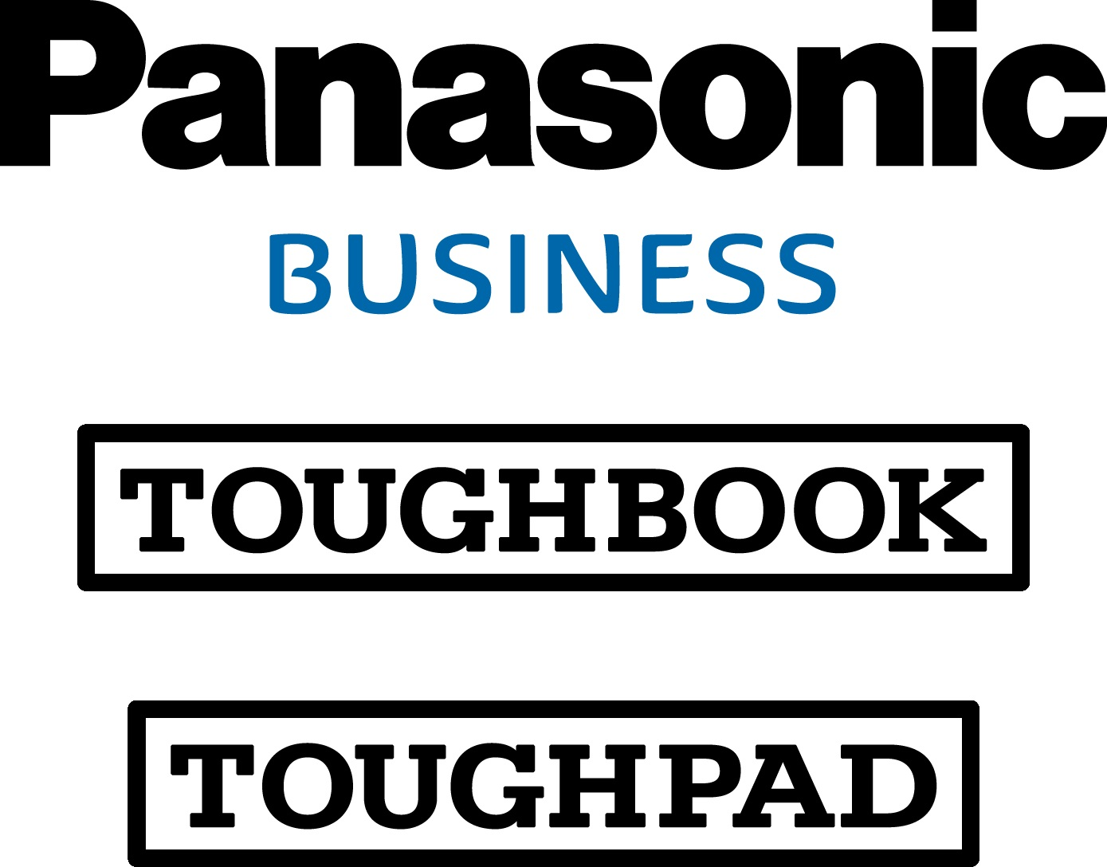
Press release
Computer Product Solutions

Panasonic Partners with FusionPipe to Offer Authentication Software as part of Toughbook and Toughpad Mobility Solutions.

Computer Products Solutions, a division of Panasonic System Communications Europe (PSCEU) (“Panasonic”), and FusionPipe Software Solutions Inc. (“FusionPipe”), a Vancouver-based developer of authentication & data security solutions for enterprises, today announced a new partnership through which Panasonic will sell and support FusionPipe’s patented QuikID™ authentication solutions to its European customers, resellers and distributors.
QuikID^{M} is patented software, engineered to improve end-user authentication (lock/unlock) for ruggedised PC’s, laptops, tablets and VPN networks. It eliminates the need for username / password combinations, tokens, smartcards, OTPs (one-time passwords) or USB’s, offering a superior user experience while increasing work force productivity without compromising data and network security.

Fusionpipe is one of the latest Independent Software Vendors (ISV’s) to become officially certified and approved for use with Toughbook or Toughpad devices, under Panasonic’s new Certified ISV Programme.

John Harris, Head of Engineering at Panasonic Computer Products Solutions, said “I have been working with the FusionPipe team since I first met them at Mobile World Congress 2015 to evaluate QuikID™’s technical merits, security provisions and the potential of their authentication technology. I have not only been impressed with the FusionPipe team and their technology, but also the opportunity that this innovative solution brings to our existing customer base, prospects and distribution channel.”

FusionPipe’s CEO & Chairman David Snell said: “We are honoured and excited to have Panasonic become one of our major Value Added Resellers for our ground-breaking authentication technology. As the titan in the ruggedized device marketplace, their vision, market strategy and growing user base for their popular devices is key to the success of our mutually advantageous business partnership.”

Panasonic will sell FusionPipe’s QuikIDTM software as part of its ProServices range of offerings within its existing line of distribution channels across the European Economic Area, Switzerland and Turkey .

For details of Panasonic Toughbook and Toughpad solutions visit www.toughbook.eu

ENDS

About Panasonic System Communications Company Europe (PSCEU)

PSCEU is the European branch of Panasonic Systems Communications Company, the global B2B division of Panasonic. PSCEU’s goal is to improve the working lives of business professionals and help their organisations’ efficiency and performance. We help organisations capture, compute and communicate all sorts of information: image, voice, and textual data. Products include PBX telephone switches, document printers, professional cameras, projectors, large visual displays, rugged mobile PCs and fire alarms solutions. With around 400 staff, engineering design expertise, global project management capability and a large European partner network, PSCEU offers unrivalled capability in its markets.
PSCEU is made up of four product categories:

- Communication Solutions, including professional scanners, multifunctional printers, telephony systems and SIP terminal devices.
- Visual System Solutions, including projectors and professional displays. Panasonic offers the widest range of Visual products, and leads the European projector market with 28% revenue share (Futuresource B2B market tracking, Q1/2014).
- Professional Camera Solutions, including Broadcast & ProAV products, security, fire alarm systems and industrial medical vision (IMV) technology. Panasonic is one of the top two professional camera vendors in Europe.
- Computer Product Solutions helps mobile workers improve productivity with its range of Toughbook rugged notebooks, Toughpad business tablets and electronic point of sales (EPOS) systems. As European market leaders, Panasonic Toughbook had a 66% revenue share of sales of rugged and durable notebooks and Panasonic Toughpad held a 59% revenue share of sales of rugged business tablets in 2015 (VDC Research, March 2016).

About FusionPipe
FusionPipe Software is a dynamic, rapidly growing technology company whose mission is to replace passwords, smart cards and tokens using smartphones and wearables to enable more convenient and secure end user authentication. We are the leader in world-class authentication and advanced data security solutions for Enterprises. Our patented technology addresses the growing global need for convenient yet secure authentication and identity management. FusionPipe provides Enterprises with disruptive technology, that is easy to use and implement, increases productivity and lowers the total cost of ownership. For more information on FusionPipe’s innovative authentication technology solutions, visit: www.fusionpipe.com.

Disclaimer:
- All brand names shown are the registered trademarks of the relevant companies. All rights reserved.
- All working conditions, times and figures quoted are optimum or ideal levels and may differ as a result of individual and local circumstances.
- Specifications, product availability and price given herein may be changed at any time without prior notice.

