Alu Design eyes mass appeal with new OP chair range, offering simplicity, flexibility and value

Now more people than ever will be able to experience an Alu Design chair. That’s the message from the Norwegian maritime pilot chair and deck rail specialist with the launch of its new OP series; a flexible and functional range of six seats, offering a unique combination of build quality, comfort and value for money.

The OP series is, according to CEO Einar Ulrichsen, Alu Design’s key to unlocking a broader market share. It brings the characteristics and quality of the company’s premium products to a wider audience, at a competitive price:

“Since launching in 2008 we’ve established the firm as a global leader in high quality, durable and intelligent maritime chairs,” Ulrichsen notes. “Now we want to democratise that offering a little.

“By working closely with the industry we’ve identified a clear demand for flexible seating solutions that are easy to install, offer a simple range of functionality and a competitive price tag. The OP chairs do all this and more – giving users our hallmark design, construction and ergonomic standards, but not the specification that is demanded in our premium products.”

As with all Alu Design chairs, the OP series is manufactured in lightweight yet robust aluminium and provides the user with high comfort and durability seat cushions and backs for the optimum working environment. Six varieties are available – namely the Office, Standard, Standard with air suspension, Shock Mitigation Seats, Operator Chair, and Operator with air suspension – as well as a ‘build your own’ version and menu of options for customers seeking bespoke solutions.

This flexibility means that the firm can now offer a state-of-the-art seating experience for all vessel types, including high speed vessels, fishery and fish farm vessels, navy ships, and all offshore vessels.

“We believe this is an excellent way to grow the appeal of the brand,” comments Frank Inge Robertsen, Alu Design Marketing Director, “without diluting the very quality that has made that brand so successful in the first place. It’s an exciting time for the business and, we think, for a new breed of Alu Design customer.”

Alu Design will continue to market its existing range of premium products, providing customers that require high levels of functionality and specification with solutions that are tailor made to meet their operational challenges. The business currently supplies advanced pilot chairs and deck rails to clients including Kongsberg Maritime, Oceaneering, Rolls Royce and MHWirth, amongst others.

Those eager to experience the chairs first hand will be able to do so between 2 – 5 June at the Nor-Shipping exhibition in Lillestrøm, Norway, where they’ll be unveiled at Alu Design’s dedicated stand C04-28a at the Norwegian Pavilion. The firm will also be exhibiting at Seawork International, stand B83, 16-18 June, Southampton, UK.

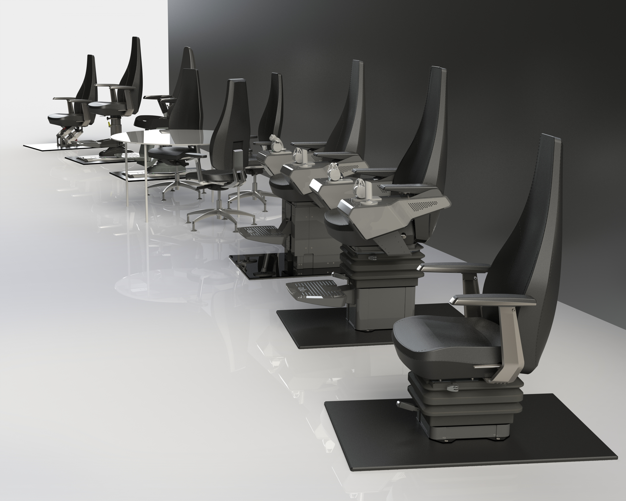
The new OP chair series from Alu Design, offering quality, flexibility and value

Alu-Design & Services offers world-class pilot chairs and deck rails to the marine, navy, offshore and commercial industries. Our innovative products are designed with care, manufactured in accordance to stringent quality requirements and marketed with love. Our offerings can be customized to meet individual customer needs.
The company was established in 2008 in Kristiansand, Norway (the first chairs hit the market the following year) and has quickly grown to be recognized as a global leader in its field.
For a full list of our global customer base please see www.alu-design.no

For further information about Alu Design, please contact Frank Inge Robertsen, Alu Design Marketing Director, on 0047 907 59 295 or via email at frank@alu-design.no

