Contact

Åge Straume, CEO, Deep Sea Mooring
+47 907 60 823 / aast@deepseamooring.com
Hogne Folkestad, VP Offshore, StormGeo
+47 91 80 69 28/ hfo@stormgeo.com
PRESS RELEASE
Bergen/Straume, 12 November 2014

StormGeo and Deep Sea Mooring announce collaborative agreement

StormGeo and Deep Sea Mooring have signed an agreement to provide notifications of weather-related movements of floating offshore units and vessels undertaking complex marine operations. This innovative service will help customers save money and time, while enhancing planning and safety standards.

“We are delighted to sign this agreement with StormGeo,” comments Åge Straume, CEO of Deep Sea Mooring. “It means that together we can offer an excellent planning tool, enabling users to make early decisions regarding forthcoming marine operations and thus minimise the movement of vessels and helicopter decks. This will result in significant savings for our customers.”

The notifications are made possible through the combination of detailed weather forecasts and advanced hydrodynamic models, which can identify critical movements on floating offshore units. By doing so, recipients can be alerted to the actual consequence of the forecasted weather on vessels, rather than just the weather itself.

“This agreement with Deep Sea Mooring compliments and supports our ambition to deliver high quality services that facilitate optimum decision-making on weather-sensitive operations. In a time when the focus on cost saving and efficiencies is so great, it’s more important than ever to combine detailed weather information with optimal planning capabilities to execute critical offshore work,” notes Hogne Folkestad, VP Offshore in StormGeo.

StormGeo will publish and support the notifications, while Deep Sea Mooring will be responsible for the hydrodynamic models and all calculations of motion resulting from the expected weather.

In principle, this high-tech approach can be used for all marine operations. As an example, it is now possible to forecast movements and wind speeds on helicopter decks several days in advance. By doing so, it is possible to determine whether the conditions/movements are within the set landing criteria for helicopter traffic. As a result, the efficiency of planning and coordinating helicopter traffic could be significantly enhanced.

A further example is illustrated by floatels that utilise DP (Dynamic Positioning). Here the direction the floatel should have to minimise walkway movement can be calculated, thus increasing availability before disconnection. In addition, information regarding disconnection windows is delivered in advance, meaning the process can be undertaken in safety during calm weather, rather than, in worst case scenarios, waiting for automatic disconnection.

Other applications for the service encompass drilling operations and offshore lifting operations on floating units.

Folkestad and Straume conclude that customers will experience increased availability through the use of their technology, and have a better basis for planning, decision-making and performing secure operations. This, they stress, will be important in reducing operational expenditure.

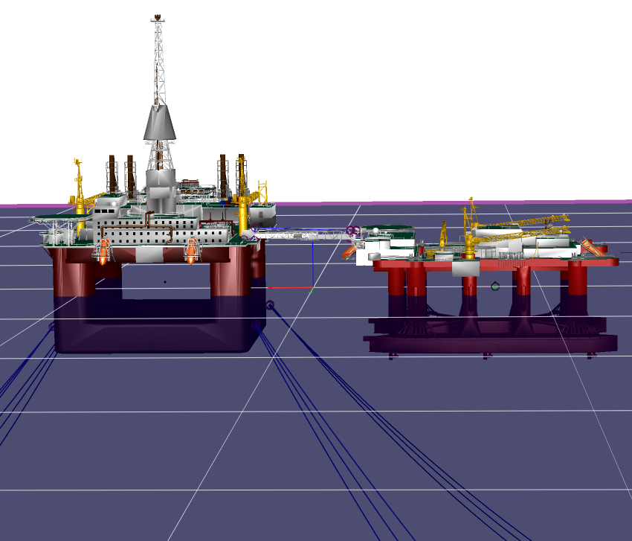
About Deep Sea Mooring
Deep Sea Mooring is the trusted choice for oil and gas companies and drilling operators that demand the best in safe, innovative and optimum quality mooring solutions. Founded in 2008, Deep Sea Mooring is the market leader on Norwegian Continental Shelf and is expanding internationally. The firm currently has operational bases in Norway and Australia, employing 43 persons, and provides pre-lay mooring, rig moves, marine engineering, mooring equipment rental, and offshore services to its growing client base. Deep Sea Mooring is owned by HitecVision, a leading private equity provider in the oil and gas industry.
About StormGeo
StormGeo is one of the world's largest commercial providers of weather services. Headquartered in Bergen, the company offers advanced solutions to support decision-making for a worldwide customer base in the offshore oil and gas, renewable energy, shipping, media and aviation. StormGeo covers all areas of the world through a network of 24/7 monitoring and forecasting centres. The company has 340 employees at offices in Bergen, Stavanger, Oslo, Stockholm, Copenhagen, Aberdeen, London, Hamburg, Singapore, Baku, Houston, Dubai, San Francisco, Moscow, Rio, Anchorage, Seoul, Hong Kong, New York, Muscat, Miami, Shanghai and Tokyo.

