PRESS RELEASE 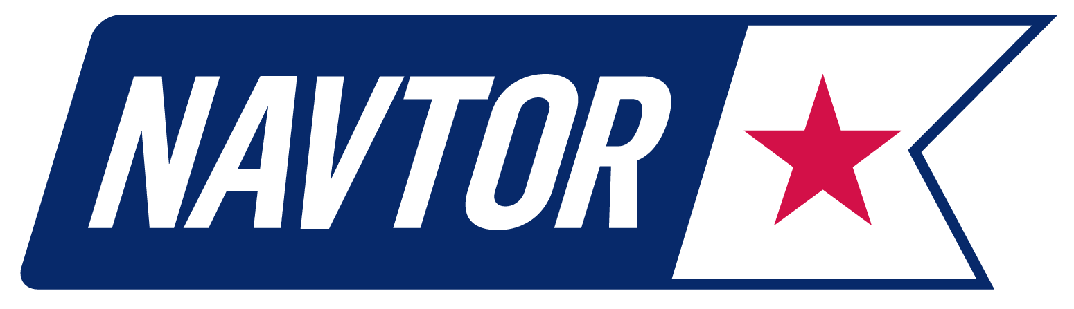
NAVTOR optimises passage planning efficiency and safety with NavStation

21 June 2016, Norway: NAVTOR is aiming to re-imagine the mandatory process of vessel passage planning to help navigators optimise both their time and voyage safety. The Norwegian headquartered e-navigation specialist has today launched a new passage planning module for its NavStation software, allowing navigators to effortlessly create the required documentation while planning vessel voyages.

In another first for NAVTOR - which launched both the world’s first type approved Pay As You Sail ENC service and, in NavStation, the first digital chart table – the new development marks a breakthrough in vessel administration. It automatically logs all necessary passage plan information into the plan as a voyage is mapped out, with type specific formulas available for different vessels to ensure all relevant details are captured. Once this stage is complete the document can then simply be printed out and signed by the captain, ready for inspection by port state authorities and other relevant organisations.

“It’s all part of our on-going mission to simplify tasks for navigators and enhance efficiency for shipowners and operators,” states NAVTOR CEO Tor Svanes. “Until now, passage planning has been done manually, with the emphasis on the navigator to input all the necessary, correct data.

“This takes that entire burden off their hands, digitalising the process and ensuring safety through automatic checks that help reduce the chance of human error. It’s easier for them, while saving significant man-hours per vessel, adding up to real time and cost efficiencies for owners fleet-wide. It’s just another step forward to realising the huge potential of e-navigation.”

The passage planning module is one of numerous options now available on the NavStation, which, using ENC’s as its foundation, overlays all the data navigators require – such as weather data, tidal information, digital publications, and other services like piracy updates – on a single computer screen, or ‘gigapad’ touch screen device. This helps put navigators in complete control, with all essential, updated information in one place, at their fingertips.

Bergen-based chemical tanker owner and operator Utkilen has been piloting the new module over the course of 2016. Safety Manager Haakon Losnegaard is clear of the benefits it offers over more traditional passage planning procedures.

“There’s a real need for a smarter way of doing things,” he states. “We’ve been using a more or less in-house developed tool for passage planning over the last 15 or so years. This has done the job, but has also presented challenges.

“For example, when planning a new route on the ECDIS, all waypoints had to be manually inputted into an Excel sheet. This is time consuming and also opens the door to errors. With the NavStation module, waypoint data can be transferred electronically, ruling out potential typing mistakes and errors. NavStation Passage Planning is intuitive to use, has a logical layout and, thanks to its functionality, is definitely a time efficient tool. The availability of shore support is another benefit.

“So far the trial has been office-based, but we’ll be rolling it out across our fleet of 18 vessels as soon as possible. It is, quite simply, a huge leap forward for the essential practice of passage planning and documentation.”

This latest development comes as NAVTOR celebrates its fifth birthday. Since its launch, and the subsequent release of its ENC service in 2012, the firm has established itself as a global leader in e-navigation – bringing a series of products to market that streamline and simplify tasks for navigators, while enhancing safety, security and efficiency for shipowners and operators.

NAVTOR now operates offices in Norway, Russia, Singapore, Japan and Sweden, providing innovative e-navigation products and services worldwide.

Utkilen's chemical tanker Xanthia sailing in the Gulf of Bothnia.

Utkilen Safety Manager Haakon Losnegaard

About NAVTOR
NAVTOR is a market leader in the provision of innovative e-navigation solutions, services and technology for the maritime sector. All of NAVTOR’s products and services are developed in line with the company philosophy of simplifying tasks, increasing efficiency and improving operations. Through the application of cutting edge digital technology, NAVTOR’s team makes life easier for navigators, and safer, clearer and more efficient for shipowners and operators.
The firm was established in 2011 and is headquartered in Egersund, Norway, with subsidiaries in St Petersburg, Russia (NAVTOR Russia LLC), Singapore (NAVTOR Singapore Ltd. Ptd.), Japan (NAVTOR Japan K.K.) and Sweden (NAVTOR NAUTIC AB).

www.navtor.com

About UTKILEN
Utkilen AS is a fully integrated shipping company with headquarters in Bergen, Norway. Utkilen dates back to 1916. Today it owns and operates 18 chemical tankers ranging from around 5,000 to 20,000 dwt in size. Utkilen is one of the major seaway transporting companies of chemicals and other bulk liquid cargoes in Northern Europe.

www.utkilen.no

Media Contact:
Willy Zeiler
Marketing & Communications Manager
willy.zeiler@navtor.com
mobile: +47 906 67 036

