
For Immediate Release - 3rd January 2013

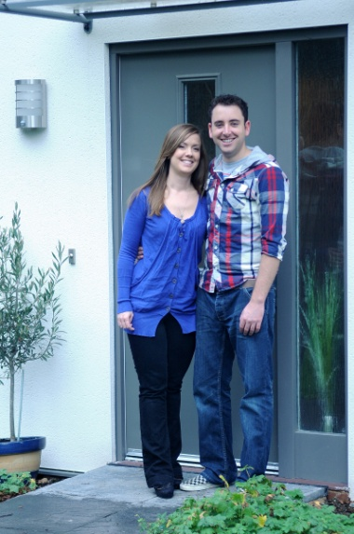
Name: Sarah Booker and Nick Martin
Situation: First time buyers
Scheme: Shared ownership
Location: Chichester
Provider: Affinity Sutton
Contact: 0300 100 0303
Website: www.affinitysutton.com
After three years of both renting and living back at home with parents, Sarah Booker and her partner Nick Martin decided it was time to consider their long term plans, opting for a three-bedroom family house as their first step onto the property ladder. The couple were attracted to the shared ownership scheme by leading affordable housing provider Affinity Sutton, which offered them a brand new home at Graylingwell Park on a part buy/part rent basis, with only a five per cent deposit.
Sarah, 32, and Nick, 28, who both work in marketing, were immediately drawn to the spacious and eco-friendly houses at Graylingwell Park. Nick says: “We did look at other shared ownership developments, but we were attracted by the size of the rooms and the large gardens at Graylingwell.”
After viewing a showhome, Sarah and Nick put down a five per cent deposit of just £4,200. The couple bought a 28 per cent share in a three-bedroom house for £82,600 and they plan to buy more shares in the future and eventually own their property outright. The monthly cost of their new home is around £495 for the mortgage and around £580 subsidised rent on the remaining share of their home and service charges.
The location was important for the couple; they both work on the outskirts of Chichester and Sarah’s family live close to the town. Nick, who is originally from Waterlooville, only has a 15-minute commute to his work at VHB Herbs, a fresh herb and seedlings supplier, and for Sarah it is a 20-minute cycle ride to her job at Philips Healthcare.
Sarah says: “We wanted to be close to Chichester and Graylingwell Park gave us the best of both worlds; walking distance to the town where we enjoy meeting up with friends but also because it’s set within beautiful and peaceful parkland. It is so close to the coast and surrounding countryside too, it’s perfect for our weekend bike rides.”
Graylingwell Park has recently launched Nightingales, the latest collection of new homes to be built at the former hospital. The outstanding new development, set in 85 acres of extensive parkland and only around a mile from Chichester city centre, has been developed jointly by Linden Homes, Affinity Sutton and the Homes & Communities Agency and is the UK’s largest carbon neutral scheme.
All of the homes are fitted with impressive energy saving features including high levels of insulation and heating and hot water supplied to all homes by a central heat and power plant.
The couple’s transition into their first home has been so successful; they have now recommended shared ownership to friends and family, and Nick’s cousin is now looking into buying at Graylingwell Park.
Sarah says: “We really enjoy living here and our friends are always so impressed with our new home. Everything was made so easy by Affinity Sutton - they were really helpful and took the stress away from the whole house-buying process.”
-ends-
Photograph: Sarah and Nick in their new home at Graylingwell Park in Chichester. For information call Affinity Sutton on 0300 100 0303 or visit www.affinitysutton.com
Notes to Editors:
Graylingwell Park has recently received a Gold Green Apple Award for ‘Built Environment: Best Use of Mixed Development’.

In 2010/11 Graylingwell Park was awarded:
- Best Sustainable Development and Best Brownfield Development in the What House? Award
- Sustainable Larger Social Housing Project of the Year 2010 by Inside Housing and Sustainable Housing in association with the Chartered Institute of Housing.
- Best Low or Zero Carbon Initiative by Housebuilder Magazine
- Highly commended for Most Eco Aware Project in the 2011 First Time Buyer Readers’ Awards

Affinity Sutton has just won ‘Social Housing Provider of the Year’ for its innovative approach to green homes in the Sustainable Housing Awards. Linden Homes recently won ‘Housebuilder of the Year’ in the 2012 Building Awards. In 2011, Linden Homes won a Bronze award for ‘Housebuilder of the Year’ and Affinity Sutton achieved the Gold Award for ‘Housing Association of the Year’ in the What House? Awards

Graylingwell Park has been created out of a progressive partnership between Linden Homes, Affinity Sutton, the Homes and Communities Agency, Chichester District Council and English Heritage to provide a sustainable and environmentally responsible development offering 750 new homes, 300 of which will be affordable homes, and exceptional community amenities.

Further media information:
Nikki Ackerley/Emma Stevens
Property House Marketing
01483 561119
emma@housegroup.co.uk

