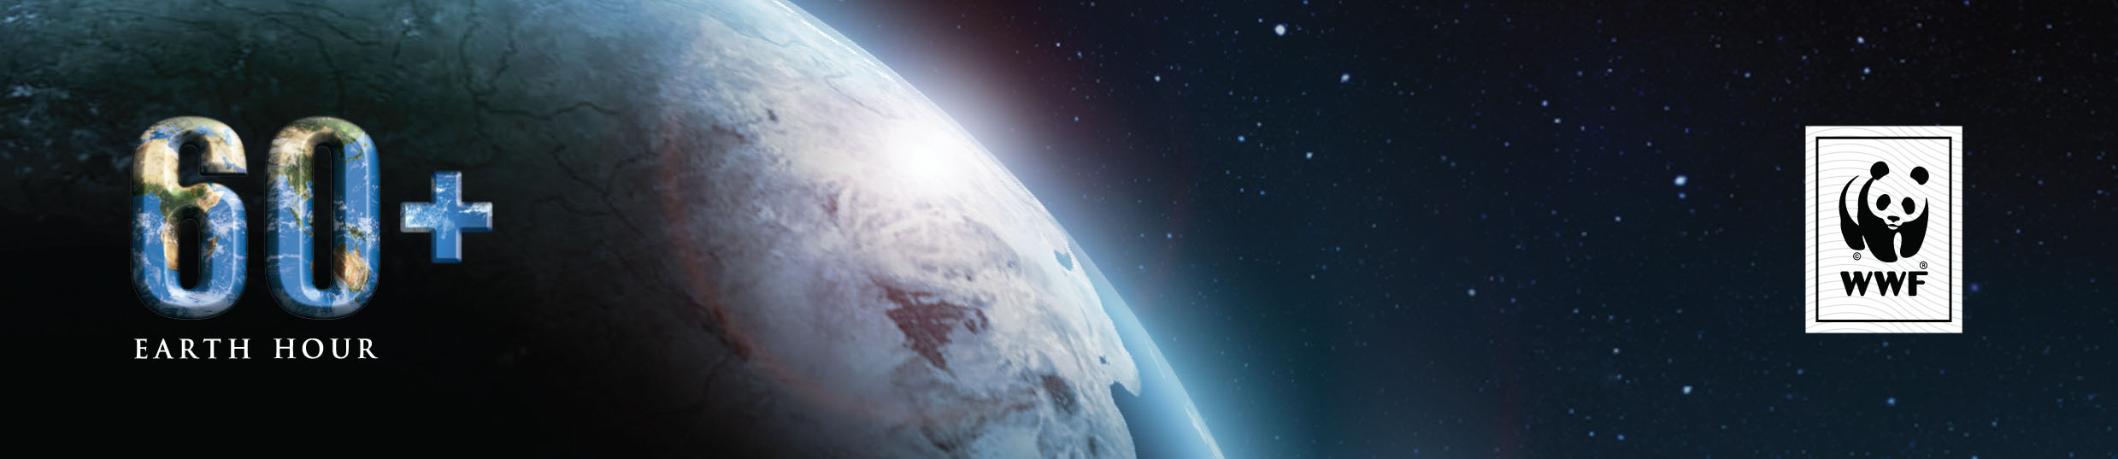
MEDIA RELEASE
UNDER STRICT EMBARGO UNTIL WEDNESDAY, FEBRUARY 27 11:00AM GMT+8
EARTH HOUR MORE THAN LIGHTS OFF

Earth Hour launches global 2013 campaign as a platform for outcomes to change the planet

FEBRUARY 27 2013, SINGAPORE: Earth Hour, the world’s largest movement for the planet, has launched its 2013 campaign on the back of record environmental outcomes it achieved in 2012.
Andy Ridley, CEO and Co-Founder of Earth Hour, spoke at the media launch of the environmental campaign in Singapore today. Earth Hour 2013 will take place on Saturday, March 23 at 8:30PM.

“Earth Hour has always been more than a lights off campaign, and we are now seeing some extraordinary environmental outcomes on the way to achieving our long-term vision,” Ridley said.
“Last December, the Russian parliament passed a long-awaited law to protect the country’s seas from oil pollution, after the voices of 120,000 Russians were presented to the government during our I Will If You Will campaign for Earth Hour 2012,” he said.
Following on from the massive success of its 120,000-strong signature petition, WWF’s Earth Hour in Russia has launched its 2013 campaign aiming to secure more than 100,000 signatures from Russian citizens to petition for amendments to the current forest legislation. If successful, it will return a ban on industrial logging in an area of land equal to twice the size of France, with protective forests equalling almost 18% of all forest territory in the country.
In Africa, the first Earth Hour Forest has begun in the nation of Uganda, an important first step in the fight against the 6,000 hectares of deforestation that occurs in the country every month. WWF Uganda identified close to 2,700 hectares of degraded land, and set a goal to fill it with at least 500,000 indigenous trees as part of their Earth Hour 2013 campaign.

In Botswana, former President Mr Festus Mogae has made a four-year commitment to plant one million indigenous trees as part of his I Will If You Will challenge, starting with 100,000 in a severely degraded area in Southern Botswana called Goodhope.

Across Latin America, preparations for ‘La Hora Del Planeta’ are well underway with Argentinian Earth Hour organisers and WWF affiliate Fundación Vida Silvestre Argentina, mobilizing thousands of participants to help champion the passing of a Senate bill to make Banco Burwood the biggest Marine Protected Area (MPA) in the country.
If the pending Senate bill is passed, the 3.4 million-hectare MPA will raise the level of protection of Argentina’s Exclusive Economic Zone* from 1% to 4%.

In the USA, nearly 35,000 Girls Scouts took part in Earth Hour last year through the Save Energy Project, and installed 132,141 energy efficient light bulbs across the country. The impact is a staggering 75,392,654 pounds of CO2 emissions eliminated, equivalent to the CO2 sequestration from planting 7,286 acres of trees per year*.

“These outcomes both evidence the power of our collective action and the potential for future outcomes for the environment, generated by hundreds of millions of people coming together as part of the Earth Hour movement,” Ridley said.

The importance of the grassroots element of inspiration of Earth Hour is evident in the case of two volunteers in Libya, Mohammed Nattah and Muhammad Bugashata, who with the help of Libya’s scout groups have successfully created the first environmental movement in their country post civil war.
“I wanted to join in 2011 but that wasn't an option because my city went through a lot that year - the war and everything," said Nattah.
“This year we’ve been able to get the movement to spread from two to five cities across the country, with locals and NGOs taking part in various I Will If You Will challenges,” said Bugashata.

Ridley believes that in the face of the threat of an unsustainable future, the grassroots nature of the Earth Hour movement and the can-do attitude of its participants to mobilize action, are the tipping points helping to deliver real environmental outcomes, both big and small.
“People from all walks of life, from all nations around the world, are the lifeblood of the Earth Hour interconnected global community. They have proven time and time again that if you believe in something strongly enough, you can achieve amazing things. These stories aren’t unique, this is happening all over the world,” he said.
Since 2007 when 2.2 million people took part in the first Earth Hour in Sydney, Australia, Earth Hour has massively expanded to over 7,000 cities and towns in 152 countries and territories with hundreds of millions of participants across seven continents.
In 2013, Earth Hour is not merely an annual event, but is a continuous movement driving real actions to change the world we live in.

Earth Hour 2013 will take place at 8.30pm – 9.30pm on Saturday 23 March

-ends-
* An exclusive economic zone (EEZ) is a sea-zone over which a state has special rights over the exploration and use of marine resources.
*Data provided by Girl Scouts Forever Green – Save Energy, developed in partnership with the Environmental Protection Agency and Earth Hour http://www.girlscouts.org/gsforevergreen/Earth-Hour.asp
See the Earth Hour 2013 Official Video at www.ehour.me/2013ViD
Press images from the global media launch can be downloaded at http://ehour.me/WmbuK8
Press images of Earth Hour can be downloaded at http://earthhour.org/media-centre/images
Downloadable video footage of the global event will be available in four B-rolls for media, covering major regions at http://www.earthhour.org/media-centre/videos

Media enquiries:
Benjamin Vozzo, Earth Hour Global E: benjamin@earthhour.org Ph: +65 8223 1728
Mai Tatoy, Earth Hour Global E: mai@earthhour.org Ph: +65 9017 7411

To join the global community head to:
- Earth Hour www.earthhour.org
- Facebook www.facebook.com/earthhour
- Twitter www.twitter.com/earthhour
- YouTube www.YouTube.com/EarthHour
- Google+ http://plus.google.com/+EarthHour
- Instagram http://instagram.com/earthhourofficial

About Earth Hour
Earth Hour is a global environmental initiative in partnership with WWF. Individuals, businesses, governments and communities are invited to turn out their lights for one hour on Saturday March 23, 2013 at 8:30 PM to show their support for environmentally sustainable action. In 2013, Earth Hour’s I Will If You Will concept invites individuals and organisations to challenge others to an ongoing environmental commitment beyond the hour. Earth Hour began in one city in 2007 and by 2012 involved hundreds of millions of people in 152 countries across every continent, receiving reports as ‘the world’s largest campaign for the planet’.

About WWF
WWF is one of the world’s largest and most respected independent conservation organisations, with almost five million supporters and a global network active in more than 100 countries. WWF’s mission is to stop the degradation of the earth’s natural environment and to build a future in which humans live in harmony with nature, by conserving the world’s biological diversity, ensuring that the use of renewable natural resources is sustainable, and promoting the reduction of pollution and wasteful consumption.

