QUARTER ENDED DECEMBER 31, 2014/2015 FISCAL YEAR RESULTS

eDreams ODIGEO’s revenue margin grew by 2% to €317.4 million

- The company is on track to meet annual target of €90 million in adjusted EBITDA

- Growth in expansion markets and in non-flights business saw 2% growth in revenue margin

- Adjusted EBITDA was €65.1 million, in line with analyst consensus. Adjusted EBITDA margin was 20.5%

- Adjusted net income at close of the third quarter was €10 million

- Cash at the end of the third quarter was €65 million

- Net debt decreased by 6% to €405 million compared to the same period last year,

Barcelona, 26 February 2015 - eDreams ODIGEO (www.edreamsodigeo.com) closed its third quarter with a 2% increase in revenue margin compared to last year, amounting to €317.4 million. This growth was due to the improvement in revenue margin per booking, both in flights and non-flights, which grew by 4%. Adjusted EBITDA in the quarter is in line with the company’s forecast of €90 million for the full year.

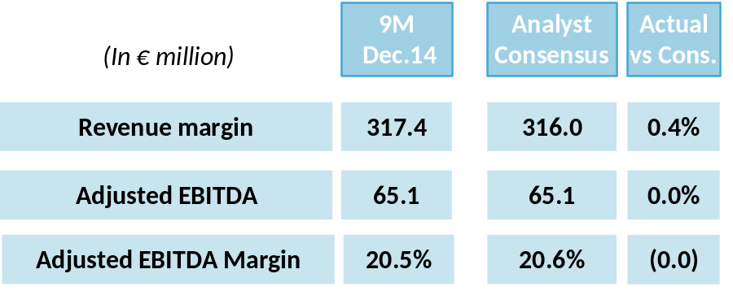

During this period the company obtained a revenue margin in flights of €249.4 million and increased its revenue margin in the non-flight business, which comprises hotels, car rental, and other auxiliary services, by 12% to €68 million. The results also benefitted from the contribution from Liligo meta-search engine.

Growth in the third quarter this year was also supported by strong performance of bookings and revenue margin in Spain and the expansion markets (excludes Spain France and Italy).
During the first 9 months of this year, revenue margin and bookings in the expansion markets grew by 9% and 12% respectively.

In international markets (excluding Germany, the United Kingdom, and the Nordic region) saw revenue margin increase by 38% in the quarter compared to the same period last year (see graph) and by 24% for the nine months, reaching 14% of the company's total revenue margin.

International Market Evolution
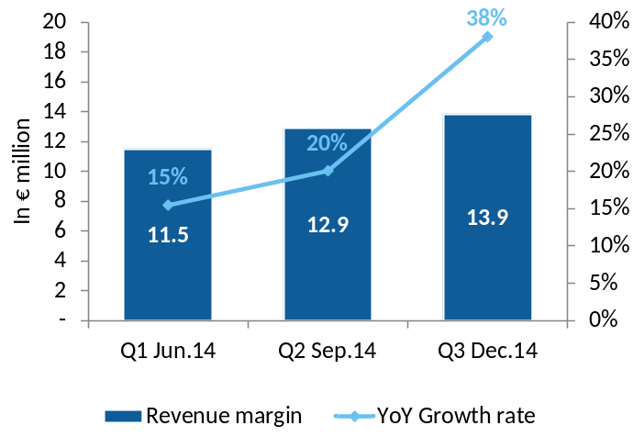

The CEO of eDreams ODIGEO, Dana Dunne, said "I am pleased with our performance in the third quarter which is fully in line with our annual targets of flat revenue margin and an adjusted EBITDA of €90 million at close of year. I am working closely with the teams across our business to develop plans to support the long-term development of eDreams ODIGEO.”

________________________________________________________________________________

About eDreams ODIGEO
eDreams ODIGEO (www.edreamsodigeo.com) is one of the main distributor of online flights in the world (in terms of revenue) and one of the largest European e-commerce companies. Under its five brands - eDreams, GO Voyages, Opodo, Travellink and Liligo - it offers the best deals in regular and charter flights, low-cost airlines, hotels, cruises, can rental, holiday packages, travel insurance and stays of different duration to more than 15 million customers all over the world. It is also a very effective platform for advertisers to reach their markets of interest in a personalised way, both locally and globally. With a presence in 44 countries, the company has a human team of about 1,700 professionals. eDreams ODIGEO is listed in the Spanish Continuous Market and had a turnover of €4,384 billion last year.

For more information:
Peter Carlsson, Country director eDreams ODIGEO Nordic
Phone: +46 70-511 81 52
Email: peter.carlsson@odigeo.com

