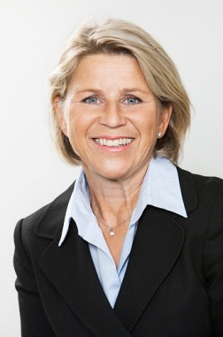
SIRPA-HELENA SORMUNEN
General Counsel and member of Executive Management of Fortum Corporation as of 1 September 2014
Born: 1959
Education: LL.M., Helsinki University, 1984
Previous positions
2012 - Patria Oyj, General Counsel
2004 - 2012 Nokia and Nokia Siemens Networks (NSN)
Several legal and managerial positions in the areas of Legal and Compliance, Customer
Operations; acting General Counsel; Legal head of West Europe and
CEMEA; Legal head of EMEA
2003 - 2004 TeliaSonera Finland Oyj, Vice President, Head of Legal, Mergers and Acquisitions and Finance
2000 - 2002 Sonera Oyj, Senior Legal Counsel, Head of Legal, Merger and Acquisitions

