Press release December 2016
COLLECTION MEN: FALL/WINTER 2017
“TIME IS LUXURY” - THE STORY BEHIND

Urban Escape – this is describing a retreat from stress and busy city life and a desire for peace, relaxation and calming nature. Especially in times of abundance and overstimulation, a „less is more“ attitude applies. Comfort and quality are the new understanding of luxury. This return to the essentials is reflected in the mood of HANRO’s Fall/Winter 2017 men’s collection. The appropriate atmosphere was found in Iceland: the endless, wide open space of the breathtaking Icelandic countryside offers the perfect photo backdrop to stage the new daywear, nightwear and loungewear.
The collection features classic, noble cotton fabrics with a subtle sheen in jersey, woven or chambray on the one hand, and on the other hand more voluminous, woolen fabrics in a tweed look as woven flannels, wool and silk blends, jacquards, fabrics with different surfaces on the in- and outside, to the point of double-faces and reversible styles.
Prints in paisley, floral or minimalistic design, as well as subtle checks, are an important part of the collection. Colors are masculine with dark navy blue, dark grey, a rich dark green and black, and are combined with softer, autumnal colors inspired by nature realized in golden toffee hues and loungy gray shades.
Modern finishing such as fancy yarns and sophisticated design details taken from ready-to-wear (such as button-fronts, patch pockets, hook and eye closures, or rib details) provide a luxurious touch and are the foundation of the outerwear appeal, assuring a well-groomed, comfortable look all day or night, inside or out. Multi-wear is core – boundaries between formal business clothing, casual leisurewear and classic underwear are fluid, allowing for contemporary outfits which can be worn around the clock.

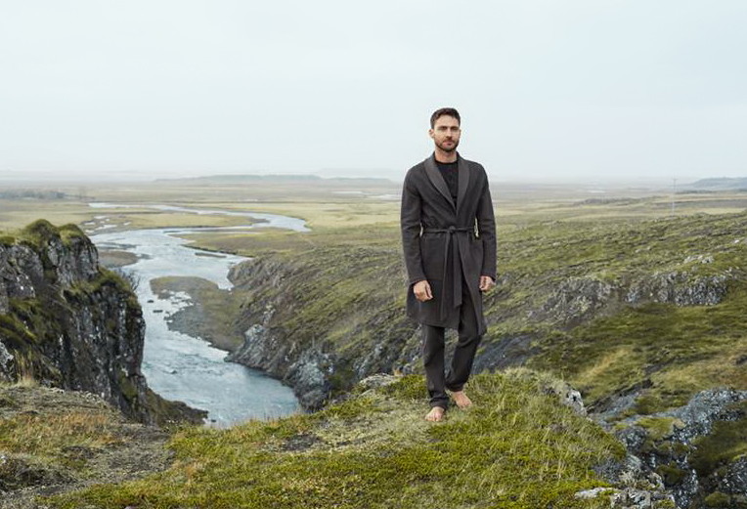

Category „CLASSICS“: Tradition meets zeitgeist. Classical elements embody a new, modern appeal thanks to a casual styling with an opulent touch. Elegant cotton qualities with a subtle sheen are especially luxurious when paired with noble paisley prints, stylish stripe designs, fancy yarns and visible stitching. Colors are classic and masculine with dark blue and black. Rich accents in cognac shades as well as fresh blue round up the color palette, and result in a noble, strong look with a subtle dandy appeal. „Night & Day“, the mix & match basic range, receives a sporty update thanks to carmine.
Highlights “NIGHT & DAY”, “CLASSICS”:
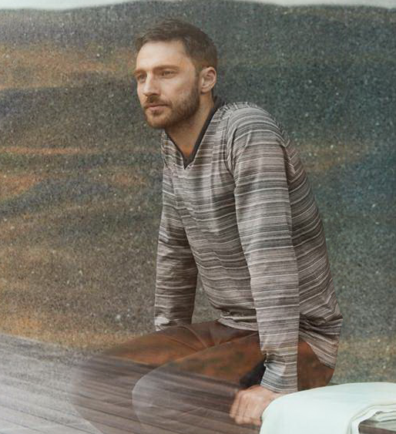 | 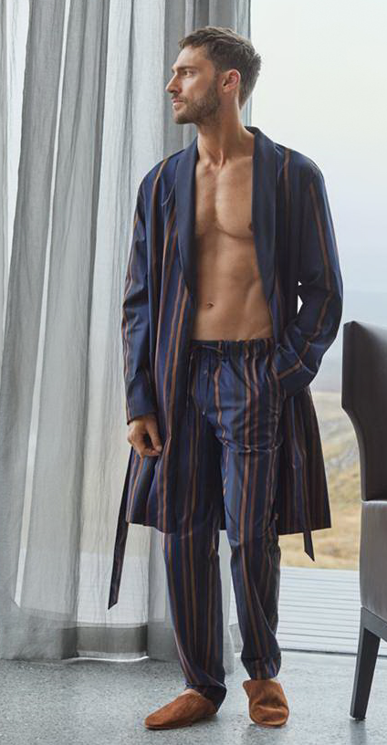 | 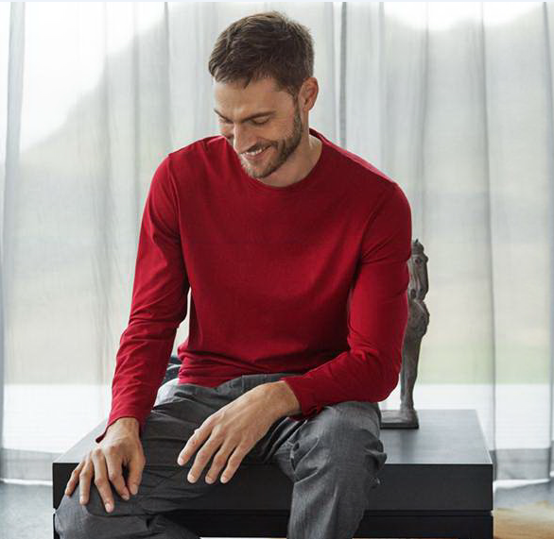
“Leandro” | “Jeremy“ | “Night & Day”

Within the „CASUAL & LOUNGE“ category, a casual, natural, well-groomed look is on the forefront. Every man can create his own individual outfit by combining the versatile styles at will. Designs are distinctive and masculine, as well as coordinated in colors, which makes it easy to convert them into stylish, sophisticated outfits for inside or out, at home or on the go. Dark blue and gray shades ranging from light to dark are core basic colors for countless mix & match options. Fresh, clear blue, warm accents in gold as well as dark green brighten up the color palette and provide a fresh update, often realized in check designs and minimalistic prints. Materials are cozy, soft winter qualities with a rustic appeal, realized as comfortable double-face with cotton or wool, as soft woven flannel, cotton-jersey with slight inside brushing, or high-quality merino wool and silk blends. Ready-to-wear inspired finishing and styles such as pants with hook and eye closure or fully reversible jackets underscore the outerwear appeal.
A new all-year Basic range “LIVING” introduces sleep & lounge styles with a night to day attitude – new wardrobe favorites which are especially versatile and offer wearing options for any situation of daily life.

Highlights “CASUALS & LOUNGEWEAR”,
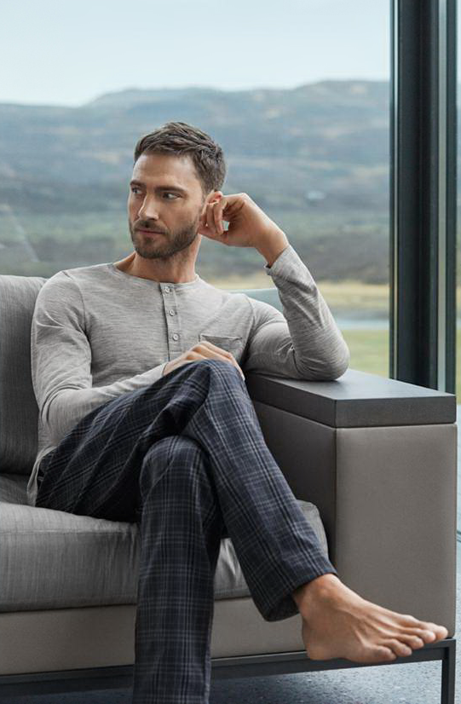 |  | 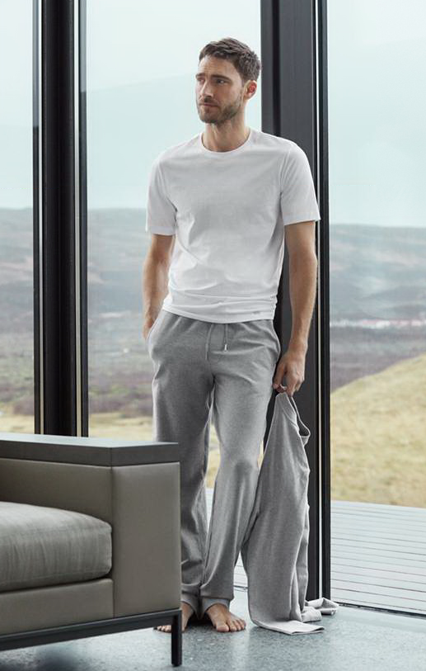
“Finn” | “Paul” | “Living”

The versatile DAYWEAR assortment from HANRO sees every man stylishly, comfortably and easily throughout the day. Popular underclothing in reliable HANRO style are offered in fashionable colors featuring new, sophisticated patterns. Cotton jerseys are on the forefront, but also elastic piqué made from micro-modal and cotton, as well as fine rib fabrics are offered. The woven boxers are matched to the nightwear & loungewear collections, showing paisley, ornamental or mini prints, and subtle stripes and checks. Colors are a perfect round-up of the sleep and lounge styles with blue and gray shades ranging from medium to dark, as well as fresh accents of autumnal cognac and strong red. WARMWEAR presents favorite underwear for winter days with blends of cashmere and silk or merino wool and silk.

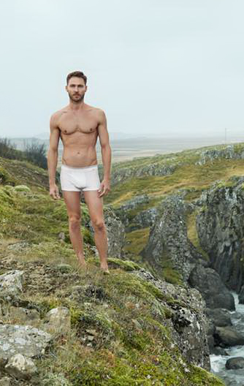 |  | 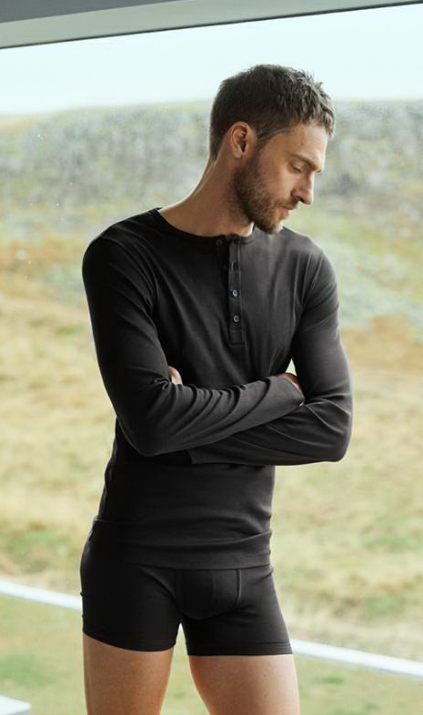
„Liam“ | „Elias“ & „Sporty Stripe“ | „Eric“
Collection report: Describing the individual series
(if not stated otherwise, all styles available from 15th July 2017)
NIGHT & DAY (Trend)
Around the clock, day or night: this modern mix & match series made from 100% single jersey or woven cotton offers the perfect fashionable basics in a sporty chic look. New, refined designs in fine checks with carmine as a fresh color accent, as well as a black and white chambray with subtle denim appeal provide a trendy update to the collection.

Trend-Styles FW17:
- 5418 V-Shirt ½ sleeve
- 5431 Shirt 1/1 sleeve
- 5436 Long pants
- 5384 Nightgown casual cut; featuring a long, woven button front
- 5461 Long-sleeve pajama

CLASSICS
Jeremy
Classic inspiration and modern interpretation: ‚night to day‘ mix & match collection with a luxury appeal in a noble, autumnal color palette. Made from 100% cotton in single jersey or woven. Available in a paisley print or a broad vertical stripe pattern, featuring solid shirts in dark navy blue or golden ‚toffe‘.
- 5574 Long pants single jersey
- 5575 Long pants woven
- 5576 Shirt 1/1 sleeve single jersey
- 5577 Robe woven

Valentin
For real pajama lovers: a wide selection of sets in different designs made from interlock cotton. Choose between styles with or without button front, solid or with pants in a sophisticated paisley print.
- 5622 Pajama 1/1 sleeve
- 5623 Pajama 1/1 sleeve with button-front
- 5624 Pajama ½ sleeve
- 5625 Pajama /1 sleeve full button-front

Leandro
Elegant nightwear with masculine charm: classical V-neck pajamas in creative stripe designs. Made from high-quality, double-mercerized single jersey cotton with a noble, subtle sheen. Choose from either a stripe pattern with hand stitching-style seams, or a classic stripe design featuring fancy yarns in a textural flamé look.
- 5521 Pajama ½ sleeve
- 5522 Pajama 1/1 sleeve
- 5523 Pajama 1/1 sleeve

Henry
Sophisticated nightwear in fashionable pajama style. Woven pajama and stylish, elegant robe with shawl collar, made from iridescent cotton chambray in structural mini jacquard design, featuring inside lining and trendy piping.
- 5693 Pajama 1/1 sleeve Top can be worn as all-day shirt for various occasions
- 5694 Robe

CASUALS & LOUNGEWEAR
Fynn
Modern winter lounge collection offering casual nonchalance. Styles in woolen flannel look made from different, cozy, soft fabrics offering many wearable options: made from woven flannel, high-quality merino wool and silk blend, or cotton single jersey, slightly brushed inside. Casual cuts and fashionable details. Color selection: a subtle tartan and a minimalistic print to combine with different grey shades, dark green and denim blue.

- 5668 Long pants from woven flannel; with cuffs and drawstring waist
- 5669 Long pants color-contrasting fold-over cuffs; drawcord
- 5670 Shirt 1/1 sleeve V-neckline; breast pocket; rounded hem
- 5671 Serafino 1/1 sleeve from wool and silk; button front
- 5672 Robe from woven flannel

Roman
Casual lounge styles for various wearing options, indoors or outdoors. Made from cozy double-face cotton featuring a ribbed surface on the inside and a smooth surface on the outside. The stylish jacket includes pockets and is fully reversible. In dark ‘marine’ combined with ‘hazel’.
- 5234 Long pants cuffs; drawcord;
- 5237 Pullover high collar neckline; raglan sleeves in the front
- 5238 Casual Jacket reversible; trims in contrasting color

Paul
Relax in style – at home or on the go. Luxurious casualwear in a woolen tweed look made from a soft double face jersey blend including cotton and wool. The textural piqué stripe outside fabric with a subtle bi-color effect offers a refined contrast to the smooth, solid inside lining. Stylish blazer, slim pants with hook and eye closure and zipper, as well as a versatile robe which can be worn from both sides.
- 5203 Long pants hook and eye closure; zipper
- 5204 Blazer patch pockets
- 5205 Robe versatile; color-contrasting shawl collar

Living (new to the Basic assortment)
Whether relaxing, travelling or doing activities – these versatile, casual styles are just the perfect fashionable leisurewear for inside or out. Pants, sweatshirt and jacket made from soft French Terry cotton, slightly brushed inside. The versatile t-shirts made from opaque single jersey cotton with a smooth feel are easy to combine with every outfit.
- 5070 Short Pants rib inserts; drawstring; pockets
- 5071 Long Pants drawstring; pockets
- 5072 Sweatshirt rib insert along the neck
- 5076 Jacket rib details; zipper; pockets
- 5050 Shirt ½ sleeve
- 5051 Shirt ½ sleeve V-neck
- 5053 Shirt 1/1 sleeve

LUXURY - HANRO SELECT
HANRO Select second delivery from Aug 15th, 2017
Noble luxury collection for the classy look of a gentleman. The high-quality, natural cotton fabric made from finest yarns for a super soft feel provides highest wearing comfort on cold winter days yet are pleasantly lightweight to wear. Classic pajama in refined paisley jacquard. Elegant robe with inner lining from soft cotton paisley print and almost tweedy outer surface. Colors in dark blue and dark red featuring a tonal paisley print underscore the luxurious dandy attitude.
- 5343 Pajama
- 5346 Robe

WARMWEAR
Light Merino
The winter favorite: Comfortable warmwear made of a super-light merino wool & silk in a newly interpreted retro-style – revised styling with new details for versatility and casual look for cool weather. New for Fall/Winter 2017 in shades of ‘silver’ and black.
- 4065 Longleg forward-set shoulder seam; ribbed round neck; long button front
- 4066 Shirt ½ Arm ribbed round neck
- 4067 Shirt 1/1 Arm long john in functional button-front fly design

Silk Cashmere
The ultimate luxury on cold winter days to be worn inside or out, in revised contemporary designs: Sophisticated shirts and close-fitting longleg made of an exclusive blend of silk and cashmere for warmth and highest wearing comfort. New colors: a light ‘monument’ color and elegant dark ‘dusty night’.
- 3151 Longleg with fly
- 3152 V-Shirt ½ Arm rounded hem
- 3153 Shirt 1/1 Arm rounded hem

DAYWEAR
Elias
Contemporary underwear made from elastic cotton jersey in fashionable prints. Covered woven waistband for the highest comfort. Offers versatile daywear or nightwear options. Available as paisley or floral ornament print.
- 4038 Pant covered woven waistband
- 4029 Boxer with button-fly; covered woven waistband

Sporty Stripe
Noble bottoms in 100% mercerized cotton single jersey with very fine horizontal stripes, which can be perfectly combined with the versatile V-neck shirt as comfortable daywear or nightwear options. Bottoms in toffee-colored ‘cork stripe’ and ‘blue stripe’. T-shirt in ‘marine’.
- 4080 Slip
- 4081 Pant
- 4082 Boxer with button-fly
- 4083 V-Shirt ½ sleeve

Liam
Underwear that offers a sporty and fresh look, made from ultra-soft, elastic Piqué fabric with micro-modal and cotton. Bottoms in a contemporary low-cut design. Color selection: gray ‘moonrock’, dark blue ‘midnight navy’ and pure white.
- 4070 V-Shirt ½ sleeve slightly forward-set seam
- 4071 Low Cut Brief soft waistband with logo inside
- 4072 Low Cut Pants soft waistband with logo inside

Eric
Stylish, retro-inspired look featuring modern cuts. Made from especially fine, noble, mercerized cotton in 1:1 rib, with inserts of 2:2 rib. Available in white and dark gray ‘cliff’. New style: a long-sleeve shirt with button-front.
- 4054 Brief jersey waistband; slight low cut
- 4055 Pant jersey waistband; slight low cut
- 4057 V-Shirt ½ sleeve
- 4064 Serafino 1/1 Arm button-front

Cotton Essential TwoPack
Fashionable underwear from cotton jersey with elastane for a guaranteed fit and wearing comfort, all with a contemporary logo waistband design. Each style is available as a convenient value-double pack combination in dark gray & blue (‘ferminate blue/coal melange’) or strong red & dark blue (‘rosso/marine’).

- 3075 Slips TwoPack woven logo waistband
- 3078 Pants TwoPack woven logo waistband
3079 Pants TwoPack elongated leg, covered waistband

Micro Touch
The popular, modern underwear, made of a particularly soft and smooth microfiber, follows the body’s every movement. The boxer briefs appear in shades of ‘smoke blue’ and medium gray ‘elephant’ for FW17.
Shadow
Modern basics: Underwear with subtle stripes, made of cotton and elastane for a perfect fit. A perfect match to the “Cotton Superior” shirts. Fashion colors for FW17: ‘mud’ and ‘ferminate blue’.

Cotton Superior
Popular series in the classic HANRO styling made of finest cotton and elastane. A perfect match to the “Shadow” series. Colors for FW17: ‘mud’ and ‘ferminate blue’.

Fancy Woven
An easy companion around the clock: the modern woven boxers made of 100% cotton in fashionable designs are the perfect everyday underwear. Available in five stylish prints in stripe design, paisley print, floral ornament print, mini print, and black & white print.

- 4013 boxer
- ‚toffee stripe‘
- ‚little dots‘
- ‚floral ornament‘
- ‚classic paisley‘
- ‚black / white woven‘

Fancy Woven TwoPack
The popular woven boxers attractively packaged as a double pack. Depending on taste and mood, they are available in 3 creative wintery combinations of print or check with solid.

- 4014 Boxers 2-Pack:
- ‚floral ornament‘ / ‚black iris‘
- ‚subtle check‘ / ‚black‘
- ‚classic paisley‘ / ‚blue chambray‘

COMPANY INFORMATION:
HANRO of Switzerland – Pure luxury on skin! HANRO is an international luxury brand for lingerie, daywear, nightwear and loungewear for ladies and men. Ever since it was founded in 1884 by Albert Handschin and Carl Ronus in Switzerland, the company has stood for Understated Luxury, natural elegance, and garments which are a pleasure and comfort to wear. HANRO products are marked by highest quality standards and excellent craftsmanship. The careful development of unique materials from natural fibers, ingenious designs and decades of tradition, combined with technical innovations, are what make HANRO such a distinctive brand. HANRO products are produced almost exclusively within Europe. In 1991, HANRO joined the Austrian Huber Group. Today, HANRO can be found at the most exclusive stores in almost 50 countries. www.hanro.com

PR CONTACT:
Nina Rehmann | HANRO International GmbH | +43 5523-505-6735 | press@hanro.com

